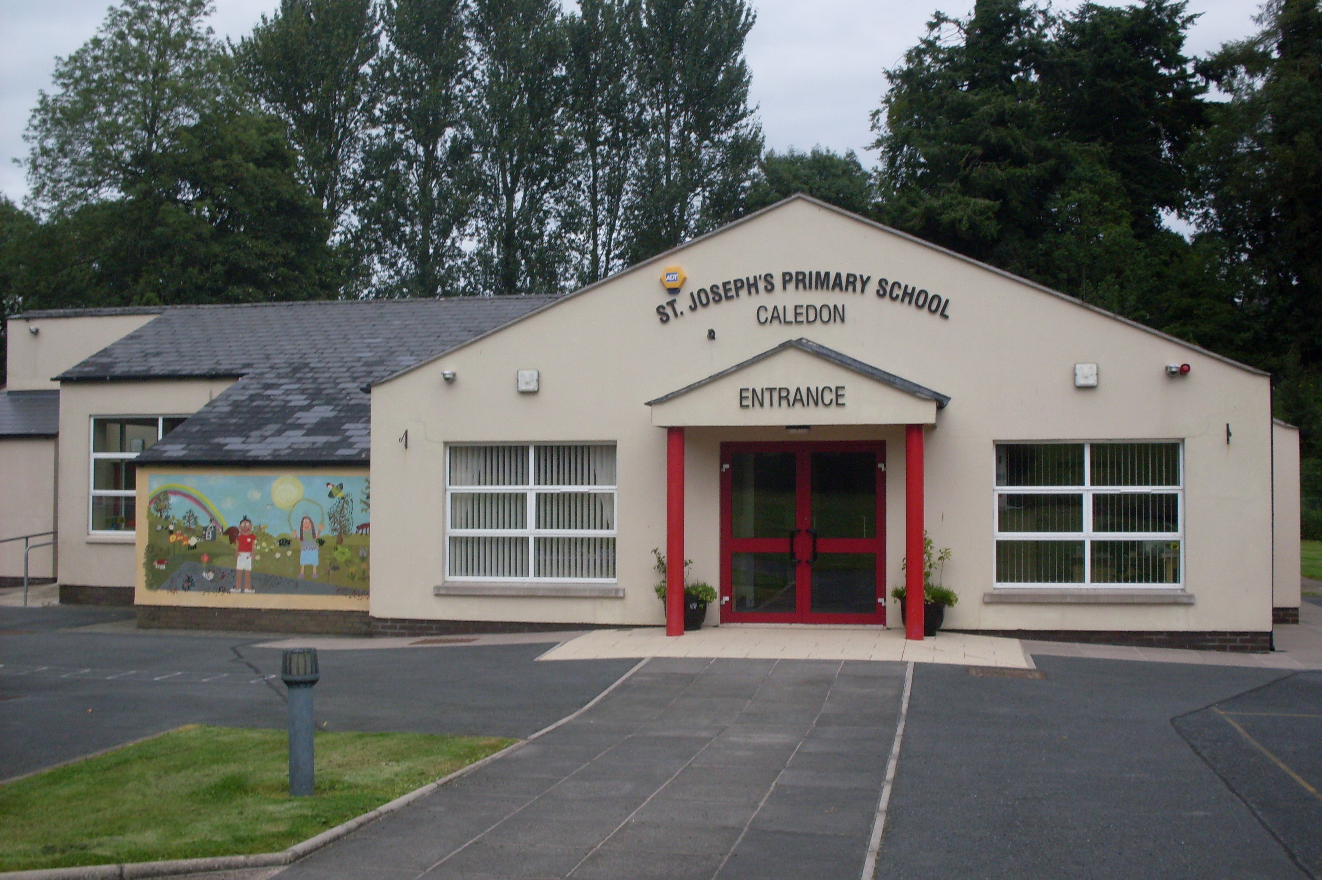

St. Joseph’s Primary School,
14, Derrycourtney Road,
Caledon,
Co. Tyrone
BT68 4UF
Tel: 37568537
Principal: Mrs Marie McKenna

St Joseph’s Primary School

Newsletter – August 2020
Dear Parents
We are delighted to say preparations are well underway to welcome all of our children back for the Autumn term.
Of course, these are unusual times and new and necessary adjustments have had to be made to cope with the challenges we face. Hopefully the following guidance will set out clearly what you and your children can expect when the children return to school.
First of all, I would like to begin by stating that the health and safety of our school community is the guiding principle underpinning our practice going forward. We are very aware that the children may need time to adjust to the routine and increased structure of the school day. Our aim is to settle children back to routine in atmosphere of care and understanding.
To begin with this the return date for the classes:
Week beginning 24th August
Monday | Tuesday | Wednesday | Thursday | Friday
P7 only  9am- 12 noon | P7 & P1 only  9am- 12 noon | All children return  9am-12 noon  P7 children stay until 2.45pm | All children return  9am-12 noon  P7 children stay until 2.45pm | All children return  9am-12 noon  P7 children stay until 2.45pm

NB: No school transport or school dinners available this week.
No school on Monday 31st August
All children will return for the full day on Tuesday 1st September.

Uniform
To facilitate washing of uniforms we are suggesting that children wear full uniform on alternative days i.e.
We hope to do as much outdoor activities as possible so suggest the following:
Monday, Wednesday & Friday :-PE school uniform
Tuesday & Thursday : - normal school uniform
School Bags & Homework
School bags should not be brought in to school until further notice. We plan to send homework home from the week beginning 14th September in plastic folders. The work will go home on the previous Friday to be returned the following Friday. A fresh pack will then be sent home on that Friday for the following week.
A peg – for coats and shoe bags - will be allocated in the corridors outside the classroom. Your child’s name will be above the peg. Lunchboxes are to be left below the peg. Indoor shoes should be worn.
School Day
When children arrive at school, the P1- 4 children will come through the door at the side of Mrs McKenna’s classroom. The P5- 7 children will enter the school via the door beside Miss Largey’s classroom. Staff will be on hand to direct and help pupils. The children will immediately hang up their coat and put on their indoor shoes. BEFORE ENTERING THE CLASSROOM, THEY WILL WASH THEIR HANDS IN THE BATHROOM. Hand sanitisers will be available at all entrance/exit points. The children will remain in their class ‘bubble’ for the duration of the day.
Children will go straight to their named, dedicated seat in their classroom.
Children can bring in their own pencil case WHICH MUST REMAIN IN SCHOOL. No stationary items will be shared. Suggested items are: 2 pencils, sharpener, glue stick and colouring pencils.
Break and Lunch Times
Dinners - £2.60 per day
Children taking a hot meal will sit at a table in their ’bubble’ and their meal will be brought to them.
Lunches
Packed lunches will be eaten in the classroom.
The two ‘bubble’ classes will play on separate playgrounds.
Every time the children enter and exit the building or use the toilets they will wash their hands. Hand sanitisers and hand washing facilities are also available in all of the classrooms.
Break
For the foreseeable future we have suspended our fruit breaktime and will offer a slice of toast and glass of milk instead. The cost of this is £2.50 a week.
Home-time
Children will exit the building via their class door. Parents can collect their child in the playground. Bus children will be brought to the bus. It is not mandatory for children to wear masks on the bus but it is recommended. Children must stay in the seat designated to them by the driver.
Parents
We have always been proud of our ’open door’ ethos to all of our families. However, I am sure you will understand and appreciate that to limit the chances of spreading the infection we must limit access for adults on the school premises. Parents should not enter the building unless they have an appointment. Please wait outside for your child to be collected at home time. Younger children will be met by an adult at the door and assisted to change their shoes and wash their hands by a member of staff. Social distancing of 2 metres must be observed at all times between adults. If you have made an appointment to see the teacher, please wear a mask and use the front door.
Keeping Healthy
It is vital that children do not come to school if they are unwell, and particularly if they have a temperature. If your child feels unwell during the course of the day, he/she will be isolated in the Principal’s office to wait for you to come and collect them.
Confirmation
The Sacrament of Confirmation will be celebrated in St Joseph’s Church, Caledon on Saturday 5th September @ 5pm. Only 6 members (Including the child) of a family should attend the ceremony. There will be a practice in St Joseph’s Church on Friday 28th August @ 7pm with Fr Cathal.
First Confession & First Holy Communion – P5 children
First Confession will take place in school (date to be confirmed). First holy Communion will take place in St Joseph’s church on Saturday 26th September @ 11am.

Yours sincerely.

M McKenna
Principal

