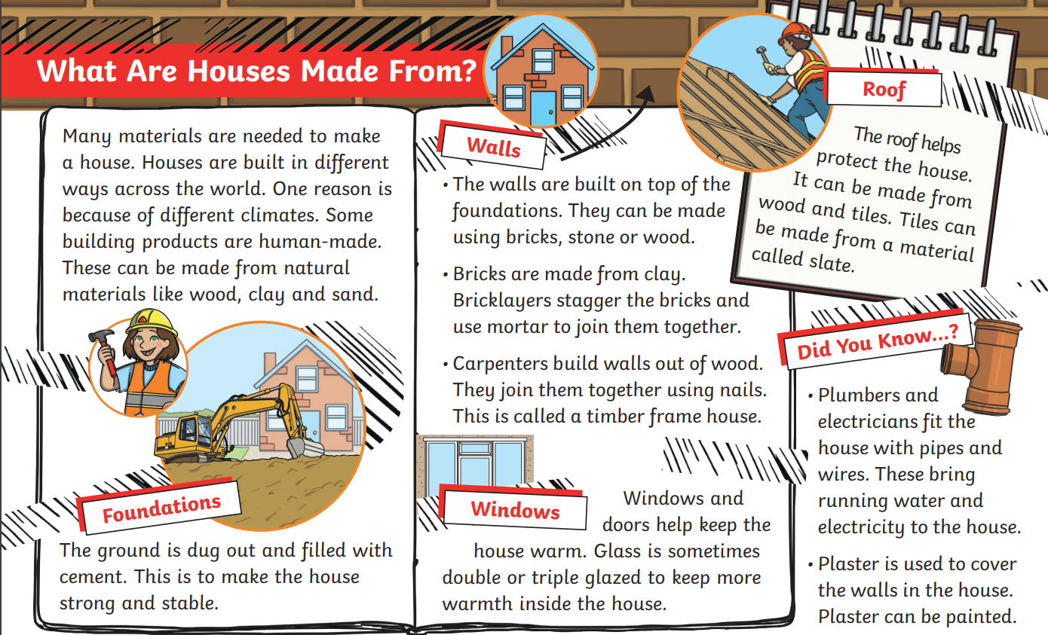

The children have been learning to answer their comprehension questions in full sentences by repeating the question in their answer with me in school.
They should answer these questions orally (speaking) as opposed to writing the answer out : )

- Why are houses built in different ways? Clue: The word climate means the weather.
Example of how the children should begin answering for the first questions is – Houses are built in different ways because_____________________________.
- What machine builds the foundations?
- What can the walls be made of?
- What do windows and doors help to do?

