**What to do today**

*IMPORTANT! Parent or Carer – Read this page with your child and check that you are happy with what they have to do and with any weblinks or use of the Internet required.*

**1. Reading time**

Read the poem *Dad and the Cat and the Tree* by Kit Wright.

**2. Sequence events in the poem**

Cut up and shuffle the set of *Dad Cat and Tree Picture Cards*.

* By reading the captions and looking at the pictures, place the cards in the correct order on the two *empty grids.*
* When you are sure you have got them in the right order, glue the pictures down. Number them 1 – 12. Later, colour your cards in and use them to tell someone else the story.

**3. Writing time**

What might happen next? How will Dad get out of the tree? Will someone have to go up to rescue him?

* On *What Happens Next* draw what you think will happen now that the Dad is stuck in the tree.
* Write some sentences under your picture. Remember to use capital letters to start your sentences and full stops to finish them.

**Now try these Fun-Time Extras**

* Write down things at home that have made you laugh on *Funny things that have happened in my family.* Draw a picture of one of these.
* Explain to someone to say how you would get a cat out of a tree. Can you draw a picture of you saving the cat?

**Dad and the Cat and the Tree**

|  |  |
| --- | --- |
| This morning the cat got  Stuck in our tree,  Dad said, “Right, just  Leave it to me.”  The tree was wobbly,  The tree was tall.  Mum said, “For goodness  Sake don’t fall!”  “Fall!” scoffed Dad,  “A climber like me?  Child’s play, this is!  You wait and see.”  He got out the ladder  From the garden shed.  It slipped. He landed  In the flower bed.  “Never mind,” said Dad,  Brushing the dirt  Off his hair and his face  And his trousers and shirt.  “We’ll try Plan B. Stand  Out of the way!”  Mum said, “Don’t fall  Again, OK?”  “Fall again?” said Dad.  “Funny joke!”  Then he swung himself up  On a branch. It broke. | Dad landed *wallop*  Back on the deck.  Mum said, “Stop it!”  You’ll break your neck!”  ‘Rubbish!” said Dad.  “Now we’ll try Plan C.  Easy as winking  To a climber like me!”  Then he climbed up high  On the garden wall.  Guess what?  He *didn’t fall!*  He gave a great leap  And he landed flat  In the crook of the tree trunk –  Right on the cat!  The cat gave a yell  And sprang to the ground,  Pleased as Punch to be  Safe and sound.  So it’s smiling and smirking,  Smug as can be,  But poor old Dad’s  Still    Stuck  Up  The  Tree! |

*by Kit Wright*

|  |  |  |
| --- | --- | --- |
| The cat is stuck in our tree. | Mum, Dad and me are looking at it. | Dad gets a ladder. |
| The ladder slips. | Dad climbs on a branch. | The branch breaks. |

|  |  |  |
| --- | --- | --- |
| Dad climbs on the wall. | Dad jumps on to the tree. | Dad lands on the cat! |
| The cat jumps down from the tree. | The cat is smug. | Dad is stuck up the tree. |

|  |  |  |
| --- | --- | --- |
|  |  |  |
|  |  |  |

|  |  |  |
| --- | --- | --- |
|  |  |  |
|  |  |  |

**What Happens Next**

|  |
| --- |
|  |

**____________________________________________________________________________________________________________________________________________________________________________________________________________________________________**

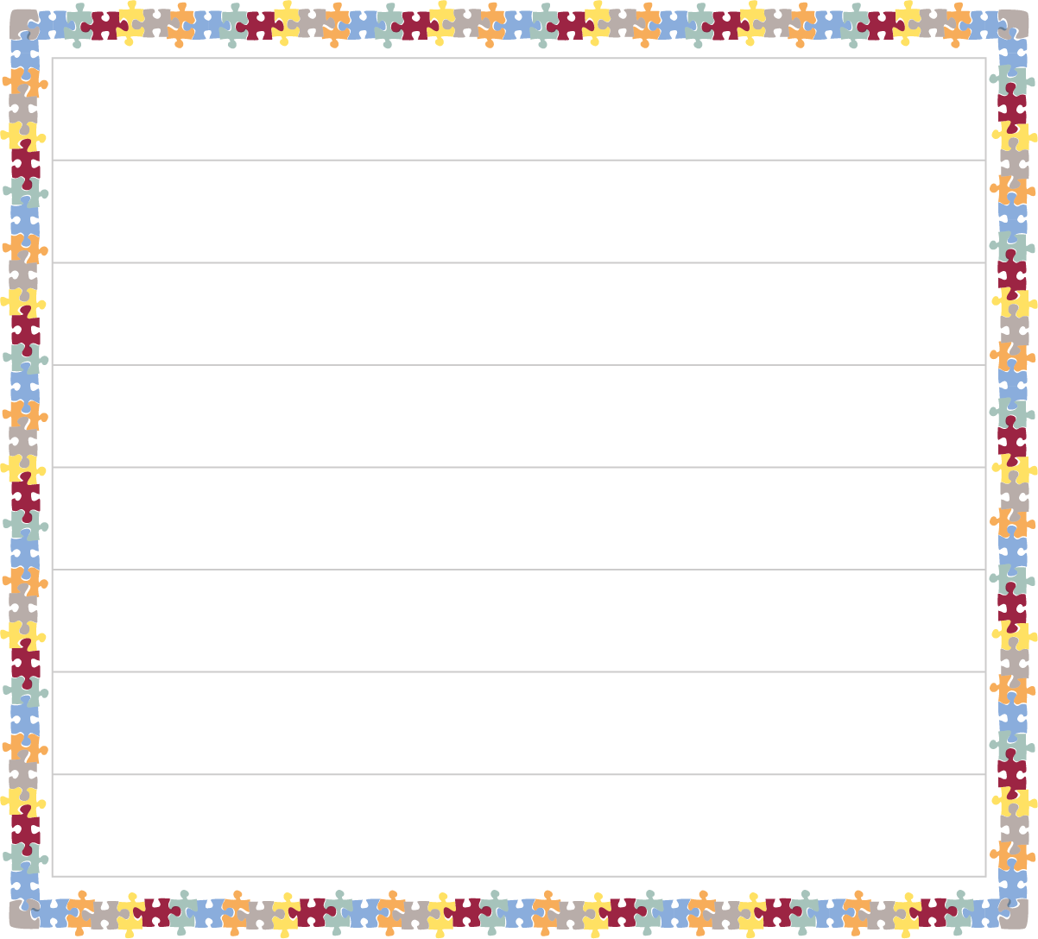**Funny things that have happened in my family**

|  |
| --- |
|  |