**What to do today**

*IMPORTANT! Parent or Carer – Read this page with your child and check that you are happy with what they have to do and with any weblinks or use of the Internet required.*

**1. Reading time**

Read the two poems, *If You Should Meet a Crocodile* and *The Vulture*

* What things do the poems have in common?
* Which do you like the best? Why is that?

**2. Rhymes in poems**

Use a coloured pen to highlight the pairs of rhyming words in *The Vulture.*

* Are you sure that you have all pairs listed on *Rhymes in The Vulture*?
* Read the other words in the box below the table. Copy each into the correct rhyme section. Think of other rhyming words….

**3. Writing about animals and their food**

Print off either the *Picture of the Vulture* or the *Picture of the Crocodile*.

* Stick your picture in the middle of a large piece of paper.
* Name your animal, e.g. *A* *Vulture.*
* Label the different parts of your animal with words and short phrases (e.g. *beak, feathers, big bald head, very sharp claws for holding things* etc.)

**Now try these Fun-Time Extras**

* Stick a paper plate onto a large piece of paper or draw round a big plate on a piece of paper so that you have a plate shape.
* On your plate, draw what horrible things you think a crocodile or a vulture’s dinner might contain! Write some sentences next to the plate to explain what gruesome objects they are eating.
* On *My Favourite Three Animals* draw pictures of these creatures and write a sentence for each one saying what they like to eat.

**If You Should Meet a Crocodile**

If you should meet a crocodile,

Don’t take a stick and poke him;

Ignore the welcome in his smile,

Be careful not to stroke him.

For as he sleeps upon the Nile,

He thinner gets and thinner;

But whene’er you meet a crocodile

He’s ready for his dinner.

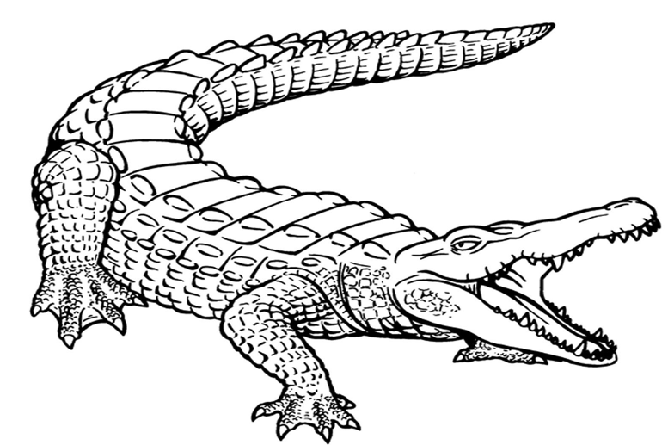

*Anon*

**The Vulture**

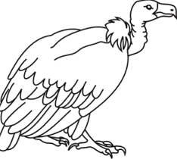

The vulture eats between his meals

And that’s the reason why,

He very, very rarely feels

As well as you or I.

His eye is dull, his head is bald,

His neck is growing thinner.

Oh! What a lesson for us all

To only eat at dinner.

*Hilaire Belloc*

**Rhymes in The Vulture**

|  |  |  |  |
| --- | --- | --- | --- |
| meals  feels | why  I | bald  all | dinner  thinner |
|  |  |  |  |

|  |
| --- |
| **dry wall seals pie tall**  **beginner sigh eels sinner wall**  **eye winner kneels** |

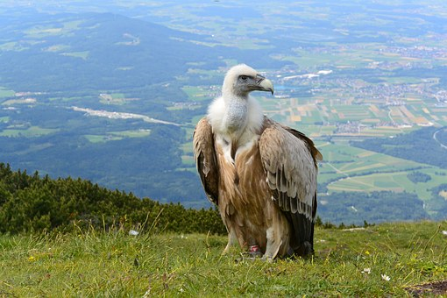

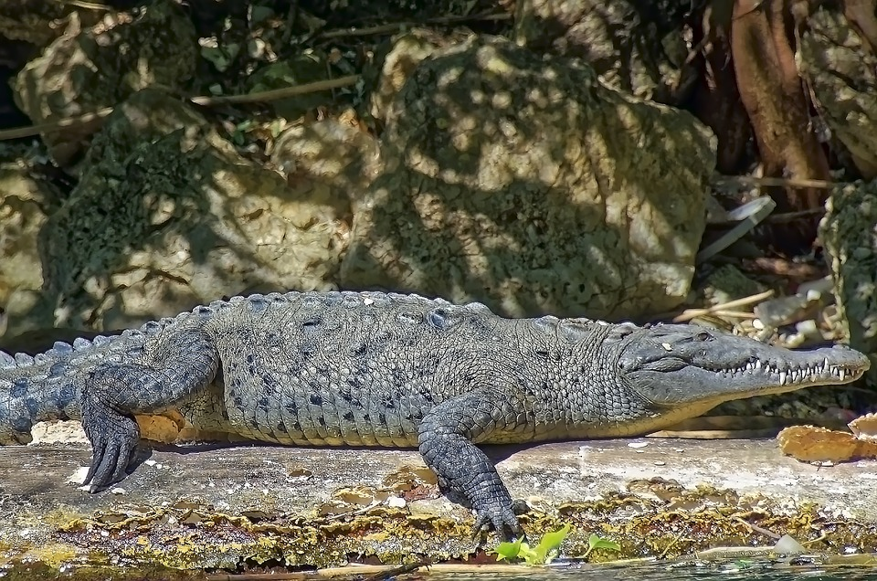

**My Three Favourite Animals**

|  |  |
| --- | --- |
| **Animal** | **What they like to eat** |

|  |  |
| --- | --- |
|  | **______________________________**  **______________________________**  **______________________________**  **______________________________**  **______________________________** |
|  | **______________________________**  **______________________________**  **______________________________**  **______________________________**  **______________________________** |
|  | **______________________________**  **______________________________**  **______________________________**  **______________________________**  **______________________________** |