CHAIRMAN’S REMARKS

Dear Parents

I am pleased to present to you the 2016/2017 Governors’ Report for Gibson Primary School. This was an extremely significant year in the life of Gibson Primary School. Not only did we have an inspection but we also had the retirement of two senior teachers who spent the majority of their teaching career at Gibson Primary School and we would like to thank both Mrs Hamilton and Mrs O’Hara for their years’ service and also wish them a happy retirement.

We were delighted that the inspection highlighted the successes of our school and that they deemed the school to be ‘outstanding’. While this what we would have expected it is pleasing to know that the excellent work we witness is evident to external professionals. It would be remiss of us if we were not to pay credit to all the staff and congratulate them on this achievement.

We are also aware that a successful school can only work if good relationships exist between the school and parents. To this end we appreciate everything you do to support the school and we acknowledge how fortunate we are to be able to work with you all in such a positive way.

This report is only able to offer a sample of the work that is completed in one school year. It does however provide us with an opportunity to demonstrate the success and achievements of our pupils and staff. It also highlights the excellent standard of education that is associated with Gibson Primary School. We continue to be extremely proud of the staff, pupils and parents of Gibson Primary School and the strong community ethos that exists. The behaviour of our children and the support of parents are exceptional and we believe it is one of the things that make our school special.

Despite the on-going financial pressures and the variety of changes imposed by the introduction of the Education Authority, Gibson Primary School continues to thrive. We are acutely aware that despite these issues our children continue to make significant progress academically, socially and emotionally and they are presented with a wide variety of opportunities each academic year. This is only possible due to the commitment of our staff and we as Governors wish to pay tribute to them.

On behalf of all of the members of the Board of Governors, I wish the staff and pupils at Gibson Primary School every success in the 2017/18 school year.

Canon Robert Clarke
(Chairman of the Board of Governors)

THE BOARD OF GOVERNORS

Transferors’ Representatives:
Canon R Clarke (Chairman)
Rev J Cowan
Mrs A Hamill
Mr W D Reilly

Western Education & Library Board Representatives:
Mr J Gilmour (Vice Chairman)
Canon R Clarke (Chairman)
Mr M Beattie

Parents’ Representatives: Teacher Representative:
Mr R Loughlin Mrs W Irwin
Mrs L Armstrong

Principal:
Mr K Sterritt (Non voting member of the Board)

The Board of Governors is required to meet 3 times each year but in practice meetings occur more often than this. During 2016/2017, the Governors met regarding:
- The Delivery of the Northern Ireland Curriculum
- Staff Appointments, Attendance & Welfare
- Admissions Policy and Open Enrolment
- Self-Evaluation and School Development Planning
- Policy Review
- Budget Management
- Performance Review & Staff Development
- Promoting Positive Behaviour
- Salary Review
- Responding to Department of Education and EA Initiatives
- Child Protection and Safeguarding measures
- Reporting to parents

The four-year term of office of the new Board began in September 2014 and will run until 2018
ENROLMENT

Due to the excellent reputation and high standard of education our school continues to grow with enrolment during 2016/17 being 311 pupils (excluding the Speech and Language Units). This is an increase of 11 pupils from last year and is the highest our enrolment has been since the Lisanelly Army Barracks closed in 2007. Our pupils’ attendance continues to be above the Northern Ireland average with the school average being 95.6%. This is indicative of the positive attitude which our pupils and parents have towards school. Spells of sickness, medical appointments and family holidays during term time were the main absences.
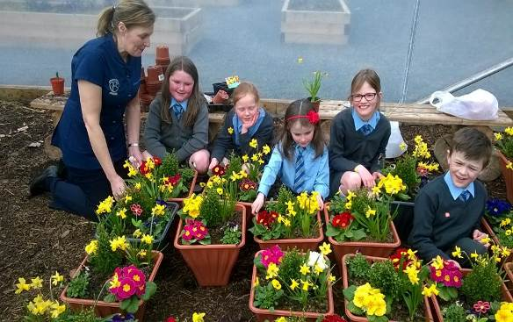

CHILD PROTECTION

Our Child Protection Policy is available to view on our school website and is circulated to all new parents annually. It is also available in paper copy upon request. Child protection procedures continue to be fully implemented and criminal background checks are carried out on all newly appointed staff and volunteers.

Mrs Hamilton is the designated teacher for child protection and Mrs Shortt is the deputy designated teacher for child protection. All staff received updated child protection training in August 2015. Mrs Irwin and Mr Sterritt both received full Child Protection training when they will take over Mrs Hamilton’s role following her retirement in June 2017. Staff training was updated in August 2017.
Children are regularly reminded to take care during assemblies or in class.
TEACHING STAFF AND IN-SERVICE TRAINING

In the 2016/17 school year, our teaching staff consisted of the Principal, Vice Principal, 12 class teachers, 2 teachers in charge of the Speech and Language Units and an Outreach teacher for Speech and Language difficulties.

The introduction of the Education Authority and on-going changes to the education system has resulted in the emphasis being placed on schools to organise, source and support their own staff development programme. We are fortunate to have a highly skilled and committed staff who have led training sessions based on the needs of the School Development Plan. Staff meetings regularly focus on sharing of best practice and ensuring the highest possible level fo educational standards.

The five ‘Baker’ days in August and five Staff Development Days are key elements of our Continued Professional Development Programme. They were used to plan and prepare for quality learning and teaching and to address specific issues identified in our School Development Plan, as outlined below.

 | DATE |  | FOCUS OF STAFF DEVELOPMENT
Baker Days | Day | Date | The focus for each day should link to, and support, the priorities identified in the school’s development plan.
Day 1 | Wednesday | 24 August | Classroom Preparation and planning  Teacher meetings & Transfer of Information
Day 2 | Thursday | 25 August | SDP review / ESAGS/TTI Audit of progress  Child Protection Refresher Training
Day 3 | Friday | 26 August | Classroom Preparation, Planning & Data Analysis  Policy Review
Day 4 | Monday | 30 August | SDP Review feedback / Target setting  Staff meeting – Identification of SDP focus
Day 5 | Tuesday | 31 August | Curriculum Content review and Curriculum Planning  Term 1 Priorities / timetable – deadlines & Coordinator Action Planning
SDDs | Day | Date
Day 1 | Monday | 27 September | Data Analysis & WAU (Practical Science) Sessions  Literacy, Numeracy & ICT Task identification
Day 2 | Wednesday | 4 January | Curriculum Content & Curriculum Planning Review  Co-ordinator Action Plan Review
Day 3 | Thursday | 16 March | Cross Curricular Skills Levelling work  Review Literacy Scheme of Work – Writing
Day 4 | Tuesday | 30 May | Data Analysis  ICT, Numeracy & Literacy Focus
Day 5 | Wednesday | 31 May | School Development Plan Review  Report Writing

While a significant amount of staff development is carried out internally a number of staff also attended training which was then disseminated to the remainder of the school staff. An overview of training received by external providers is included in the table below.

Full Name | Training Course Title
Mrs L Armstrong | ASAS 2 Day Toolkit
Mrs D Clarke | FMS Training
 | IFS Training
Mr S Elliott | 2 Day Toolkit for ASD
Mrs B Hamilton | Early Intervention Transformation
Mrs S Herron | ICT Co-ordinator Day
 | Self Review Framework & ICT Mark
 | Sharing Excellence Through Partners
Mrs W Irwin | Child Protection Training (2 days)
 | ICT Assessment Practice
Miss A McConnell | ASAS 2 Day Toolkit
Mrs V McGonigle | ASAS 2 Day Toolkit
Mrs R McKnight | Game & Wildlife Conservation
Mr K Sterritt | Child Protection Training (2 days)
 | FMS Training
 | IFS Training

STAFF

The Governors are extremely appreciative of the efforts of all members of staff. We are justifiably proud of our school and the child centred approach it adopts; this would not be possible without all the staff working together. The high standards achieved and exemplary behaviour exhibited by our pupils are a reflection of the excellent work from all our staff.

TEACHING STAFF

Principal Mr K Sterritt
Year 1 teacher Mrs L Simpson (Miss McConnell)
Year 1 teacher (Job Share) Mrs Y Aiken/Mrs H Russell
Year 2 teacher Mrs V O’Hara
Year 2 teacher Miss J Adams
Year 3 teacher Mrs C McKernan
Year 3 teacher Dr S Herron
Year 4 teacher Mrs C Porter
Year 4 teacher Mrs R McKnight
Year 5 teacher Mr S Elliott
Year 5 teacher & Vice-Principal Mrs W Irwin
Year 6 teacher Mrs C Black
Year 6/7 teacher Mrs B Jobb
Year 7 teacher Mrs B Hamilton
Language Unit teacher Mrs S Shortt
Language Unit teacher Mrs E Davidson
Language support teacher Mrs C Mulveen

NON TEACHING STAFF
1 Executive Officer (34 hours per week) Mrs D Clarke
1 Clerical Assistant (10 hours per week) Mrs L McFarland
1 SEN Classroom Assistant (32.5 hours per week) Mrs I Neil
1 SEN Classroom Assistant (30 hours per week) Ms K Picking
1 SEN Classroom Assistant (25 hours per week) Mrs V McFarland
1 SEN Classroom Assistant (25 hours per week) Mrs J Johnston
1 SEN Classroom Assistant (25 hours per week) Miss E Aiken
1 SEN Classroom Assistant (27.5 hours per week) Mrs Y Williams
1 SEN Classroom Assistant (27.5 hours per week) Ms D Fenwick
1 SEN Classroom Assistant (25 hours per week) Mrs K McFall
1 SEN Classroom Assistant (25 hours per week) Miss A White
1 SEN Classroom Assistant (20 hours per week) Mrs A McGrew
1 Classroom Assistant (21.25 hours per week) Ms L Armstrong
1 Classroom Assistant (16.25 hours per week) Mrs L Watson
1 Classroom Assistant (16.25 hours per week) Mrs T Matthews
1 Classroom Assistant (21.25 hours per week) Mrs V McGonigle
1 Building Supervisor (36 hours per week) Mr S Gilfillan
5 Supervisory Assistants 3.75 hrs per week
3 Cleaners 12.5 hrs per week
1 Cleaner 10 hrs per week
1 School Crossing Patrol 12.5 hrs per week

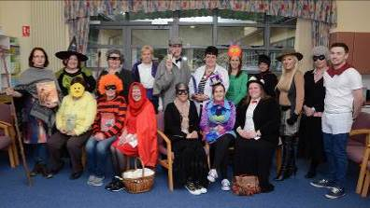
We are fortunate to have such highly motivated and talented staff who work tirelessly to ensure that our pupils have access to the best educational experiences possible.

SCHOOL FINANCE
INCOME |  |  | EXPENDITURE
Budget Share  TOTAL | 998,812  933,148 |  | Salaries: - Teachers  Salaries: - Non teaching staff  Protective Clothing  Fuel Oil  Electricity  Water  Toilet Requisites  Window Cleaning  Maintenance of buildings  Grounds Maintenance & Works  Furniture & Fittings  Equip Books & Materials  iPads  Licence Fees  Hire of Facilities  Professional Fees  Repair/Maintenance  School Cleaners  Instrumental Contribution  Transfer of Board Vehicle  Advertising  Printing & Stationery  Telephones  Sundry Expenses  Other Income  Sub Total  Savings C/F  TOTAL EXPENDITURE | 730,981  102,880  36  8,507  8,633  1,154  1,667  550  447  2,297  180  12,007  3,045  66  392  150  337  37,875  4,608  503  619  4,881  651  43  -40,637  881,871  116,941  933,148
The Financial Report presented below refers to the money allocated to the school through the Board’s L.M.S. formula. Responsibility for the management of this budget lies with the Principal and Board of Governors. Staffing continues to be the main outlay with almost 84% of our total budget allocation being used for teaching and non-teaching staff.

SCHOOL FUND ACCOUNT

The Governors would like to express their appreciation of the work done by Colhoun & Watson, Chartered Accountants and Registered Auditors in reviewing these accounts, free of charge. A summary of our income and expenditure is included below.

INCOME |  | EXPENDITURE
Book Club  Class Photos  Breakfast Club  Class outings & plays  Age NI Donations  School Trip  Co-operation Ireland  Stationery/Books  Interest  Sponsorship  Donations  Hire of Premises  Music Tuition  Staff Outing  TOTAL | 2,409  725  446  3,212  465  14,470  900  450  9  3,456  1,522  1,477  2,890  368  32,799 | Book Club  Class Outings  NeoPost Franking Machine  Subscriptions  Staff Outing  School Trip  Sundry Expenses  Curriculum Programmes  Music Tuition  PTA Outing  Charity Donations  Staff Courses  Expenses (Clubs & Open Day)  Books & Resources  Car Park Lines (Respraying)  Postage & Stationery  Sports Day/Leavers’ Assembly  TOTAL  In Year Surplus | 2,409  3,475  250  172  489  15,000  440  450  2,904  169  3,475  360  289  247  750  595  547  32,021  (778)

PARENT TEACHER ASSOCIATION ACCOUNT

We are indebted to the Parent Teachers’ Association for the substantial financial contribution that they make to our school every year. Without their support we would not be able to provide the activities, entertainment or additional resources they purchase for us.

INCOME |  | EXPENDITURE
Halloween Disco  Raffle Tickets  Quiz Sheets  School Fair  Summer Fun Night  TOTAL | 362  455  663  4,744  2,284  8,508 | General Expenditure  Miscellaneous  Halloween Expenses  Christmas Fun-day Expenses (trip to cinema)  General Christmas Expenses  School Fair Expenses  Fun Night Expenses  Bank Charges  TOTAL  In Year Surplus | 65  439  122  2,000  90  862  686  143  4,407  (4,104)
THE CURRICULUM

The Education and Training Inspectorate (ETI) carried out a detailed inspection of Gibson Primary School in October 2016. This was the first inspection since September 2009 and it focused on all aspects of learning and teaching, pupils’ attainment, pastoral provision and quality of the leadership and management. All areas were deemed to be outstanding or very good and the school was given the highest possible overall grade. While we were naturally delighted with the outcome we were not surprised. This only confirms what our own self-evaluation processes indicate.

ETI were extremely impressed by the opportunities for our pupils to develop and apply their thinking skills. In particular, they commented favourably on our outdoor learning environment, use of technology and play experiences.

“A key strength of the provision is the excellent use made of the large woodland area within the school grounds that provides the children with enriching, relevant and authentic outdoor learning experiences. This has a positive impact on the outcomes achieved by the children and contributes significantly to their overall learning.”
(ETI Report October 2016)
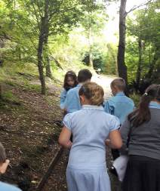
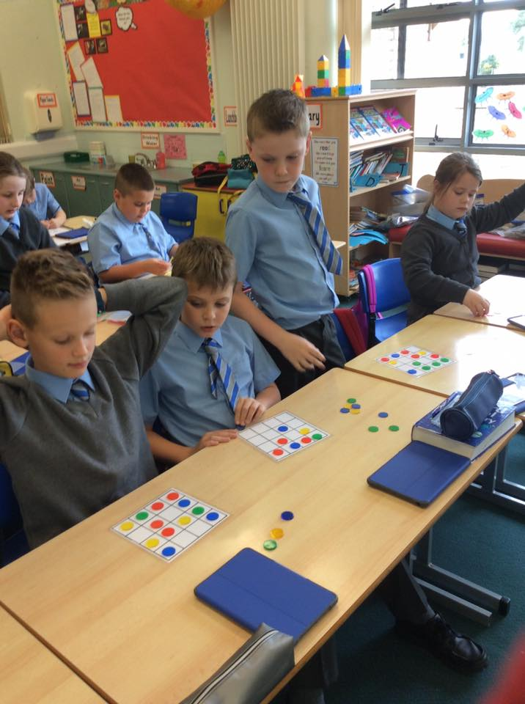

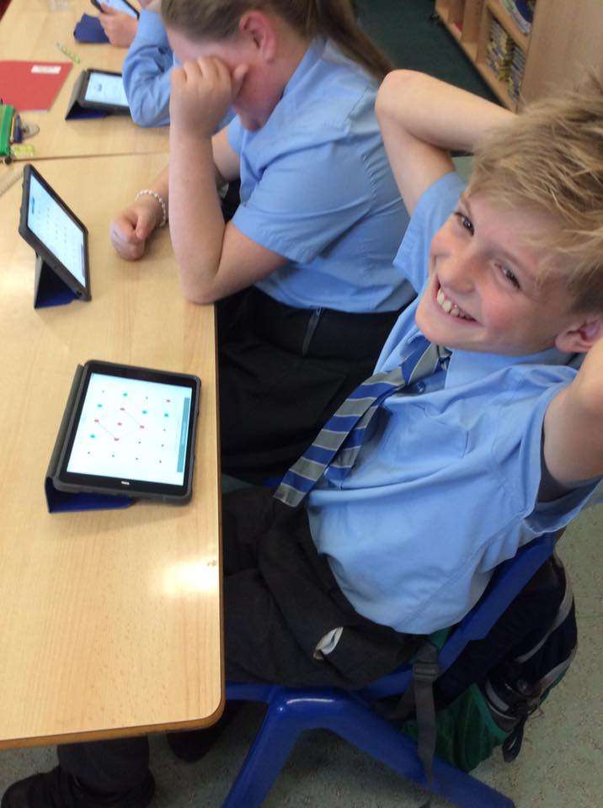

Pupils in Y5, 6 and 7 have the opportunity to learn a woodwind, brass or strings instrument. They are supported by weekly visits from the Board’s Music Service staff who provide tuition. There are opportunities for these pupils to perform to a variety of audiences throughout the school year including at our Christmas Shows and Carol Services which were once again extremely well supported.
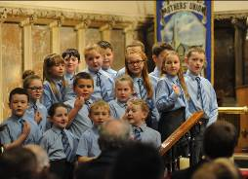

In order to celebrate our successes and identify areas for development we consult all key stakeholders including parents, pupils and staff.
- Pupils and parents are consulted every two years through an anonymous questionnaire
- Y4-7 pupils elected onto our school council identify issues which are addressed
- Staff use a variety of self-evaluation tools to carry out a whole school review

As part of the inspection process ETI also conducted a parental survey which was fed back to the school Principal.

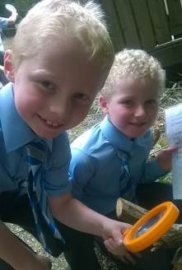
During the past number of years, we have been focused on the development of Literacy, Numeracy and ICT. Last year we focused on developing ICT and iPad skills and developing writing.

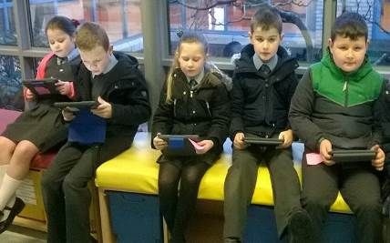

Special Educational Needs
We support all our pupils to fulfil their potential and all reasonable steps are taken to provide access to an education which provides them with this opportunity regardless of special educational need or disability.

During the school year 2016/17 our school’s S.E.N. register consisted of 56 pupils in our mainstream school and 24 pupils in our Language Units. The breakdown of children at the various stages (including our 24 children from our 2 specific Speech and Language Units) was as follows:
Stage 1: 4
Stage 2: 26
Stage 3: 13 + 23 Language Unit pupils
Stage 4: 2
Stage 5: 11 + 1 Language Unit pupil

Mrs Shortt continued as our Special Needs Co-ordinator and was assisted by Mrs Irwin our Vice Principal. A large emphasis was placed on analysing all children’s progress in order to challenge any underachievement. Additional support has been offered to a wide variety of children. Both our Language Units continue to cater for up to 12 pupils who require specialist teaching and speech therapy. These pupils are fully integrated into various school activities. During the year, eighteen pupils returned to their local schools having made good progress in the Language Unit.

COMMUNITY RELATIONS
This year a Shared Education programme with St Mary’s began which focused on developing pupils’ numeracy skills through shared educational experiences and focused teaching. We were also able to provide Spanish lesson and Salsa dancing to Y7 pupils through this programme. Our pupils also interacted with pupils from other schools at various shared events.
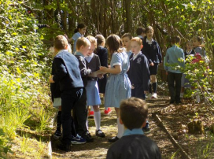
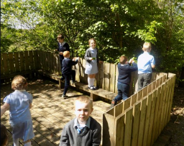

EXTRA CURRICULAR ACTIVITIES

Our extensive range of extra-curricular activities is due to our dedicated staff who give freely of their time to organise them. We were able to supplement these through additional coaches which were funded through our Extended Schools Programme.

These took place between 3.00 pm and 4.00 pm last year and included the following: -

Football Rugby Hockey Dance
Orienteering Netball Speech & Drama Knitting
Scripture Union ICT Gardening Cookery
Y7 pupils can also take part in cycling proficiency in Term 3
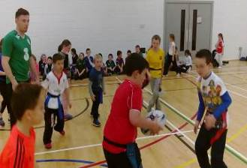
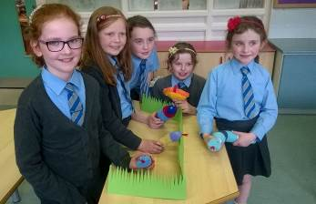

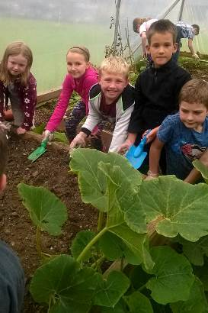
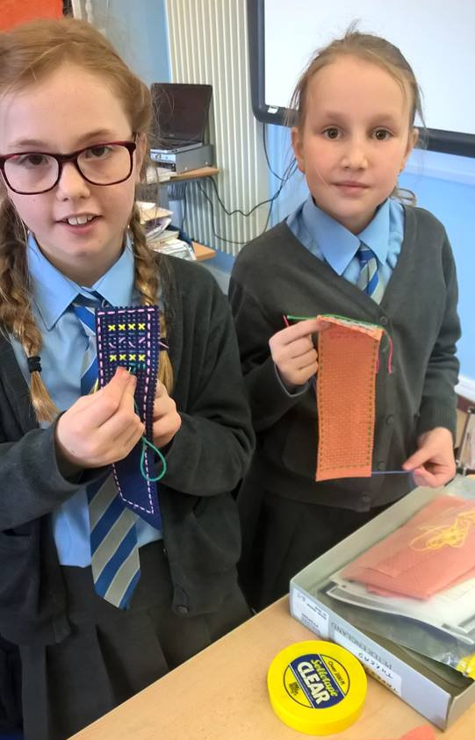

KEY STAGE ASSESSMENT OUTCOMES

All Primary Schools are required to assess pupils’ progress in English and Mathematics at the end of Key Stage 1 (Year 4) and Key Stage 2 (Year 7).

Due to industrial action not all schools submitted End of Key Stage levels however, our pupils continued to perform very positively with all results being in line with previous achievements.
Levels | Language and Literacy |  | Mathematics and Numeracy
 | Key Stage 1
Level 2 or above | 95% | 95%
 | Key Stage 2
Level 4 or above | 83% | 86%

REVIEW OF THE YEAR 2016/17
As always throughout the 2016/17 school year, our pupils were involved in a variety of activities. The following is a summary of some of the notable events and achievements.

Fifty-one new pupils began Year 1. All children settled very quickly into their new classrooms, new routines and took advantage of all the new learning opportunities.

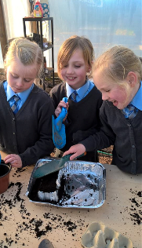
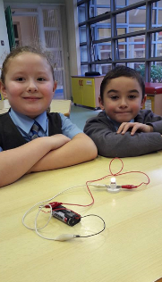

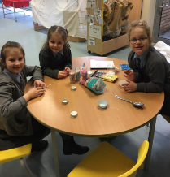

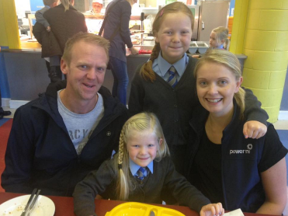
Our canteen continued to play a central role in our school and they hosted the traditional Year 1 breakfast.

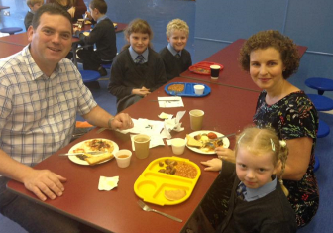
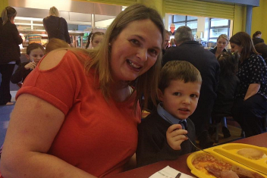

Once again the pupils and parents contributed to a number of charities with The RAFA Wings Appeal receiving over £250 and again our Shoebox Appeal was very well supported with over 100 boxes being donated to ‘The Samaritan Purse’. Our annual fundraising event took place in October which raised an incredible £3000 for our charities.

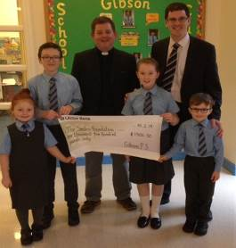
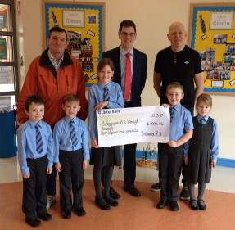

Christmas was another active time for our pupils with a number of key activities taking place including:
- Choir performances Christmas carols at the local nursing homes
- Our annual Christmas Performances in school and Carol Service in St Columba’s
- Exciting PTA events including Santa’s arrival and a Fun Day visit to the cinema

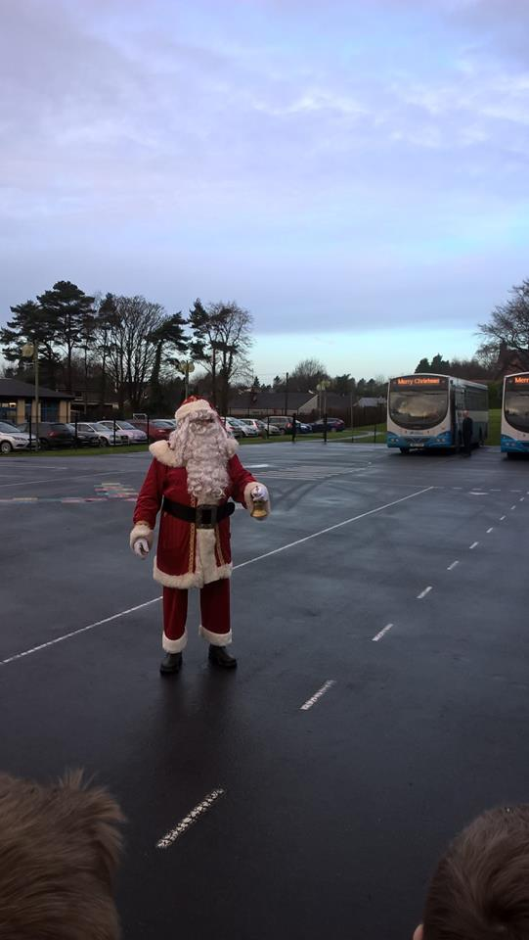
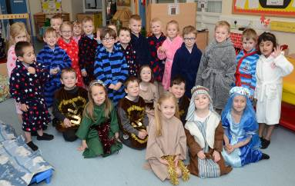

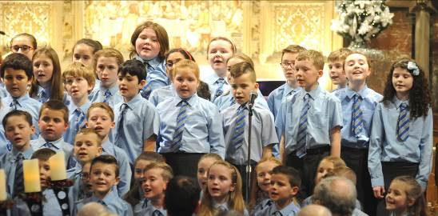

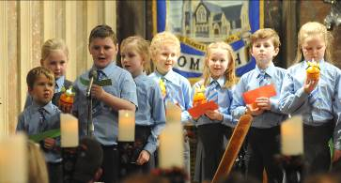
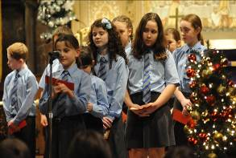

Our Year 4 pupils and their parents once again took part in our annual Paired Reading Programme. This proved very successful and it resulted in the children reading a wide variety of new material and developing greater interest and fluency. We have also availed of the Accelerated Reader programme for our pupils in Y4-7 which has proved to be extremely beneficial.

Our annual school trip for Year 6 and 7 children took place in March with over 40 pupils heading to York. As always the trip proved to be the highlight for all those who went with Flamingo Land proving to be a particular favourite. The children and staff were complimented on numerous occasions about the high standard of behaviour and manners exhibited by everyone.
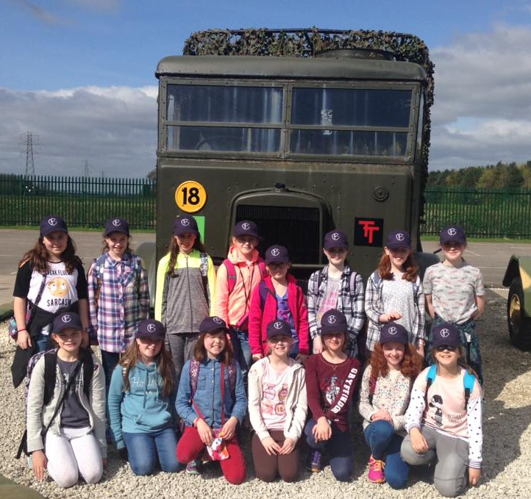
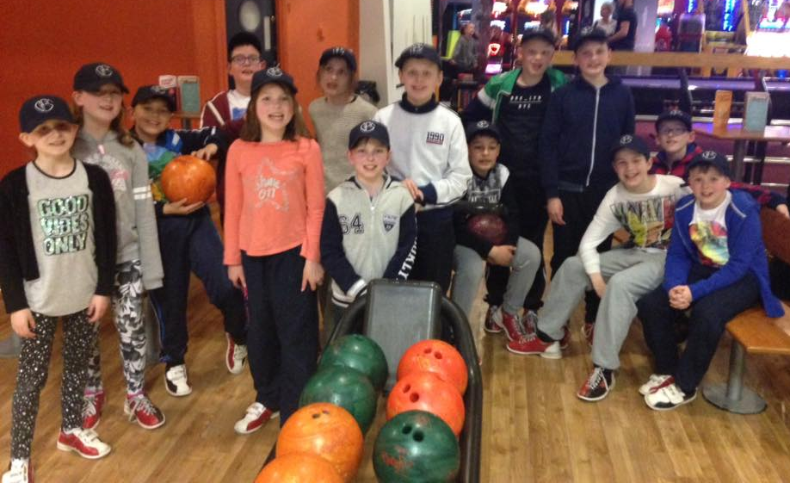

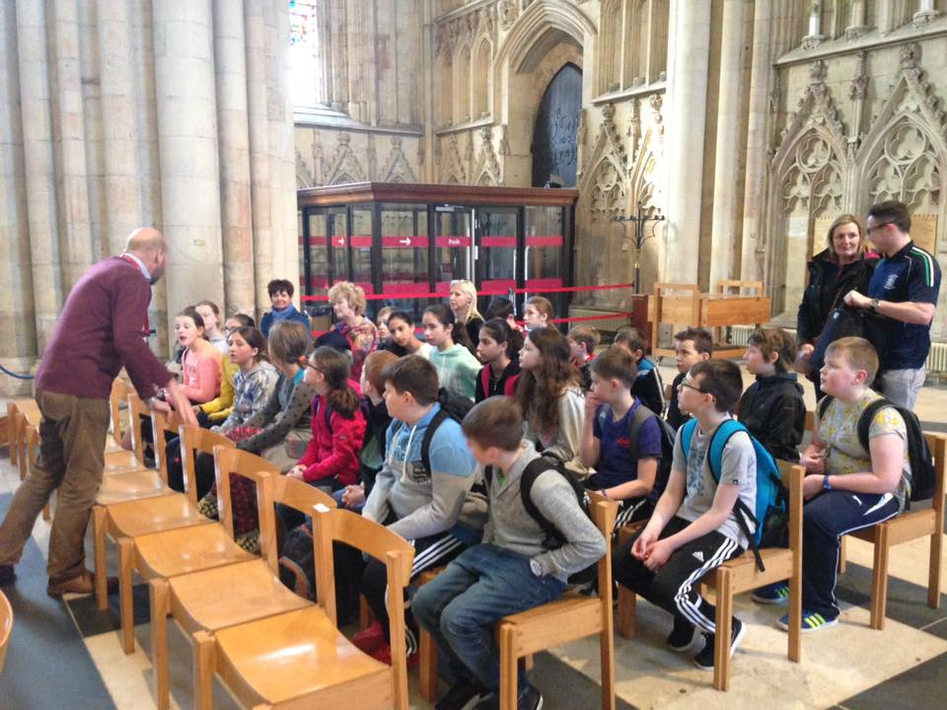
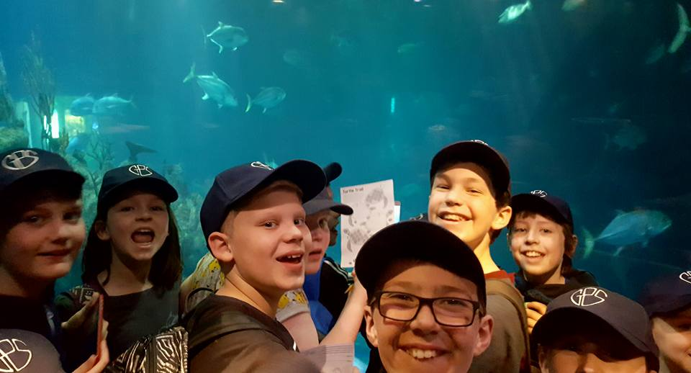

In April, pupils from Years 1 to 6 took part in the verse speaking section of Omagh Feis and, again, some outstanding performances were recorded. For only the second time our choir participated in the Omagh Feis and performed extremely well.

All classes within the school went on outings to various parts of the province throughout the year. These trips and activities are an excellent opportunity of extending learning beyond the classroom and developing children’s skills.
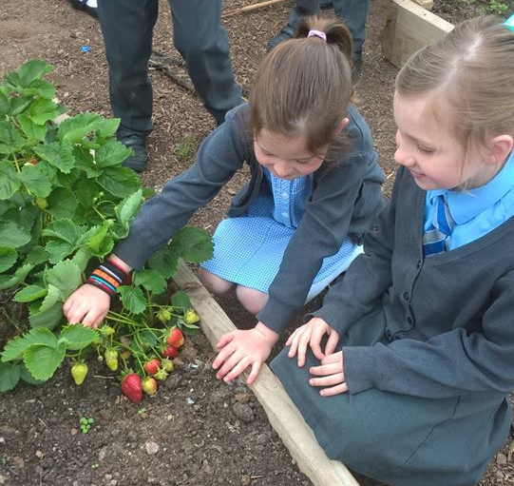
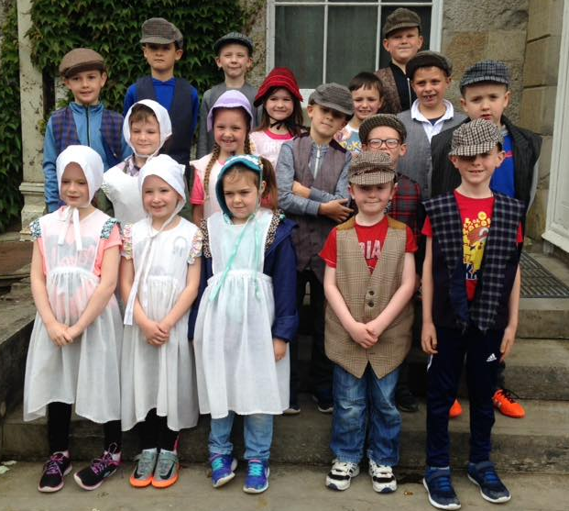
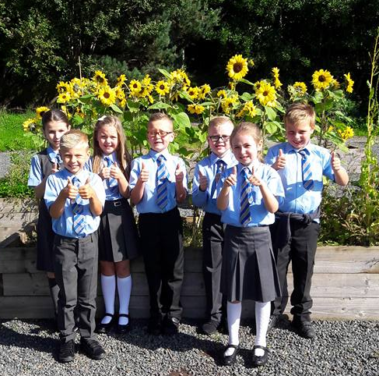

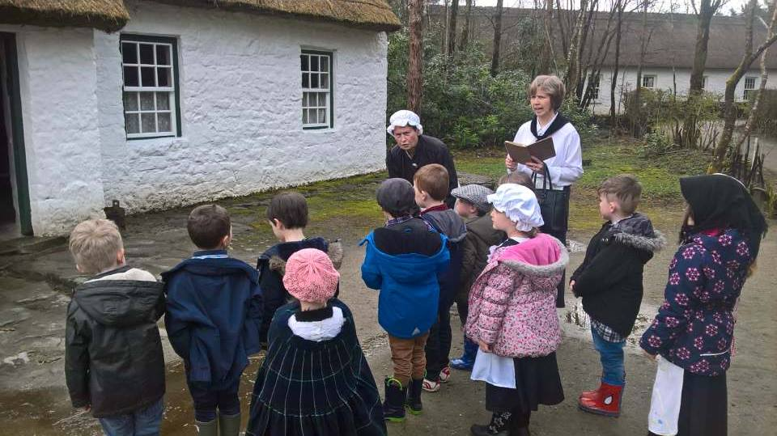
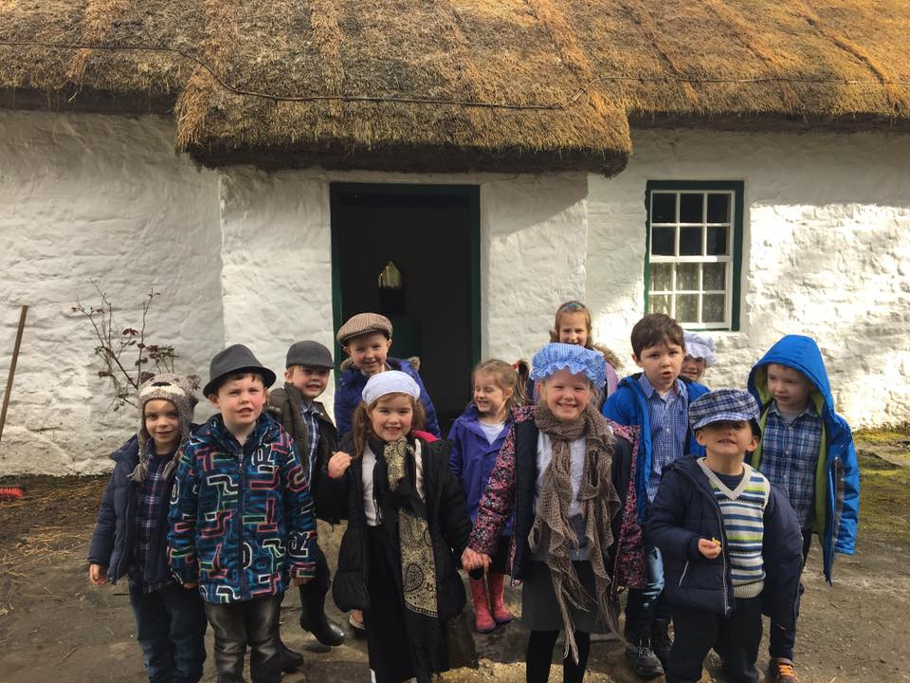

Again Sports Day was extremely well supported and a huge thanks must go to all parents and friends who supported both events. As usual the level of commitment and behaviour of all children involved was of the highest standard. Despite finishing in third place after our Sports Day results Grant House managed to win the overall House competition once all competitions results had been finalised. This was the first time in over 17 years that Grant were crowned House winners. The individual winners from Y4 – Y7 were:

Y4 Girls - Sophie Little Boys - Aaron Connell
Y5 Girls - Jasmine Hamill Boys - Zac Armstrong
Y6 Girls - Emma Dixon Boys - Gavin Kelly
Y7 Girls - Laura Zahumenska Boys - Sam Beattie

While in sport, we had another very successful year with much to celebrate. All of our teams again competed with commitment, determination and a high degree of skill.
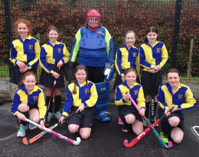
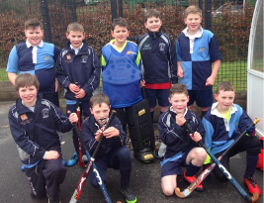

We are extremely proud of our pupils’ achievements and endeavour to provide many opportunities for our pupils to showcase these talents. A number of different performances took place this year with our choir being asked to perform at the Omagh Chamber of Commerce Charity Dinner while our Y1 pupils had a special Mothers’ Day show for our parents. These are only a few of the many ways our pupils exhibit their skills.
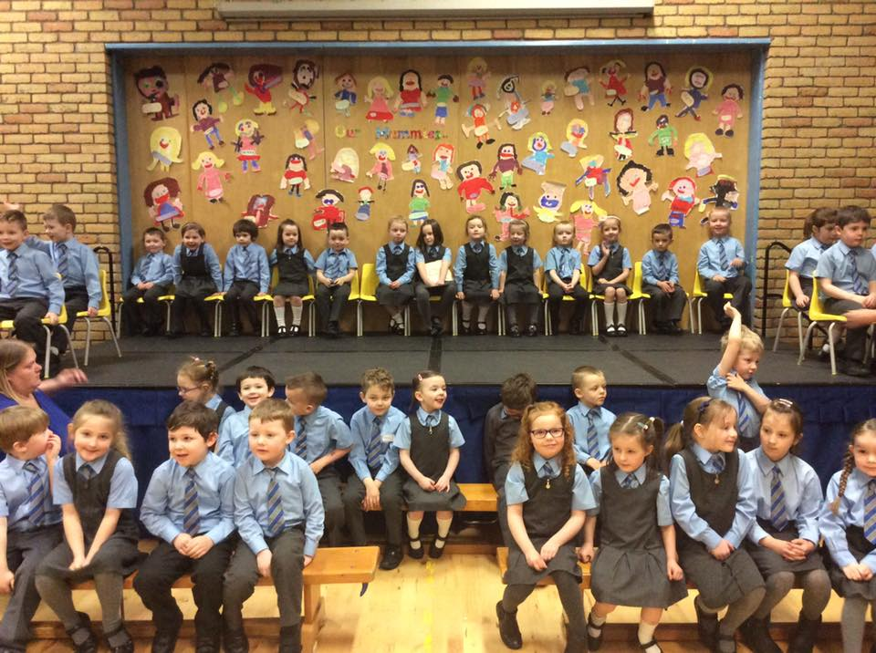
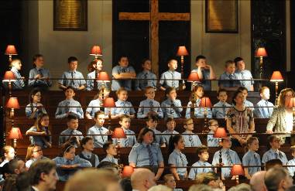

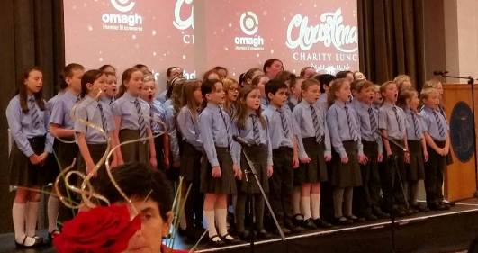

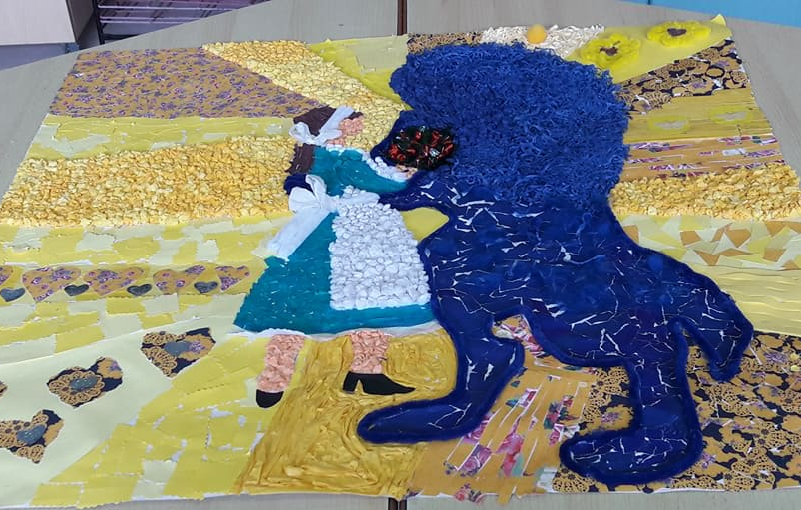
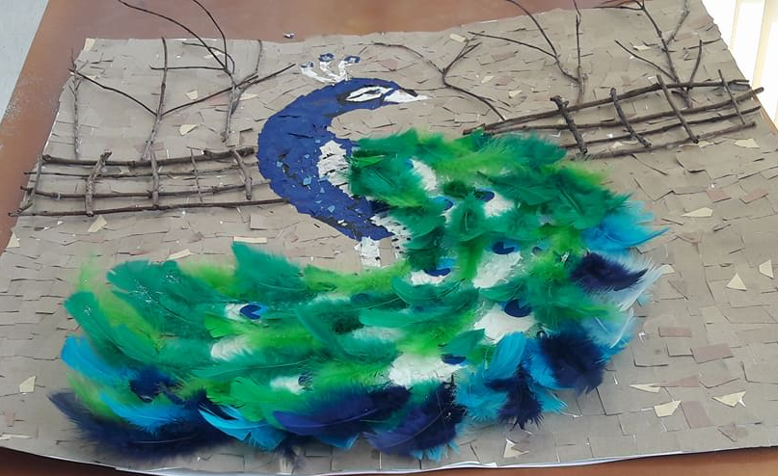
Pupils representing all year groups submitted very impressive entries for the Schools Section at Omagh Show in June 2016. This year a number of classes submitted a selection of art work which won the best exhibit in their age group.

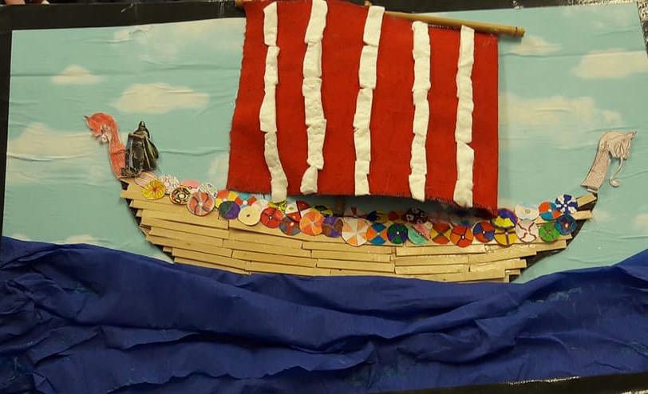

At the end of term, we held a special assembly for our Year 7 children who were presented with their Record of Achievements and their next school tie as a special present for them to wear in Year 8 – thanks must go to Wattersons for contributing to the cost of these gifts. We also had our annual Leaver’s Lunch where the Year 7 children brought their parents along with them for lunch in our canteen. This also marked Mrs Hamilton and Mrs O’Hara’s retirements and as Governors we would like to formally thank both Mrs Hamilton and Mrs O’Hara for their hard work, dedication and commitment to our school and pupils over the years.
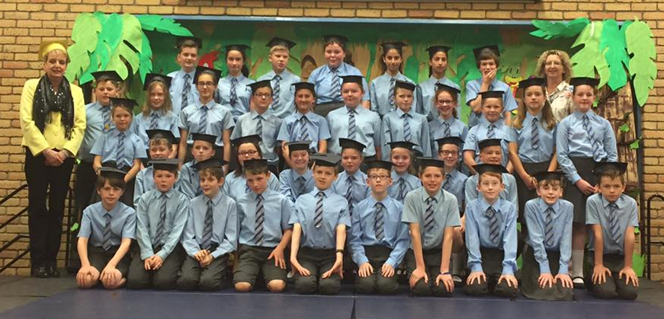

PARENT TEACHERS’ ASSOCIATION

The Parent Teachers’ Association sees two teachers elected onto the committee with Mr Sterritt holding a non voting position. Once again the Annual General Meeting was held in October. The following parents and teachers were elected to serve on the committee: -

Mr Richard Pollock (Chairperson) Mr Winston Fleming (Vice Chair)
Mrs Michelle McKinley (Secretary) Mrs Yvonne Reid (Treasurer)
Mrs Aryin Armstrong Mrs Paula Armstrong Mrs Alison Baxter
Mrs Leanne Baxter Mrs Judith Beacom Mrs Linda Beatty
Mrs Samantha Bradley Mrs Catherine Bulling Mrs Alison Callion
Mrs Louise Camac Mrs Diane Colhoun Mrs Hilary England
Mrs Fiona Fyffe Mrs Amanda Graham Mrs Stephanie Haire
Mrs Claire Hamilton Mr Roger Johnston Mrs Tracey Kee
Mrs Angela Loughlin Mre Lynne McElrea Mrs Edelle McIvor
Mrs Zoe McLaughlin Mrs Becky Sterritt Mrs Norma White
Throughout the year, the Committee met regularly to organise an interesting programme of events. Under the Chairmanship of Richard Pollock, the committee members worked tirelessly to ensure that events were meticulously planned. Their hard work contributed greatly to the success of the following events: -

OCTOBER
PTA Annual General Meeting and Hallowe’en Disco which saw the continuation of our Halloween party for Year 1 - 4 children which was held before the Year 5 - 7 disco.
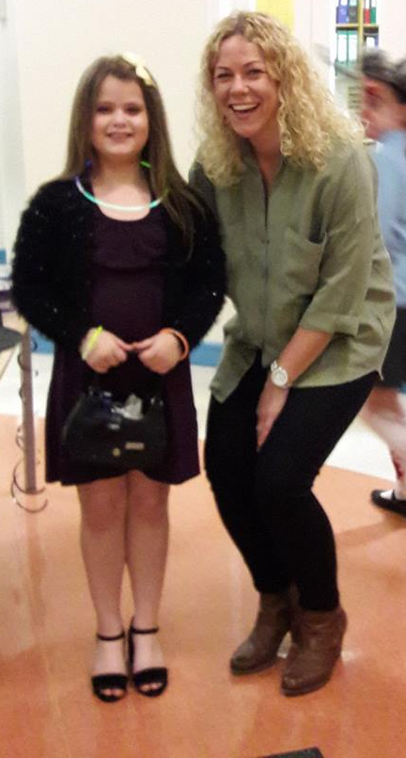

DECEMBER
December is always a busy month with our annual fun day, school decoration and Santa’s arrival and Christmas Carol Services. This year Santa took all the pupils to the cinema to watch a movie! Our PTA members put up and took down the decorations as well as organising raffles at the Y1-3 shows which raised over £500.
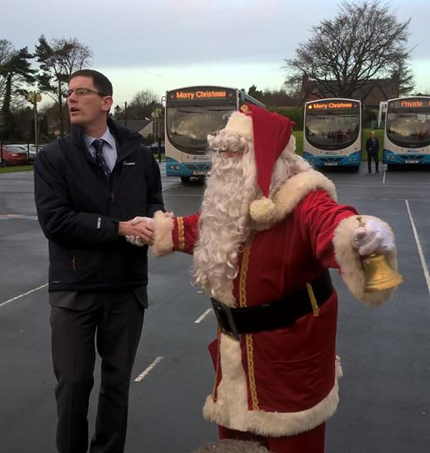

FEBRUARY
Our annual quiz sheet competition was held. This raised over £700.
Plans for our School Fair were initiated.

MARCH
Our annual School Fair was held on Tuesday 15th March and again proved to be our biggest fundraiser. This is undoubtedly because of the tremendous support of all parents and children and extreme generosity of local businesses who continue to bake cakes to be raffled, sponsor us and donate items. Thanks to their generosity and our parents’ support we raised over £3,600


JUNE
Our Fun Night thankfully enjoyed very pleasant weather which added to the enjoyment of all involved. Again an excellent night was had and this event showed up everything that is good about both our school and our PTA with a huge variety of fun events.

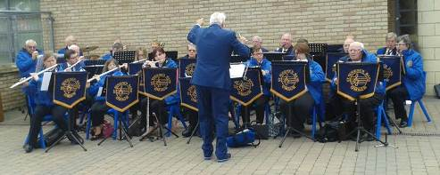

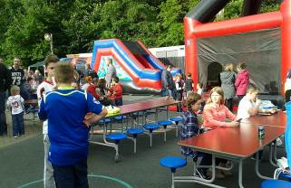
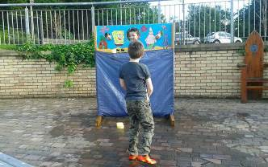

This year over £3500 was spent replacing the school sound systems. These events demonstrate only a small section of the invaluable work of our PTA. Considerable planning and hard work goes into each and every event and only highlights a small section of the tremendous work of the Parent Teachers’ Association!

The Governors and staff are greatly indebted to the Parent Teachers’ Association for this financial contribution and thank the Committee members for their excellent support to teachers and pupils throughout the year.

This completes our Governors’ Report for the 2016/2017 school year. We have a lot to celebrate and remember in the course of one year. We’re extremely proud of the achievements of all of our children and we would like to thank all of our parents for your on-going support.

