How to build a sandcastle

Have you ever built a sandcastle at the beach or in the sand tray?
Can you explain to someone in your house how to build one?
Mrs Woods has been busy making sandcastles but she is doing it in the wrong order so her sandcastles aren’t working! Mrs Woods needs you to write her some instructions to tell her how to build a sandcastle.
Below are some photos and words to help you. Remember Mrs Woods isn’t making them in the correct order so the photos are all jumbled up.
Can you write four sentences as instructions? Remember to number your instructions. And remember a capital letter at the start of your sentence and a full stop at the end.

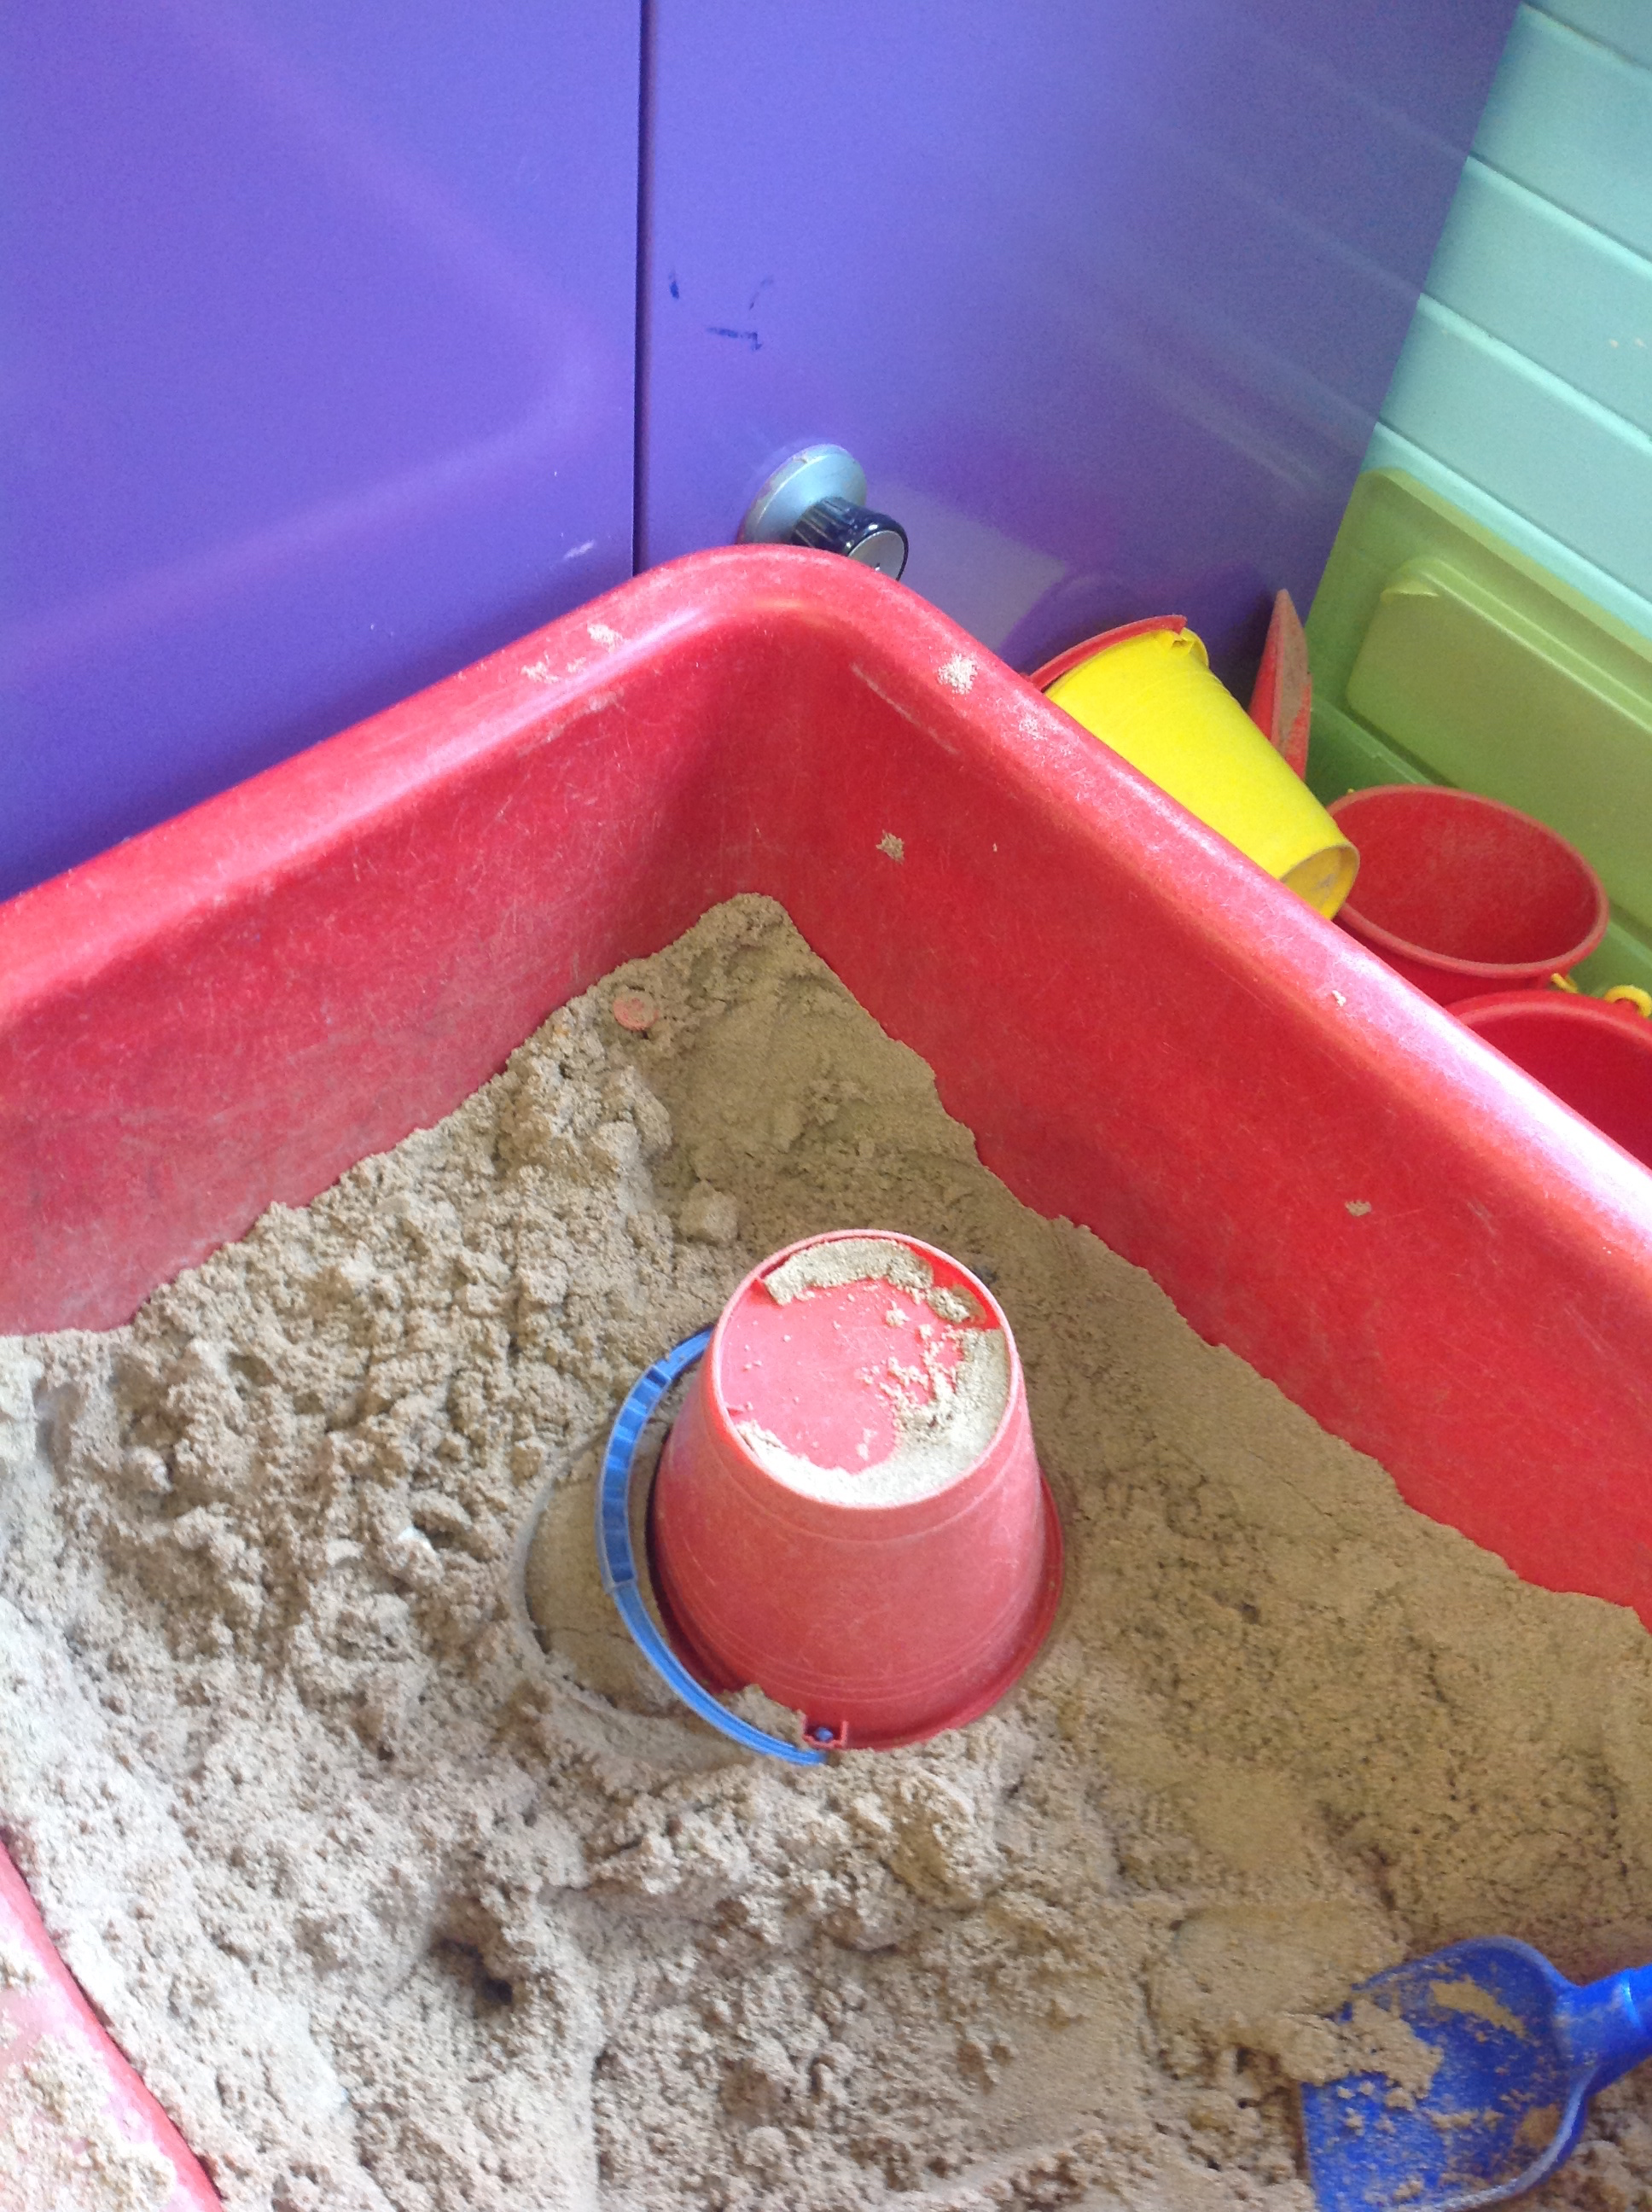
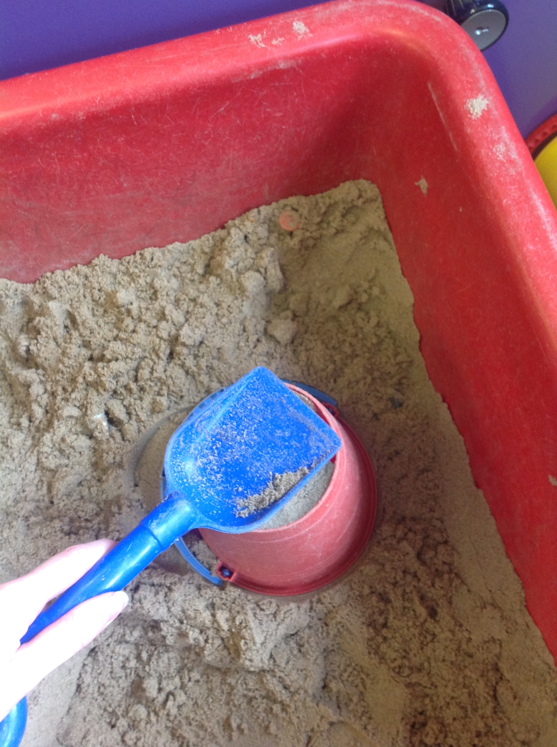
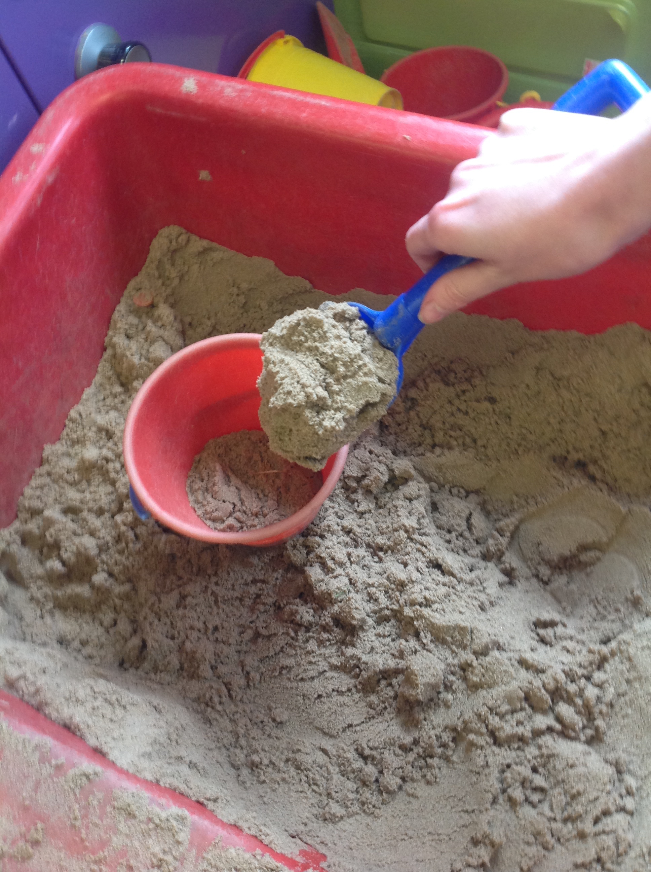
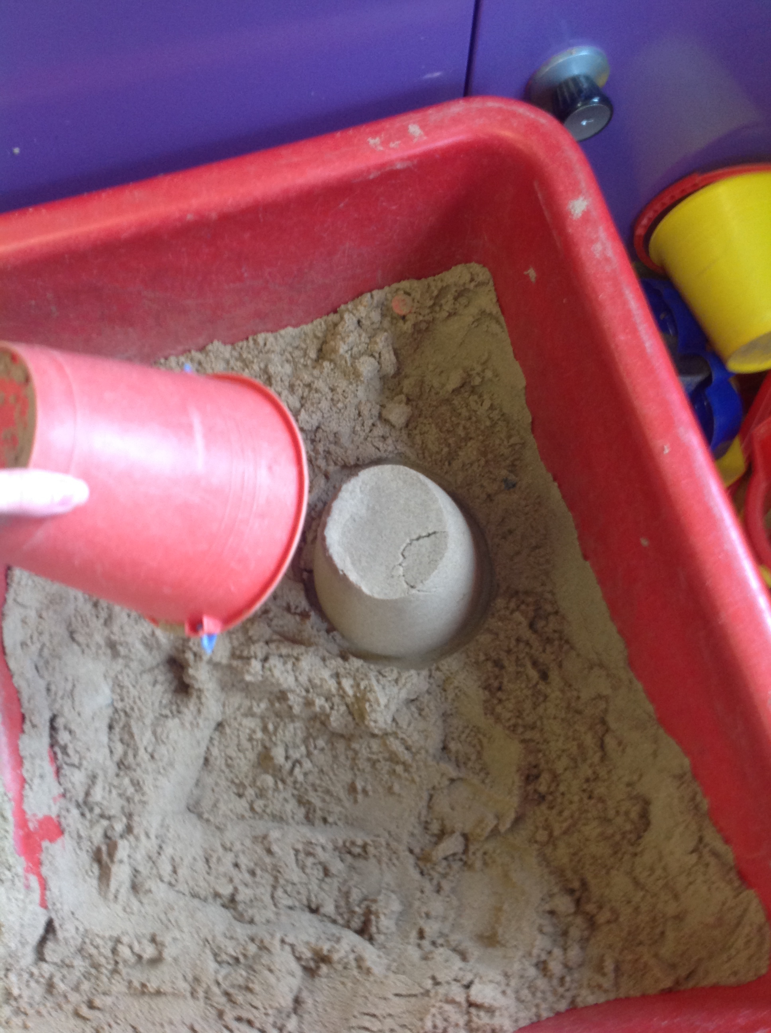

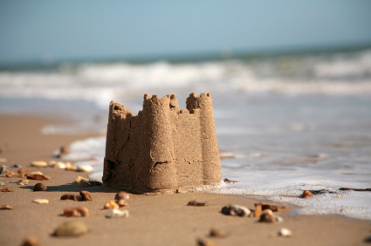
sandcastle

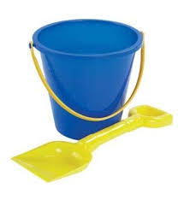
bucket

Other words…

put

fill

the

spade

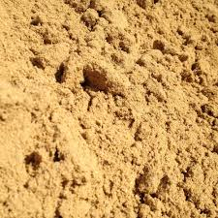

sand

