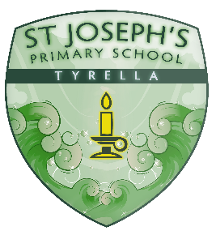
Class of 2020 !!!!

Time to Celebrate !!!

Monday : 22nd June
Virtual Leaver’s Mass @ 9.30am
Celebrated by Fr Fleck . Listen for a “shout out” to you all !!!
Go to mcnmedia.tv

Tuesday : 23rd June
Parent Pick Up!!
Enjoy reading through your Year 7 work, report and a special message from Mr McEvoy.

Wednesday : 24th June
Picnic on the Lawn!!!
A sad final farewell from us all at St Joe’s !! Come join us on the front lawn at 6pm ( Social Distancing in place). Plenty of lively music !!! Bring a rug and your picnic goodies!! Mr McVeigh will host a fun quiz before our P7 Awards ceremony. The craic will be mighty !!!
Community Farewell “Drive By” !!!!

