ALTINURE NEWSLETTER
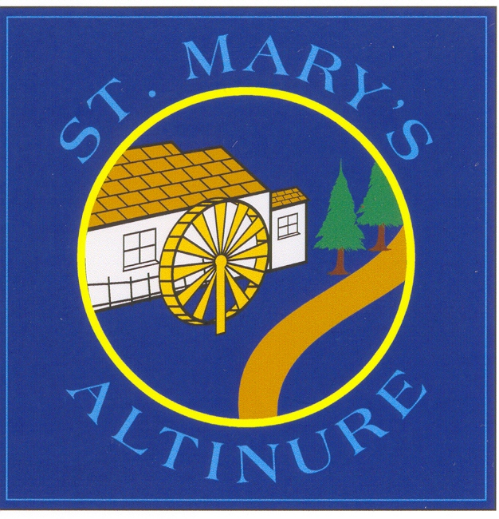
ISSUE 2 – NOVEMBER/DECEMBER 2021
PUPIL SAFEGUARDING
ANTI-BULLYING WEEK
Anti-bullying Week begins on Mon 15th November and the theme is ‘One Kind Word’. Pupils are encouraged to wear odd socks on Tuesday 16th November to demonstrate that it’s OK to be different. Pupils will discuss definitions of bullying and strategies to protect themselves from harm.
____________________________________________
ROAD SAFETY WEEK
Road Safety Week will also begin on Monday 15th November. Pupils will be involved in road safety activities to increase their awareness of how to stay safe on the roads. We remind you that pupils may need reflective strips on coats or schoolbags so that they are safe on the roads in winter.
____________________________________________
BREAK/MILK COSTS
Year 1-7 – Milk - £5 per month
Year 1 – 7 – Fruit -£5 per month
Milk and fruit must be pre-ordered and paid for. Order slips are available via school reception.
_______________________________________
SPLIT THE POT DRAW
We have decided to introduce a ‘Split the Pot’ draw each Friday, beginning Friday 12th November. To enter, place one pound in the envelope provided and write your name and contact number on the front. Envelopes will be available through pupils and via school reception. Half the total amount raised will go to the winner. The other half will go to school funds. You can enter as many times as you like and so can your family and friends! Good luck!
________________________________________
PARENT TEACHER MEETINGS
We would like to thank parents for their participation in the telephone meetings to discuss children’s progress. We appreciate your support. Primary 6 telephone appointments will be scheduled at a later date.
FLAVAHAN’S CROSS COUNTRY COMPETITION
Miss Doyle has begun cross-country trials so that pupils can be selected for our school’s Cross Country Team. P5, 6 and 7 pupils can take part in these practice races if they wish. Pupils will be informed when to bring in footwear and PE gear (preferably old as the pitch may be muddy!) A team of 6 boys and 6 girls, and possibly some individuals, will be selected to participate in the North West Heat on Friday 19th November in Thornhill College. Good luck to those involved!

________________________________________

TRANSFER TEST
The Transfer Test for Year 7 pupils will take place on Saturday 13th November. Good luck to all pupils who are completing these tests.
_____________________________________________
FIRST COMMUNION AND CONFIRMATION
First Holy Communion will take place on Sat 28th May at 11am in St. Mary’s Church, Altinure.
The sacrament of Confirmation will take place for Year 7 pupils in St Mary’s Church Altinure on Saturday 26th March at 11am.

Year 7 pupils and their parents are also asked to attend a Mass of Commitment and Light on Wednesday 10th November in St. Mary’s Church, Altinure at 7.30pm in preparation for the Sacrament of Confirmation. Please bring your child’s Baptismal Candle to this Mass.
____________________________________________
PHONICS MEETING
A Linguistic Phonics meeting will take place on Friday 26th November from 1.15pm -2pm for parents of Yr 1 and 2 pupils. The meeting will take place in a socially distanced manner in the school assembly hall and parents are asked to wear face masks. This meeting will help parents to understand the phonic sounds and provide them with strategies to promote pupil success in reading.
-------------------------------------------------------------------
PLACEMENT STUDENTS
We are excited to welcome two former pupils as teaching practice students on placement from St. Mary’s College, Belfast. In Term 2, Aisling Mortimer will teach alongside Mrs Boyle in Primary Four and Megan Gormley will teach with Miss McKinney and Mrs Hegarty in Primary 2/3.
We also welcome our new placement student, Carrie McGillion, who is carrying out classroom assistant duties in Primary 2/3.
___________________________________________
READING PARTNERSHIP AND ACCELERATED READING
Our classroom assistant Jill Hasson is undertaking Reading Partnership training soon and she will then work with selected pupils from Primary 3 to help them to improve their reading fluency. We encourage all parents to regularly spend time reading with pupils and children from P3-7 are encouraged to also read books from our Accelerated Reading library.
MATHLETICS
We promote the use of Mathletics at home to consolidate understanding of Maths concepts. 1000 Mathletics points earned in a week earns each pupil a Bronze certificate. 5 Bronze certificates make a Silver and 4 Silvers make a Gold (which is a tremendous achievement). Each P1-7 child has their own login or QR code for Mathletics. Well done to the boys and girls who are already working really hard!
_______________________________________________
DOGS’ TRUST
The Dogs’ Trust will visit our school on Wednesday 17th November to teach us how to care for dogs as pets. Cathy will bring along a trained dog to meet us. We can’t wait!

_____________________________________________
FLU VACCINATION
The School Nursing team delivered the Flu Vaccination to pupils on Wed 3rd November and they will return for a mop up session on January 13th 2022. We remind you the importance of keeping your child at home and arranging a PCR test if they have any coronavirus symptoms. We appreciate your co-operation in keeping everyone safe.
_____________________________________________

OCTOBER BIRTHDAYS
IN/AFTER SCHOOL ACTIVITIES
Monday
Play Therapy – Some KS2 pupils
Speech and Language Support – Some Foundation Stage pupils
Yoga with Monica Donaghy – P1 – 2-3pm
P5 – 3-4pm
(5 weeks from 1st – 29th Nov)
Tuesday
Gaelic – Andrena – P1/2, 2/3, P4 & P6- 9.15 – 12.00am
Swimming Yr 7 10.30 – 12.20pm
Literacy and Numeracy Club – P4
(4 weeks from 9th – 30th Nov)
Wednesday
Language & Communication Support– Some pupils- P1/2/3
Irish Yrs 5-7 1-3pm
Thursday
EA Literacy Support – Some pupils – KS2
EA Violin – Mrs Small – KS2 - 1- 3pm
___________________________________________________
TEXTING SERVICE/WEBSITE –
ADVERSE WEATHER CONDITIONS
The school text service will be available again this year to inform parents of unexpected school closures due to adverse weather. School closure information will also be posted on the school website home page. Please let the secretary know if you are not receiving texts as perhaps your mobile telephone details need to be updated on our computer system.
____________________________________________ PUPIL SAFETY
Parents who collect their children by car are reminded to collect them on dry days at the fence to the right of the school. On wet days, pupils will stay in the school assembly hall and they can be collected from reception. We remind pupils to wear seatbelts at all times while travelling. Pupils should not enter the car park without being accompanied by an adult.
If your child walks to school, please accompany them if possible and teach them how to cross safely using the Green Cross Code. We appreciate your co-operation in this matter.
___________________________________________________
ADORATION
Year 4, 5, 6 & 7 pupils will take part in Adoration in St. Mary’s Church, Altinure on Monday 15th November and Monday 13th December, between 9.30am and 12.20pm. Please remember to send a coat with your child.
________________________________________________
ADMINISTRATION OF MEDICINES
We remind you that staff members will only administer emergency medication to pupils within school hours. Emergency medication includes Epi-pens, Insulin and Asthma Inhalers. Parents of pupils who have been prescribed emergency medication must complete a consent form. These consent forms have recently been sent home for completion. It is also parental responsibility to ensure all medication is in date. Antibiotics, pain relief and other prescribed or non-prescribed medications cannot be administered due to Health and Safety risks. We recommend that medication is administered outside school hours (although family members are permitted to visit school to administer medication during the school day if necessary.) Our Administration of Medications Policy is available on the school website. We appreciate your support in this matter.

CHRISTMAS CHARITY
Every year, parents are so thoughtful and generous with Christmas gifts for teachers and Classroom Assistants. This year, we ask that, in lieu of gifts, a small donation could be made to the Foyle Search and Rescue charity. This donation can be placed in a sealed envelope and handed in at reception. Thank you!
______________________________________________
CHRISTMAS MOVIE
Following the success of last year’s Christmas movies, each class will make another short Christmas film this year for parents to view online. These films will be posted on our school’s website before we close for Christmas.
-------------------------------------------------------------------
CHRISTMAS OUTING
Primary 7 pupils will travel to the Waterside Theatre, Derry on Thursday 2nd December to watch the St. Patrick’s and St. Brigid’s musical, ‘This Is Us.’ Hopefully, they will see a few familiar faces on stage. Entrance is free but there will be a charge for the bus. It should be great fun!
______________________________________________

CHRISTMAS DINNER
Christmas Dinner for pupils will be on Wednesday 15th December. The cost will be £2.60. Numbers taking the Christmas Dinner will be needed for the canteen during the previous week.
SCHOOL CLOSURES
School closes for the Christmas holidays at 12 noon on Wed 22nd December and reopens for pupils on Thursday 6th January.
______________________________________________
CHRISTMAS APPEAL
Although shoeboxes can still be organised online with the Operation Christmas Child charity, the Derry Diocesan Catechetical Centre recommends that Catholic schools support the Trocaire Christmas Appeal or Foyle Foodbank instead. Trocaire vouchers will be available for sale through St. Mary’s Church, Altinure this Christmas. They can also be purchased online. Thank you for thinking of others this Christmas!
__________________________________________________________
CHRISTMAS HAMPERS
Our Christmas Hamper draw will take place again in December this year. Each child will be asked to donate one item for the hamper. They will be told in writing what item to bring. Four hampers will then be raffled in the week before Christmas. The other two will be donated to St. Vincent de Paul to benefit those in need. Many thanks for your continued support!
______________________________________________ YEAR 1 ADMISSIONS
Any child born between 2nd July 2017 and 1st July 2018 must begin primary education in September 2022. Applications will again be digital this year and application forms must be completed on the EA website at www.eani.org. Applications are usually made in January. More information to follow.
This year, we intend to put a short film on the school website to give parents a flavour of the wonderful education we offer at St. Mary’s PS. We are also more than happy to show any prospective new families around our school. If you are interested in finding out more about our school, please email mredmond460@c2kni.net or telephone school reception on 02877781384 to put on an appointment with Mrs Redmond. Please spread the word!
______________________________________________

