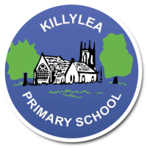
KILLYLEA PRIMARY SCHOOL - LINGUISTIC PHONICS – Week 10 - Anagrams
Anagrams
Word List 4C

MONDAY
daunting
faulty
assault
ought
trawler
dawdle

TUESDAY
applause
restaurant
enthralled
jaunt
authentic
awning

WEDNESDAY
audience
install
mauve
gaunt
autobiography
awesome

THURSDAY
Revise all spellings for Friday round-up.

LEARNING INTENTION: To be able to read, spell and use in context words with the sound ‘aw’ as in ‘saw’.

Monday: Provide synonyms or short definitions for the words listed below. Use a thesaurus to help you.
PLUS INDEPENDENT READING (At least 10 pages/one chapter!)

Word | Short Definition or Synonym (a word ,or phrase, with a similar meaning)
awesome
assault
dawdle
authentic
mauve
Tuesday: Complete the table to sort the words into their letter groups. Add 1 more word to each group.
Highlight the sound patterns. PLUS INDEPENDENT READING (At least 10 pages/one chapter!)
a | au | aw | ough

