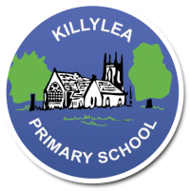
KILLYLEA PRIMARY SCHOOL - LINGUISTIC PHONICS – Week 10 - Challengers
Challengers
Word List 4C+

MONDAY
audacious
autograph
assault
aurora
ottoman
dawdle

TUESDAY
auburn
autopsy
autistic
enthralled
ostrich
awning

WEDNESDAY
audition
auditorium
autocue
gaunt
awl
austere

THURSDAY
Revise all spellings for Friday round-up.

LEARNING INTENTION: To be able to read, spell and use in context words with the sound ‘aw’ as in ‘saw’.

Monday: Provide synonyms or short definitions for the words listed below. Use a thesaurus to help you.
PLUS INDEPENDENT READING (At least 10 pages/one chapter!)

Word | Short Definition or Synonym (a word with a similar meaning)
assault
auburn
enthralled
gaunt
austere
Tuesday: Complete the table to sort the words into their letter groups. Add 1 more word to each group.
Highlight the sound patterns. PLUS INDEPENDENT READING (At least 10 pages/one chapter!)
a | au | aw | o

