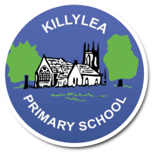
KILLYLEA PRIMARY SCHOOL - LINGUISTIC PHONICS – Week 10 - Scrabbles
Scrabbles
Word List 3B

MONDAY
thought
also
because
Santa Claus
lawn
hawk

TUESDAY
bought
always
August
autumn
yawn
straw

WEDNESDAY
brought
almost
author
claw
thaw
dawn

THURSDAY
Revise all spellings for Friday round-up.

LEARNING INTENTION: To be able to read, spell and use in context words with the sound ‘aw’ as in ‘saw’.

Monday: Provide synonyms or short definitions for the words listed below. Use a thesaurus to help you.
PLUS INDEPENDENT READING (At least 10 pages/one chapter!)

Word | Short Definition or Synonym (a word ,or phrase, with a similar meaning)
dawn
thaw
lawn
author
Tuesday: Complete the table to sort the words into their letter groups. Add 1 more word.
Highlight the sound patterns. PLUS INDEPENDENT READING (At least 10 pages/one chapter!)

a | au | aw | ough

