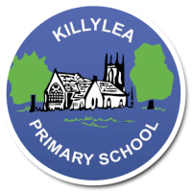
KILLYLEA PRIMARY SCHOOL – LINGUISTIC PHONICS – Week 10 - Wordies
Wordies
Word List 3A

MONDAY
walk
saw
call
because
water
yawn

TUESDAY
talk
draw
ball
odd
off
lawn

WEDNESDAY
hawk
dawn
tall
doll
thaw
jaw

THURSDAY
Revise all spellings for Friday round-up.

LEARNING INTENTION: To be able to read, spell and use in context words with the sound ‘aw’ as in ‘saw’.

Monday: Provide synonyms or short definitions for the words listed below. Use a thesaurus to help you.
PLUS INDEPENDENT READING (At least 10 pages/one chapter!)

Word | Short Definition or Synonym (a word ,or phrase, with a similar meaning)
ball
dawn
thaw
lawn
Tuesday: Complete the table to sort the words into their letter groups. Add 1 more word.
Highlight the sound patterns. PLUS INDEPENDENT READING (At least 10 pages/one chapter!)

a | au | aw | o

