**To access EA Library Service Books Online**

1. Download and install ‘Overdrive’
2. Log into librariesni.org.uk
3. Go to ebooks (you will need your library card number and a PIN – usually the last 4 digits of the number below the bar code on your library card)

**Reading Materials**

Remember, there is a wide range of materials pupils can read such as magazines, newspapers, information leaflets, etc.

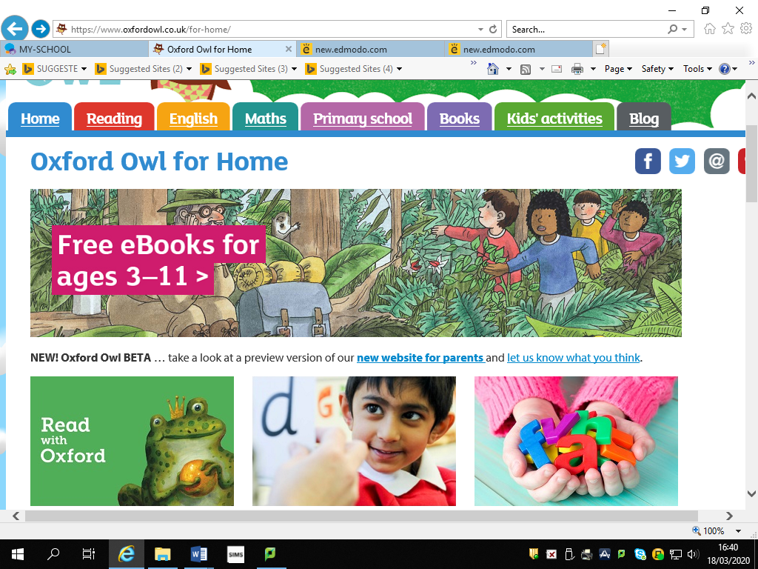

**Oxford Owl Reading**

<https://www.oxfordowl.co.uk/>

Look for the section at the top of the home page ‘Free eBooks for ages 3-11’. There is a small selection of eBooks available to read for P5-7.

**To complete an AR book quiz from home**

1. Enter the web address:
2. <https://ukhosted56.renlearn.co.uk/1892648/>
3. The logon screen you use from school will appear and you can proceed as normal.

**BBC Newsround**

<https://www.bbc.co.uk/newsround>

This website provides lots of current news articles for children to read and videos to watch.