To access NI Libraries Service Books Online
- Download and install ‘Overdrive’
- Log into librariesni.org.uk
- Go to ebooks (you will need your library card number and a PIN – usually the last 4 digits of the number below the bar code on your library card)

Reading Materials
Remember, there is a wide range of materials pupils can read such as magazines, newspapers, information leaflets, etc.
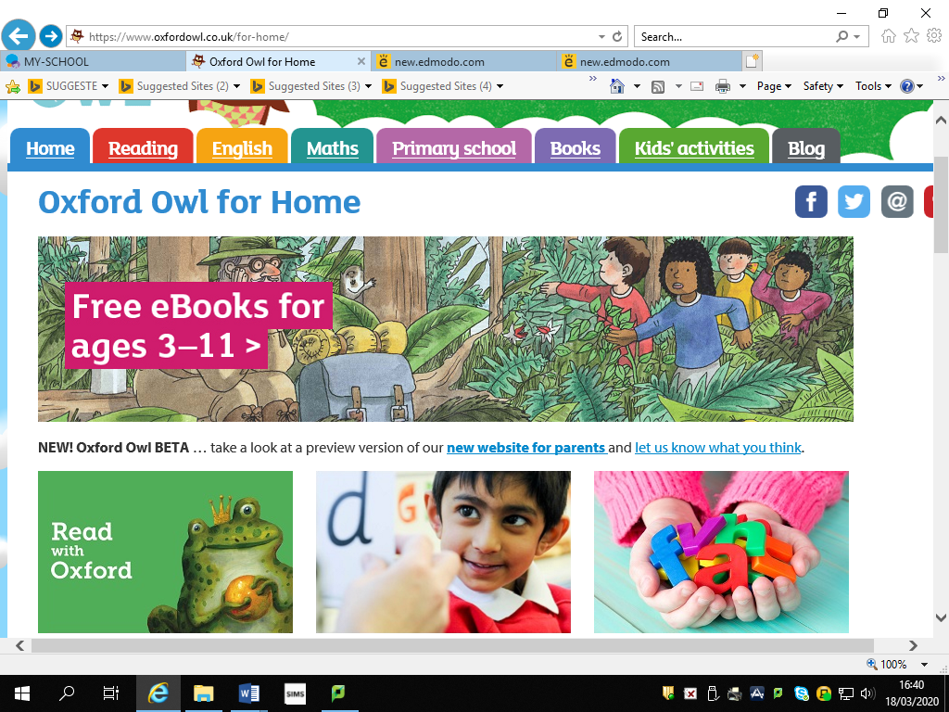
Oxford Owl Reading
https://www.oxfordowl.co.uk/
Look for the section at the top of the home page ‘Free eBooks for ages 3-11’. There is a small selection of eBooks available to read for P5-7.

To complete an AR book quiz from home
- Enter the web address:
- https://ukhosted56.renlearn.co.uk/1892648/
- The logon screen you use from school will appear and you can proceed as normal.

BBC Newsround
https://www.bbc.co.uk/newsround
This website provides lots of current news articles for children to read and videos to watch.

