Good morning everyone! Thank you P1 for sending us some photos of your 3d Robots. They were fantastic!
Primary 1 Monday 18th May 2020
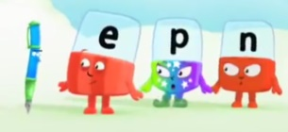
Phonics: Word family ‘en’
- Online- open website https://www.bbc.co.uk/cbeebies/shows/alphablocks
Scroll down and click on the box PEN (5 mins)
- Fun with Spellings pg15:1

Reading: Book from reading pack.
Key words: Keep revising over: all too she gets said No no But but everyone What what took

Mental Maths: Missing numbers counting forward to a given number within 20
Call out sequenced group of numbers leaving out a number. What is the missing number?
e.g. 15,16,___ 18 19 11,__ 13,14,15,16

Topic Maths: Time – Introducing clock face (analogue)
- Go on a clock hunt round your house. Are there different types? Some have clock faces with hands (analogue) others have just lit up numbers like on a TV etc. (digital)

- Watch – (YouTube) BBC Schools Numbertime: Time- Clock (15mins)
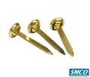
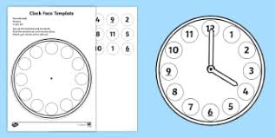
Questions linked to above:
What numbers are on the clock?
How many hands are on the clock and how are they different?
What way to the hands always move?
- Make your own Clock (cut & stick) clock face and numbers are in
your Topic Maths Booklet. You will also find pins also in an envelope
in your pack
Primary 2 Monday 18th May 2020

Phonics: (yellow cover phonics booklet) Spelling words with the ‘aw’ sound
Use a highlighter/ crayon to highlight the ‘aw’ sound variations in the list of words. Then sort the list of words into the table under the 2 variations of the ’aw’ sound.
Today our 3 focus spelling words are: was all saw (write 3 times each in different colours)

Reading: Book from reading pack.
Mental Maths: Subtract 1.2.0 from any number within 50
Instructions on the next page

Topic Maths: Time-Problem solving half past times (analogue clock)
- Revise half past Watch – (YouTube) BBC Schools Numbertime: Time- Half past (15mins)
- First page in this week’s pack-Adult guidance and question prompts & task (Alfie smith has made some mistakes when drawing the hands on his clocks can you explain what needs fixed)
- Second page- Adult guidance and question prompts & task ( Alfie’s appointment card has torn can you help him?
Monday 18th May Primary 2 Mental Maths Task
Cut along the dashed line. Adult calls out the instruction and your child colours in the answer on the 50 grid. If you don’t have access to a printer go to https://www.primarygames.co.uk/pg2/splat/splatsq100.html and splat the number on the 100 grid.
44 subtract 1 28 subtract 1
27 take away 2 39 take away 2
3 subtract 0 34 subtract 1
15 subtract 2 19 take away 2
9 takeaway 2 47 subtract 0
46 subtract 1 35 take away 2
17 take away 1 16 subtract 2
23 take away 0

At the end of the task what letter do you see?
