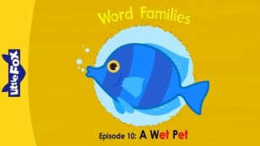
Primary 1 Tuesday 26th May 2020

Phonics: Word family ‘et’
- Online- type into Google – Little Fox word families episode 10 A Wet Pet
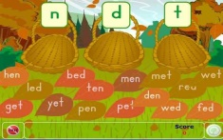
Word build and read along with the short story. (3mins 05)
- Garden Leaves- Sort words ending in en ed et http://www.literactive.com/Download/live.asp?swf=story_files/garden_leaves_US.swf

- Fun with Spellings pg 16:1

Key words: Keep revising over: all too she gets said No no But but everyone What what took
New words: up can’t some came
Reading: Book from your reading pack

Topic Maths: Sorting ( Animal Antics Sheet)
Frances went on a bug hunt in her garden and found lots of creatures. She has drawn each one and now she wants to sort them into groups. Can you help her? Cut out the pictures and sort into groups. What other ways can you sort them?

Adults
Get your child to look closely at the details. Support them but let them investigate.
(possible ways of sorting: by creature groups (e.g. all ants etc), wings/no wings, number of legs, can swim/can’t swim, with spots/no spots etc )

Primary 2 Tuesday 26th May 2020
Phonics: (yellow cover phonics booklet) Spelling words with the ‘e’ sound
Use a highlighter/ crayon to highlight the ‘e’ sound variations in the list of words. Then sort the list of words into the table under the 3 variations of the ’e’ sound.
Today our 3 focus spelling words are: said red friend

Divide tour wipe board/ a page in 4 . Spell each word using the following approach.
said | (Look and copy here)
(Cover the word and write here) | (Eyes closed write here)
Next page in your High Frequency Activity Book

Reading: Book from reading pack

Topic Maths: Sorting ( Animal Antics Sheet)
Frances went on a bug hunt in her garden and found lots of creatures. She has drawn each one and now she wants to sort them into groups. Can you help her? Cut out the pictures and sort into groups. What other ways can you sort them?

Adults
Get your child to look closely at the details. Support them but let them investigate.
(possible ways of sorting: by creature groups (e.g. all ants etc), wings/no wings, number of legs, can swim/can’t swim, with spots/no spots etc )

Mental Maths: Counting in 10’s orally forwards 0 to 50 and backwards 50 to 0

