Primary 1 Tuesday 2nd June 2020

Phonics Word family ‘un’
- Fun with Spellings pg 17:2
- Online http://www.literactive.com/Download/live.asp?swf=story_files/hanging_monkeys_US.swf

Key words: Revise up can’t some came
New words: Jumped don’t put

Mental Maths: Mental Maths: Add 1 to any number within 10
Topic Maths:
Patterns and more Patterns
http://resources.hwb.wales.gov.uk/VTC/patterns_and_patterns/eng/Introduction/default.htm

Starter/ Main activity and Plenary tasks

Let’s get outside!!! Gather your own collection of natural things and make your own patterns.
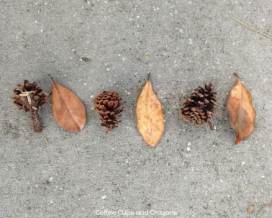

Primary 2 Tuesday 2nd June 2020
Phonics - Phonics Booklet ‘ The Family ’ text. Read and highlight the words which contain the variations of the ‘ee’ target sound.
Today our 4 focus spelling words happy she granny tree
Can you spell your words today by building a word pyramnid?
 |  |  |  | h
 |  |  | h |  | a
 |  | h |  | a |  |  | p
 | h |  | a |  | p | p
h |  | a |  | p |  |  | p |  | y
Reading: Book from reading pack
Mental Maths: Count orally in 10’s backwards from 50 then 100

Topic Maths: Days of the week
- Online https://www.abcya.com/games/days_of_the_week Help Adventure Man enter the mysterious temple by answering the questions on the days of the week
- Page in this week’s pack-Adult guidance and question prompts & task.
Tess the T.Rex is trying to remember what she did last week. Draw a picture of what she did each day in her diary using the clues. (The table in your booklet are very small so on the next page you will find a bigger copy)
- Practice spelling Monday and Tuesday

Primary 2 Days of the week
Tess the T.Rex is trying to remember what she did last week. Draw a picture of what she did each day in her diary using the clues. (The Diary is in your Topic Maths Booklet)
Sunday
Monday
Tuesday
Wednesday
Thursday
Friday
Saturday

