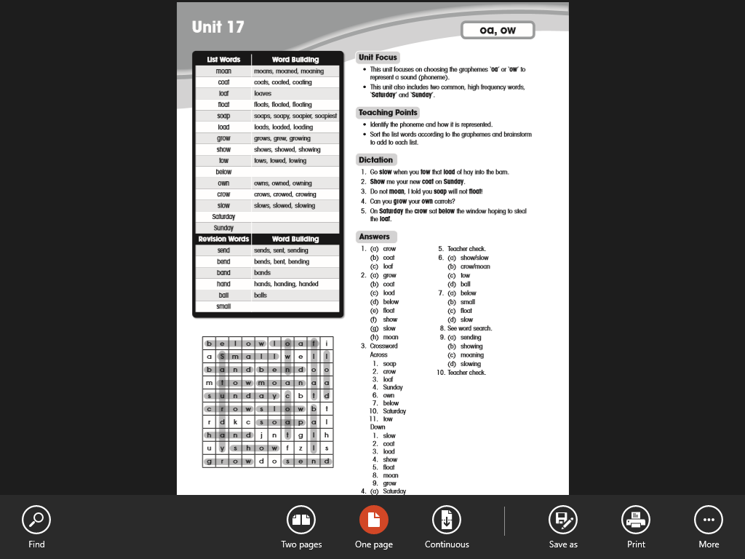**Answers to Monday**

Children should learn all spellings.

**Group 2 Literacy**

**Sheet 1**

**Word worm**

Be no me hum he we

**Sheet 2**

All of the sentences should have a capital letter at the beginning of the sentence and end with a full stop.

**Numeracy answers for both groups**

[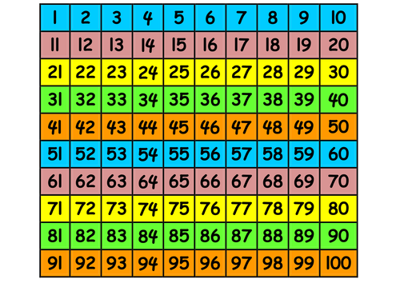](https://www.google.com/url?sa=i&url=https://www.tes.com/teaching-resource/100-square-and-number-line-6060238&psig=AOvVaw2wqYyjIvTidFvgA-FDhulb&ust=1585837370838000&source=images&cd=vfe&ved=0CAIQjRxqFwoTCMjh0tu2x-gCFQAAAAAdAAAAABAT)

**Check using the above number square.**

Red=32, 85, 51,100

Blue=26, 99, 68, 40

Green= 44, 60

Yellow-57,58,59,89,90,91,92