WALT: Count the pennies. Remember ‘p’ at the end of your answer!


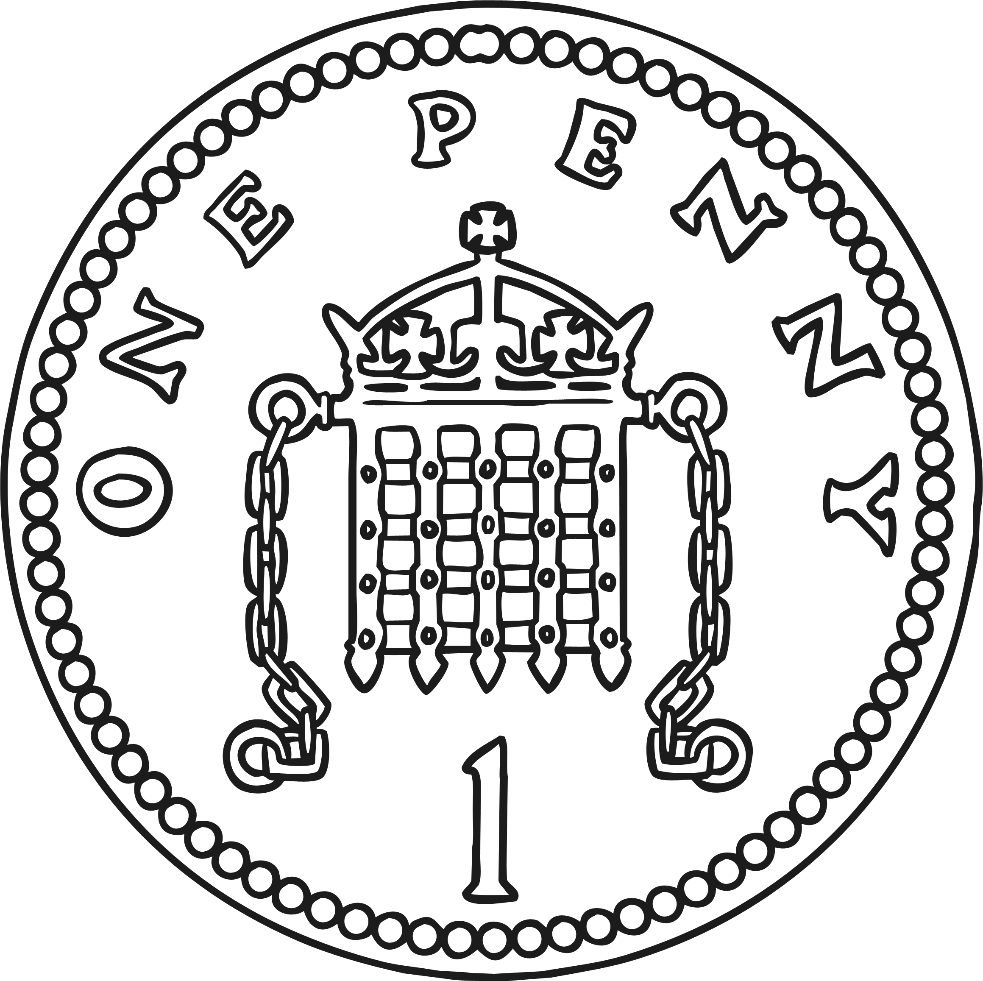
Take note of the differences in minimum font sizes for each key stage. Remember to keep th

