Toy Shop
You will need 1p coins. Use the coins to make the correct amount for each toy in the shop. Line up your coins to make the amount, or draw around them!

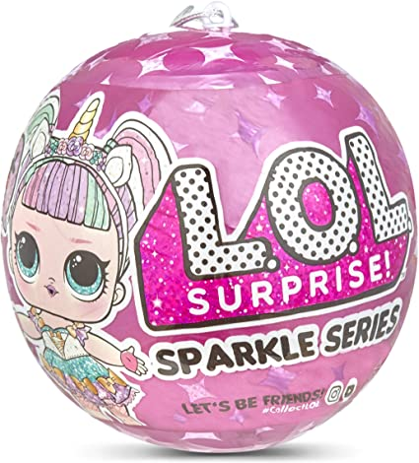3p
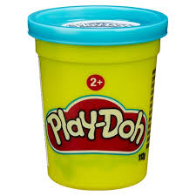5p
2p
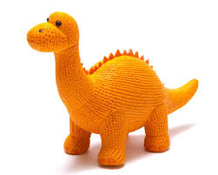 4p
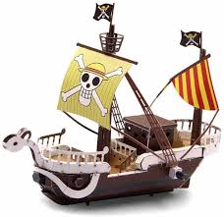 7p

