[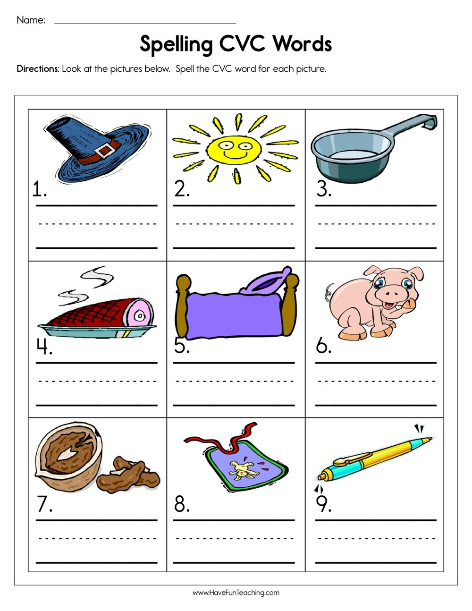](https://www.google.co.uk/url?sa=i&url=https%3A%2F%2Fwww.havefunteaching.com%2Fresource%2Fphonics%2Fspelling-cvc-words-worksheet&psig=AOvVaw3mXGeCr-ST7fmOvRqytCCI&ust=1585766466619000&source=images&cd=vfe&ved=0CAIQjRxqFwoTCJjMwsmuxegCFQAAAAAdAAAAABAE)