[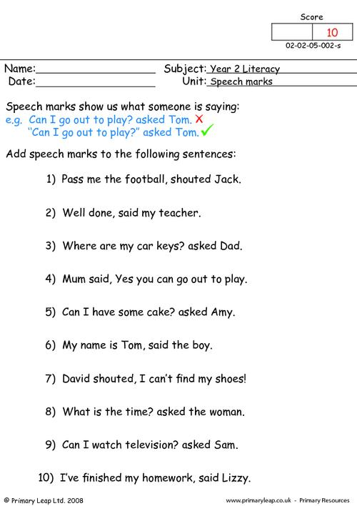](https://www.google.co.uk/url?sa=i&url=https%3A%2F%2Fprimaryleap.co.uk%2Fprimary-resources%2F725%2Fyear-2%2Fliteracy%2Fsentence-work%2Fspeech-marks-1&psig=AOvVaw2jd4mxd9-Tf_94Y4-IK8Xh&ust=1585825076606000&source=images&cd=vfe&ved=0CAIQjRxqFwoTCJjis_SIx-gCFQAAAAAdAAAAABAR)