[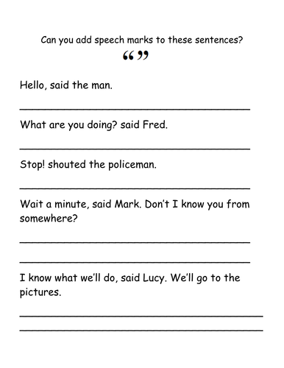](https://www.google.co.uk/url?sa=i&url=https%3A%2F%2Fwww.tes.com%2Fteaching-resource%2Fnew-year-3-inverted-commas-worksheets-11404992&psig=AOvVaw2jd4mxd9-Tf_94Y4-IK8Xh&ust=1585825076606000&source=images&cd=vfe&ved=0CAIQjRxqFwoTCJjis_SIx-gCFQAAAAAdAAAAABAE)

Can we go to the park? asked Lucy.

Come in for your dinner! called Mum.