**Friday 1st May 2020**

*Good morning P.3*

1. Nessy for each pupil (see school website for further details on how to log on)
2. Sumdog for each pupil.
3. Sumdog challenge (a new challenge is set weekly)
4. Mental maths

-Add/ subtract 10 to/from a 2digit number within 100.

1. **Literacy**

*Test*

-Complete test 33 and 34.

(see answers below)

1. **Numeracy**

*Test*

-Complete section a,b and c.

(see answers below)

*Have a nice weekend everybody and we hope you are all keeping well!

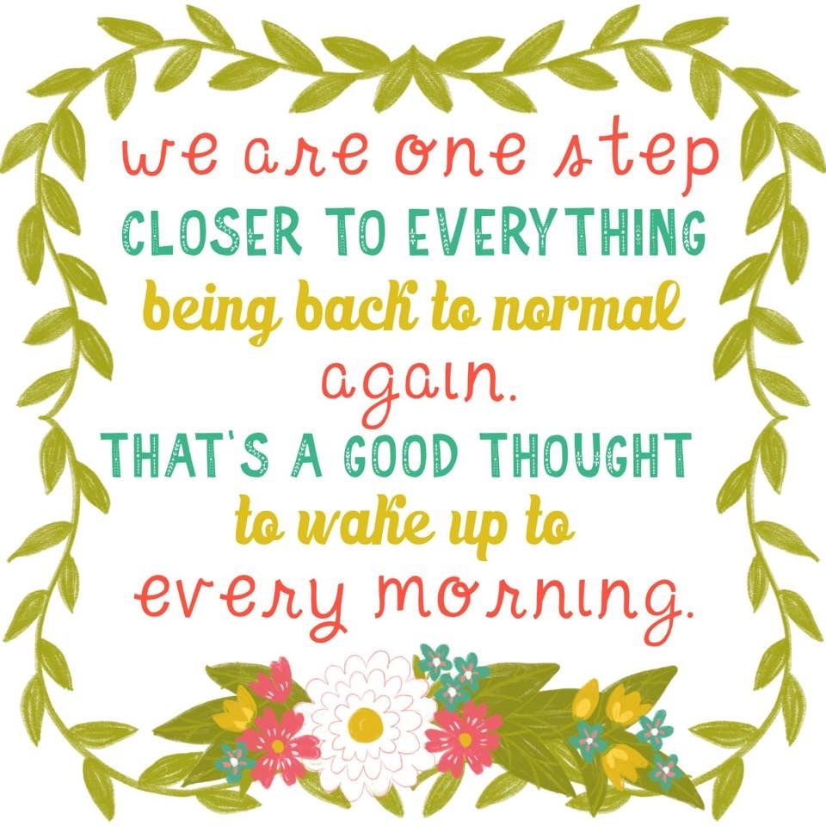

**Literacy Answers**

**Test 33**

1. j

2. j

3. Friday

4. 2

5. room

6. sea

7. she

8. dog

9. ?

10. Her

**Test 34**

1. m
2. m
3. Sunday
4. 3
5. roof
6. buy
7. and
8. back
9. ?
10. One

Numeracy Answers

**Section A**

1. 11
2. 5
3. 2
4. 7p
5. 8p
6. 10p
7. Triangle
8. A
9. Friday
10. 10 O’Clock

**Section B**

1. 8
2. 18
3. 28
4. 24
5. 3
6. 13
7. 23
8. 17
9. 2
10. 10

**Section C**

1. 10
2. 7
3. 8
4. 6
5. 11
6. 2
7. 3
8. 1
9. 4
10. 9