Monday 27th April

ASC

Hi everyone! We hope you are all keeping well. Here are some remote learning ideas for the next week.

World Around Us

As the weather has been good of late, we are sure you are all making the most of your garden space, therefore we thought we would provide some optional topic work linked to the garden. Our topic is Minibeasts. This is a very interesting topic for young children. It provides lots of opportunities to develop Literacy, Numeracy and Art skills as well as developing an understanding of the world we live in.

Here are some suggestions for activities to engage children in the wonderful world of minibeast.

* Minibeast garden hunt activity (see attached checklist)
* Counting bugs in a jar (use the attached sheets to reinforce concepts of number and counting)
* 2D shape minibeast cutting skills activities (see attached sheets with a range of minibeasts to practice cutting skills)
* Minibeast small world characters- print out and stick these images onto blocks to quickly create a wonderful small world scene. Try placing the decorated blocks into a large tray filled with bark, leaves and soil. To encourage children to create minibeast stories.
* Categorising minibeast for one criterion- legs/ no legs.
* Listen to the following eBook- the cautious caterpillar. This story is about the lifecycle of a butterfly- from egg to caterpillar to chrysalis to butterfly. This book is useful for talking to children about transition and change as well as a starting point for your minibeast theme.
* Minibeast colouring help encourage language development of different insects.
* Minibeast Photo Powerpoint useful for promoting language development of different minibeasts.
* In order to help celebrate earth day which was on the 22nd April, children to go to their gardens and take a picture of the nature around them. Here are some pictures Martell took when she was out with her camera.



We suggest accessing the following resources/ebooks from Twinkl to assist with this learning. Go to [www.twinkl.co.uk/offer](http://www.twinkl.co.uk/offer) (using the code CVDTWINKLHELPS)

**Literacy**

* High Frequency words: Please continue to revise words covered everyday these words are ‘I, the, a, and, my. This week our high frequency word is ‘dad’ listen and read the story ‘dad’ with your child. Decorate the word dad, practice writing the word and look out for the word in books.
* Phonics: Continue to revise the sounds covered to date using the Starfall website and the alphabet, which we have attached below. Introduce the new sound this week Vv. Encourage your child to think of words which begin with these sounds and ask them to draw things beginning with the sound. Access the Vv pages on Starfall <https://www.starfall.com/h/abcs/>
* Use alphabet sheets to go on a sound hunt with children to find the different sounds around the house. This will help reinforce sounds already covered in school.
* Access Jack Hartman’s phonics videos on YouTube <https://www.youtube.com/watch?v=yZjEtwr8Q4o>
* Watch out for these sounds in story books and look for objects within the home that begin with these new sounds.
* Practice the correct formation of these letters using the template below
* **Reading**: Continue to access free eBooks on the Oxford Owl website [https://www.oxfordowl.co.uk/gor-home/reading/#](https://www.oxfordowl.co.uk/gor-home/reading/)

This is a fantastic resource bank and its FREE. *It is so important that you continue to do daily reading with your children, in order to maintain skills. At least 10 mins every day please.*

We suggest the following timetable for Literacy:

Monday 27th April- Friday 1st May

Monday 27th: Decorate the V sound, and practice tracing the letter.

Tuesday 28th: Draw and circle around the things, write v in circles

Wednesday 29th Tracing lines and tracing v

Thursday 30th: High frequency word dad- listen to story, decorate and trace the word.

Friday 1st- Listen to the ebook story The cautious caterpillar and discuss the story.

Numeracy this week will focus on reinforcing number recognition up to 5, one to one counting of objects and matching the correct amount with the number. Listen to the Jack Hartman link to recap on the numbers 1-10 <https://www.youtube.com/watch?v=pzmB0GoEKkA> and complete set tasks.

* Ensure children are able to count forwards from 1-10. Touch count objects up to 5 and record. This can be completed as a practical activity with groups of objects For example socks, lego bricks, cheerios.
* Topmarks is also an excellent website to help reinforce one to one counting skills. Teddy Numbers and Underwater counting is an interactive way to help develop counting and number recognition skills.

<https://www.topmarks.co.uk/maths-games/3-5-years/counting>

We suggest following this timetable for Numeracy:

Monday 27th – Cut and stick object with correct number, you can use pictures provided or use objects or toys in the house.

Tuesday 28th-Tracing numbers 1-5.

Wednesday 29th- Trace and match the correct amount to the correct number.

Thursday 30th- Order numbers 1-5.

Friday 1st May- Minibeast practical jar counting.

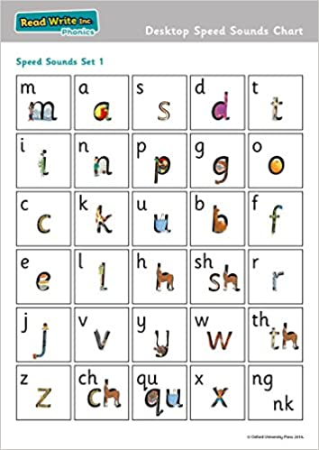

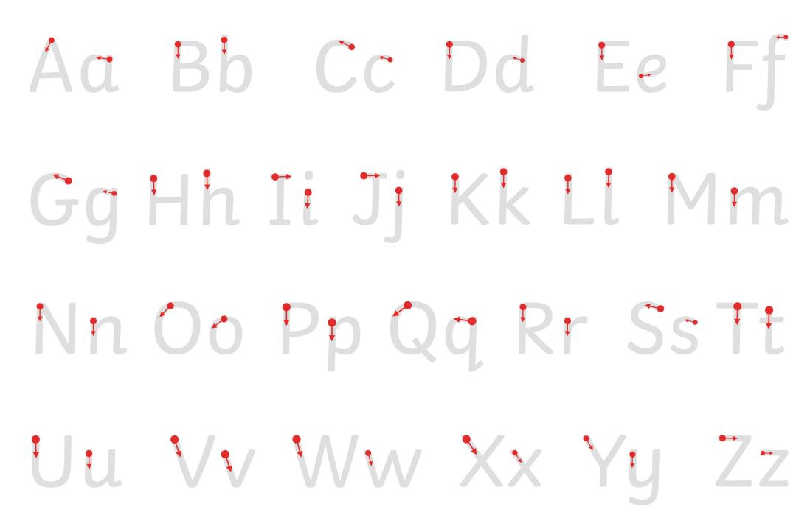

**dad**