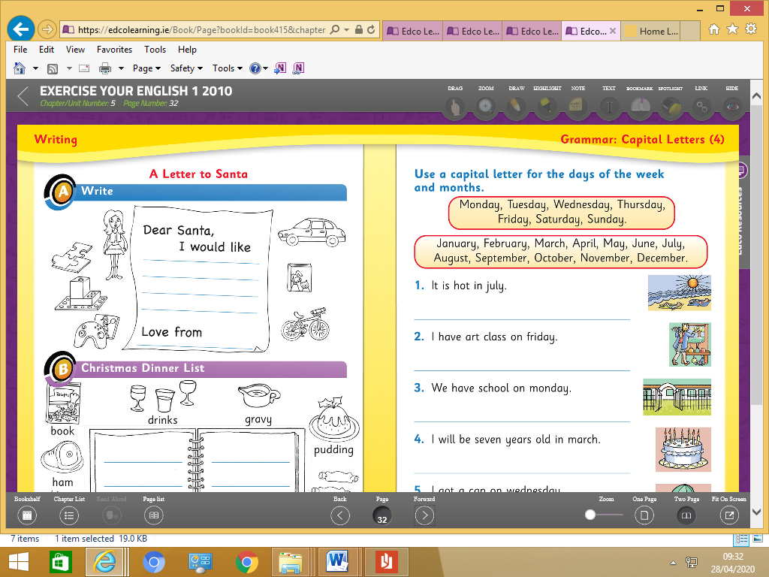

I will be seven years old in March.

We have school on Monday.

I have art class on Friday.

It is hot in July.