Long ago in the country of China there lived an old woman. She was known to everyone as Lao Lao and she lived in a tiny village in the foothills of the mountain where the Ice Dragon reigned.
Lao Lao of Dragon Mountain
Her greatest pleasure was to sit outside her home surrounded by the children of the village. There she would take a thin sheet of paper and the small pair of scissors that she kept in her front pocket, and while she cut she sang,
Fold it and cut it and turn it around
Open it up and see what you’ve found.
So beautiful were these paper-cuts that the fame of the old woman spread. People from the towns started to climb up the steep, narrow path to ask Lao Lao for one of her paper-cuts.
They would always find her sitting outside her house, busy with her scissors and singing,
Fold it and cut it and turn it around
Open it up and see what you’ve found.
And the children would watch in amazement as she unfolded the piece of paper- what would it be? A butterfly! A cockerel! A flower! Lao Lao would watch the children running home, each holding their own special gift. And as they ran, she would hear them singing,

Fold it and cut it and turn it around
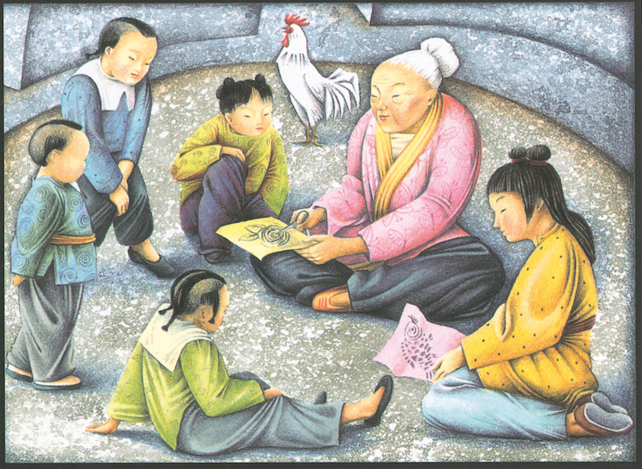
Open it up and see what you’ve found.

