We are continuing to look at halves. This includes shapes and numbers.

The first sheet involves cutting out the four shapes. Then they are folded in two. Draw a line down the middle and write half on each part. Colour in one half in each shape.

[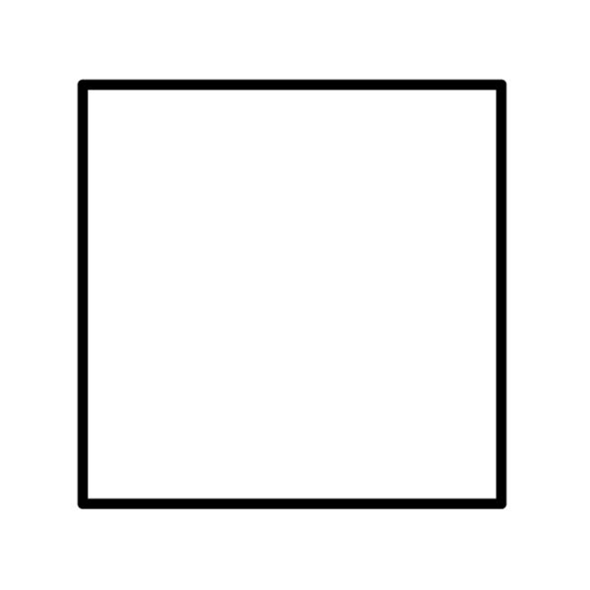](https://www.google.co.uk/url?sa=i&url=https://www.pelennapatchworks.co.uk/freezer-paper-templates-for-patchwork/square-freezer-paper-templates.html&psig=AOvVaw397fuWrGyH6aDLpluD2Wxf&ust=1584626330080000&source=images&cd=vfe&ved=0CAIQjRxqFwoTCLCYkJ6XpOgCFQAAAAAdAAAAABAK)[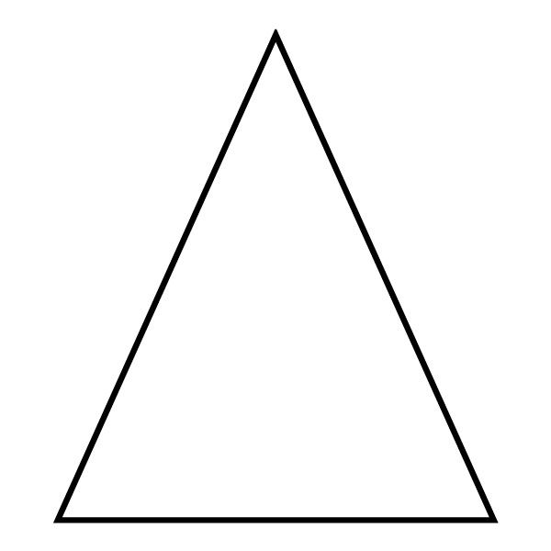](https://www.google.co.uk/url?sa=i&url=https://www.pinterest.com/pin/98375573083752186/&psig=AOvVaw17iuYEfQJOM7N4kWAxEfMn&ust=1584626474665000&source=images&cd=vfe&ved=0CAIQjRxqFwoTCPD4huOXpOgCFQAAAAAdAAAAABAW)[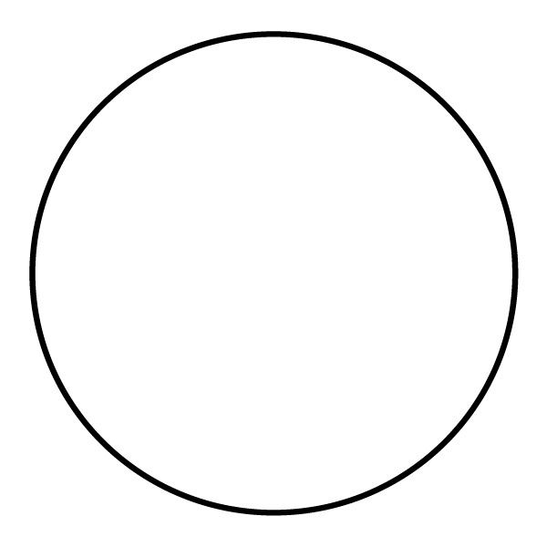](https://www.google.co.uk/url?sa=i&url=https://www.pinterest.com.au/pin/554153929128835353/&psig=AOvVaw2sAPV91FHCaolHFqbAK0Hk&ust=1584626248112000&source=images&cd=vfe&ved=0CAIQjRxqFwoTCMig1veWpOgCFQAAAAAdAAAAABAK)[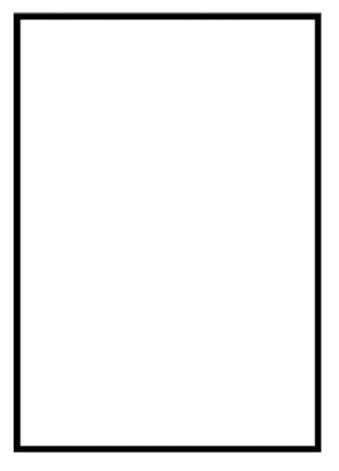](https://www.google.co.uk/url?sa=i&url=https://kinderart.com/rectangle-coloring-page/&psig=AOvVaw0cPvOxUDEJHUZ_GruMut-h&ust=1584626407723000&source=images&cd=vfe&ved=0CAIQjRxqFwoTCKi2h8OXpOgCFQAAAAAdAAAAABAU)