‘Who Takes the Train?’ Word Mat

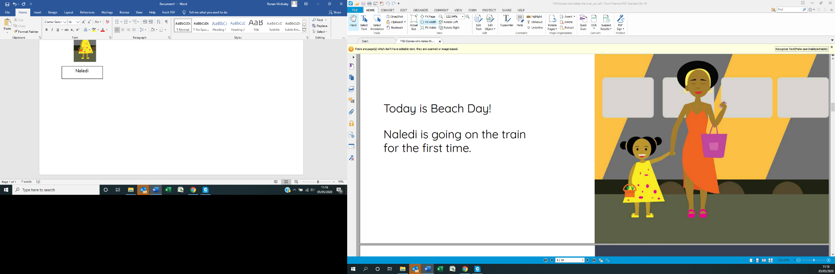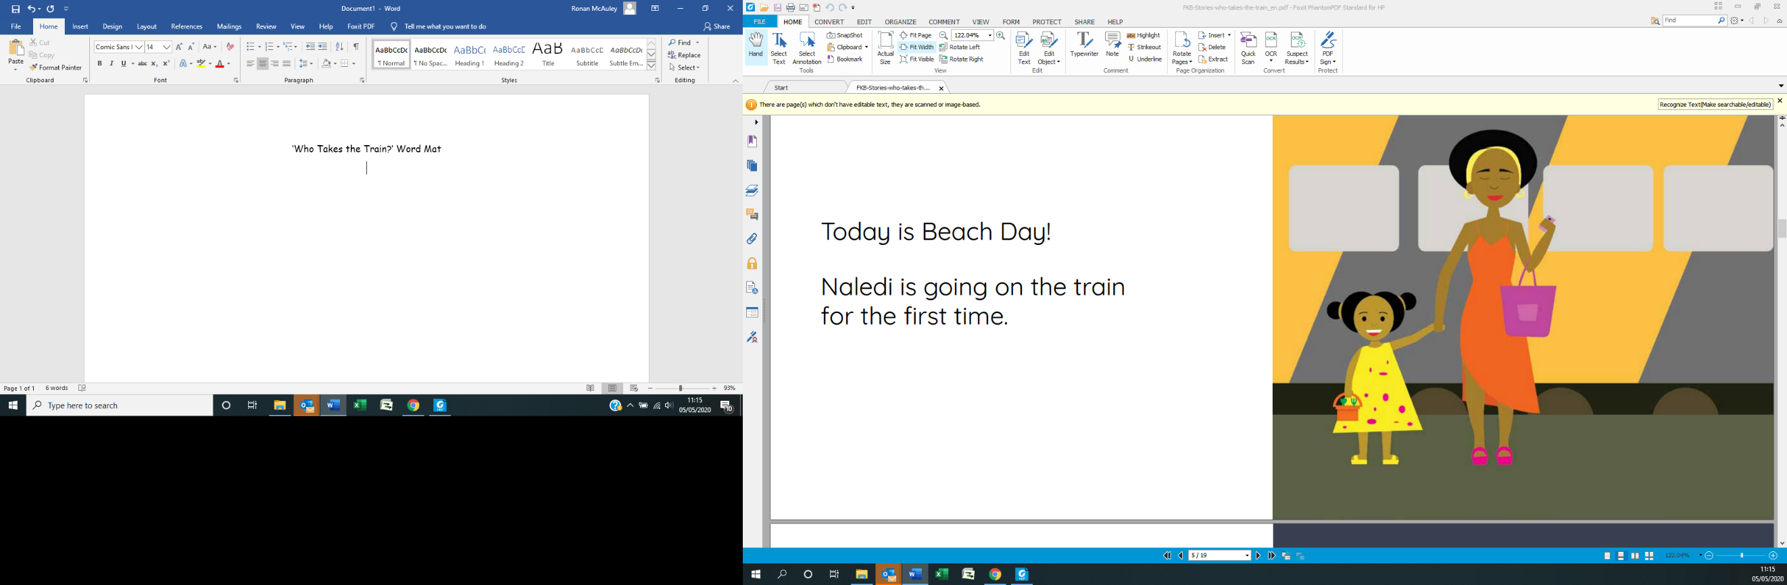

Naledi

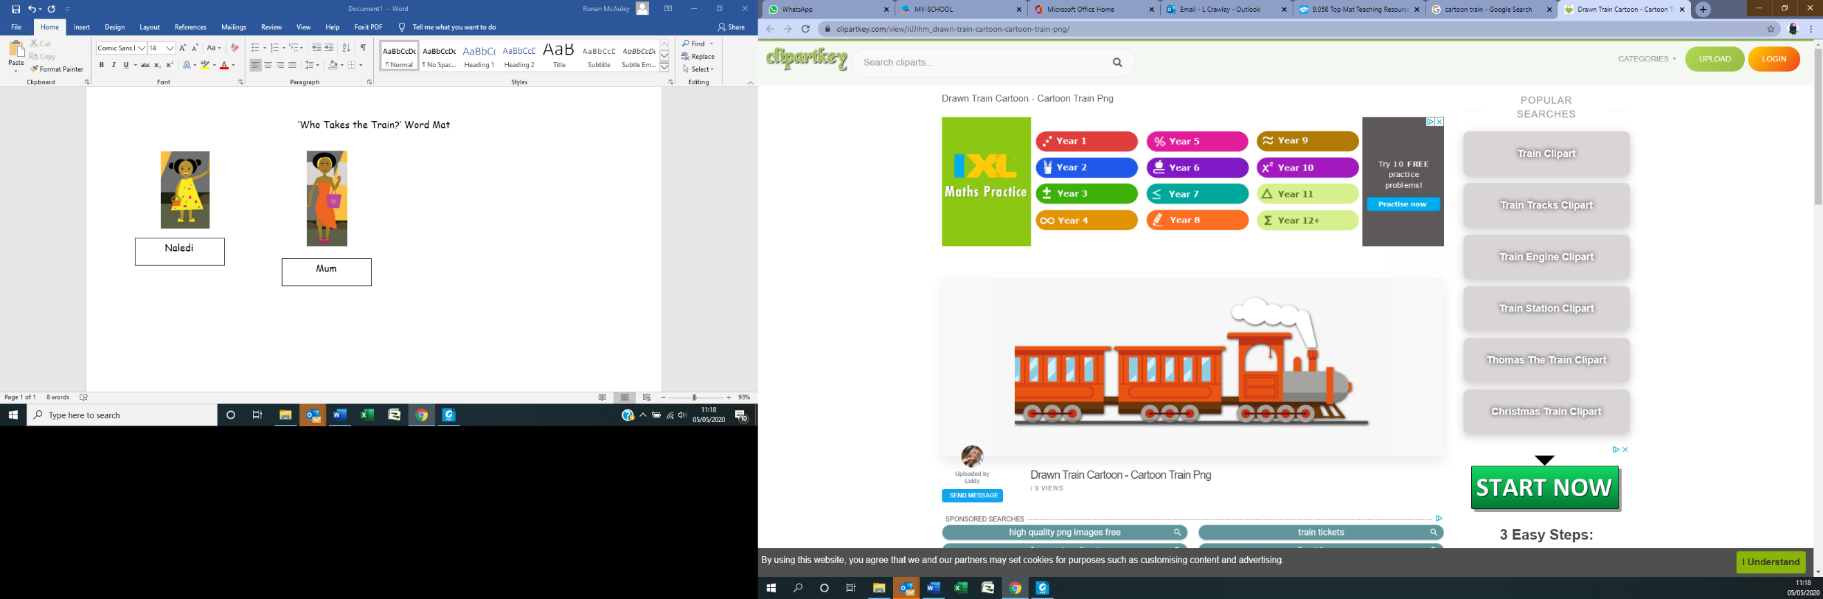

train

Mum

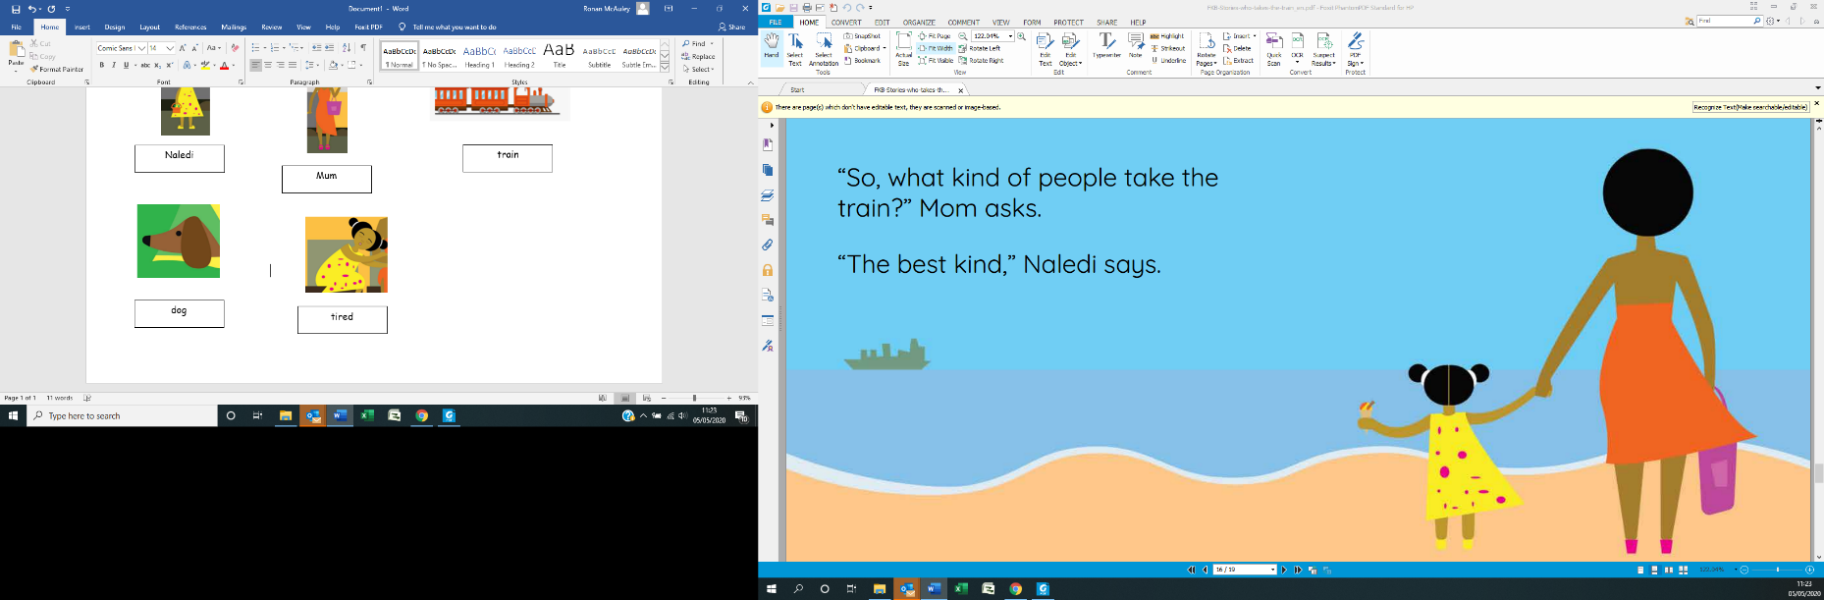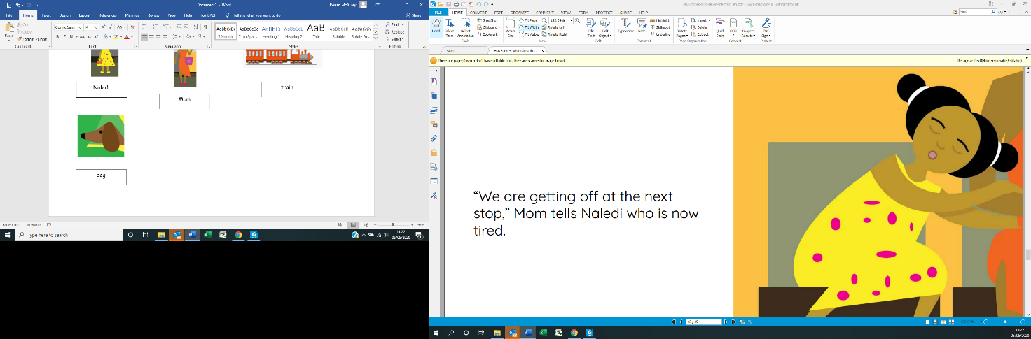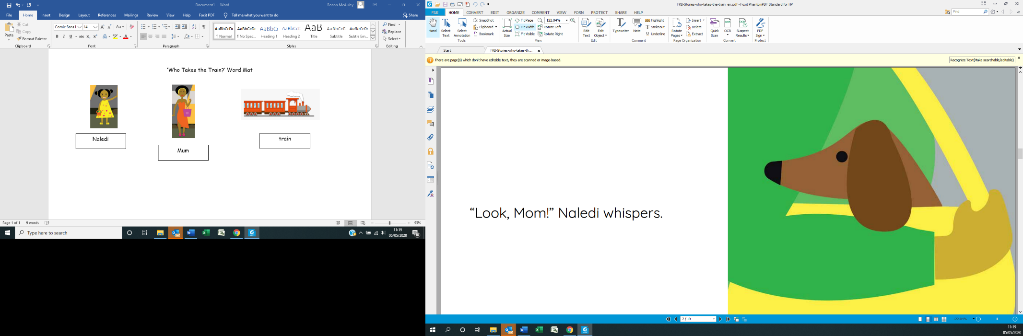

tired

beach

dog