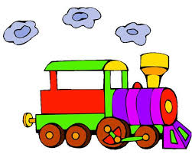 + 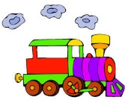 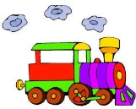 = 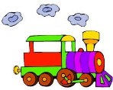 

+ =

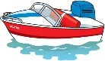 + 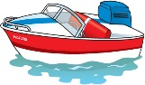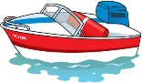 =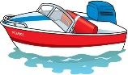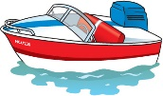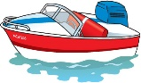

+ =

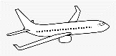Aeroplane Plane Air Airplane Aircraft Travel - Airplane Clipart ... + Aeroplane Plane Air Airplane Aircraft Travel - Airplane Clipart ... 

   



 