Who Takes the Train?

Talk Cards

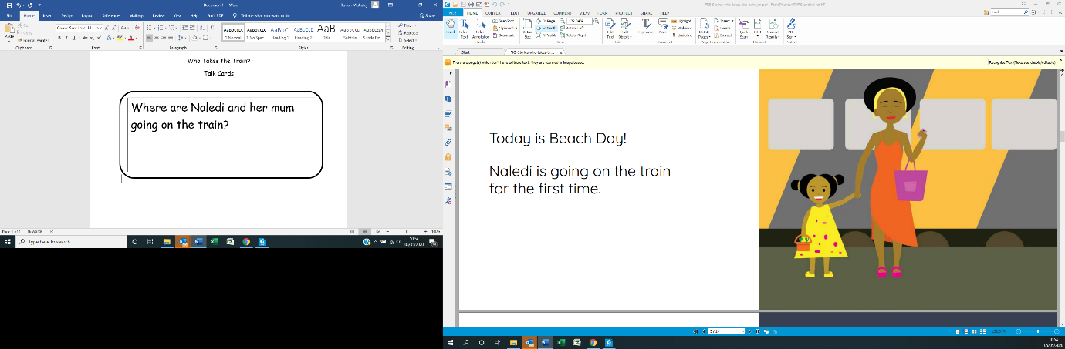

Where did Naledi and her mum go to on the train?

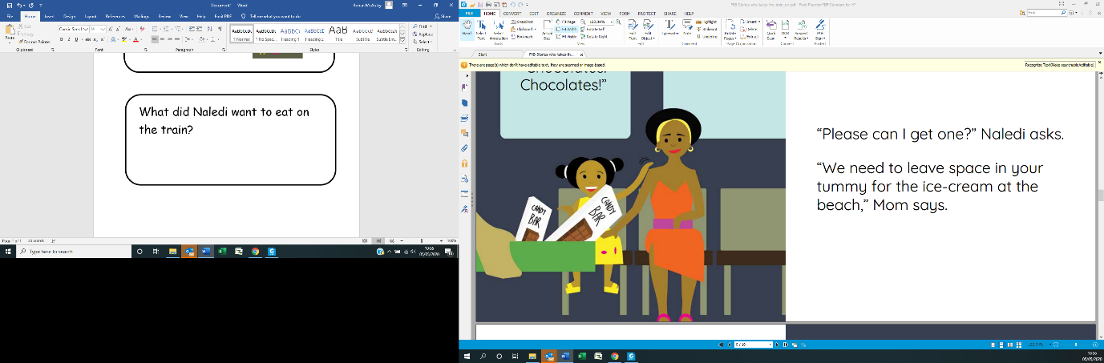

What did Naledi want to eat on the train?

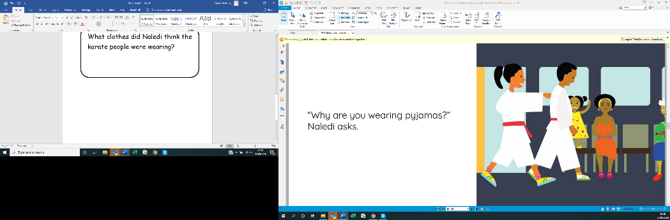

What clothes did Naledi think the karate people were wearing?

What musical instrument could Naledi hear when she was on the train?

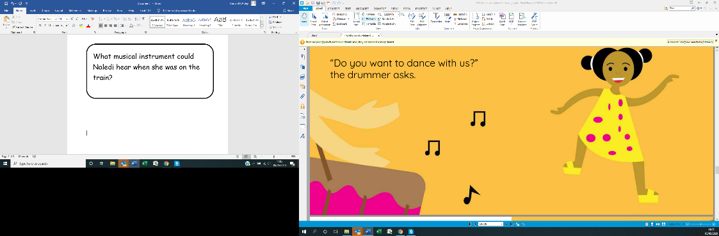

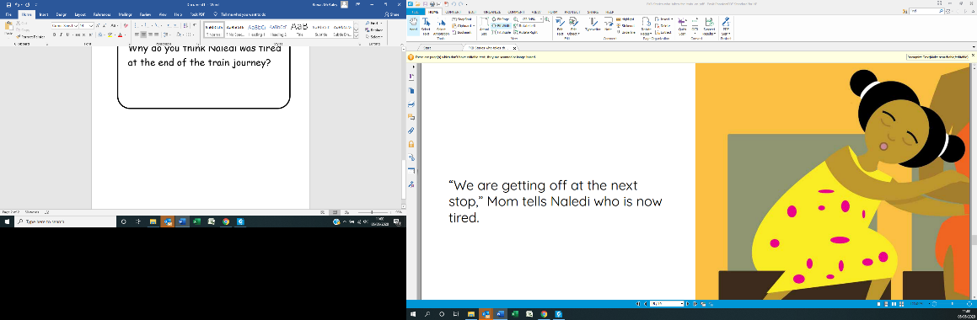

Why do you think Naledi was tired at the end of the train journey?

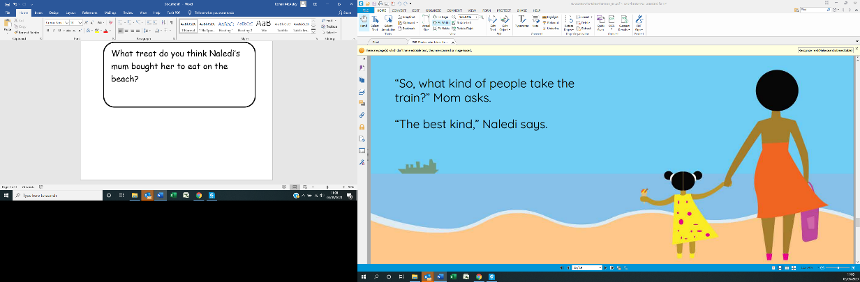

What treat do you think Naledi’s mum bought her to eat on the beach?