[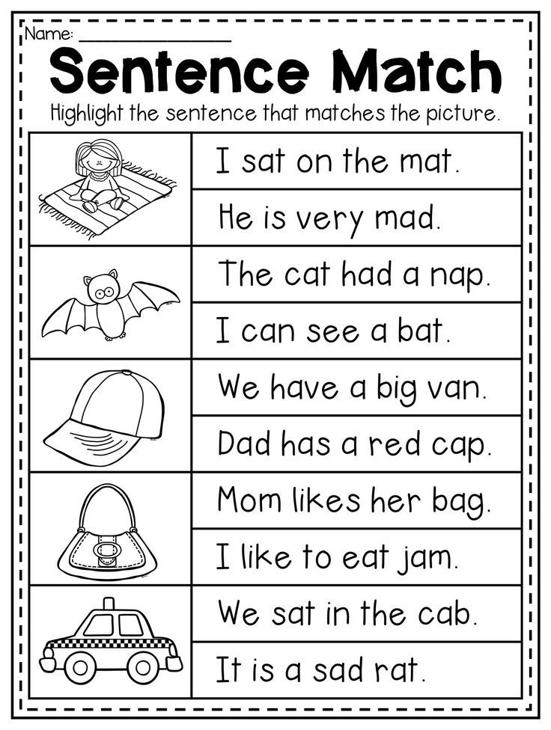](https://www.google.co.uk/url?sa=i&url=https%3A%2F%2Fwww.pinterest.com%2Fpin%2F412501647116827765%2F&psig=AOvVaw3MAyDv3PGJ8WDsnXrO4Gtq&ust=1586273082591000&source=images&cd=vfe&ved=0CAIQjRxqFwoTCPj3y-2N1OgCFQAAAAAdAAAAABAR)

[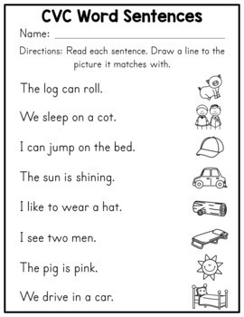](https://www.google.co.uk/url?sa=i&url=https%3A%2F%2Fwww.teacherspayteachers.com%2FProduct%2FCVC-Word-Worksheets-2453627&psig=AOvVaw3MAyDv3PGJ8WDsnXrO4Gtq&ust=1586273082591000&source=images&cd=vfe&ved=0CAIQjRxqFwoTCPj3y-2N1OgCFQAAAAAdAAAAABAc)