[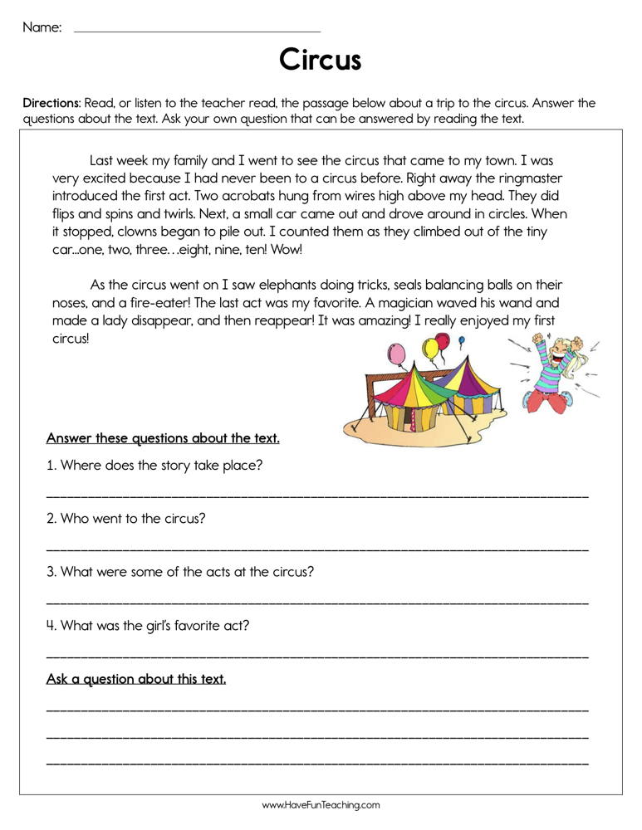](https://www.google.co.uk/url?sa=i&url=https%3A%2F%2Fwww.havefunteaching.com%2Fresource%2Freading%2Freading-comprehension%2Fcircus-reading-comprehension-worksheet&psig=AOvVaw2VTVe2FWZGf0yYemhx1vME&ust=1586252803033000&source=images&cd=vfe&ved=0CAIQjRxqFwoTCID2uafC0-gCFQAAAAAdAAAAABAL)

[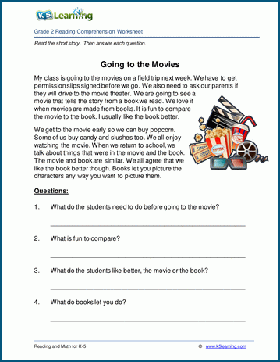](https://www.google.co.uk/url?sa=i&url=https%3A%2F%2Fwww.k5learning.com%2Freading-comprehension-worksheets%2Fsecond-grade-2%2Fchildrens-stories%2Fgoing-to-the-movies&psig=AOvVaw32Ukh-9taQ80f9Qi3lOFY_&ust=1586257566752000&source=images&cd=vfe&ved=0CAIQjRxqFwoTCOCai4fU0-gCFQAAAAAdAAAAABAf)