[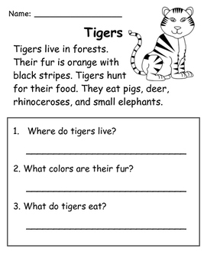](https://www.google.co.uk/url?sa=i&url=https%3A%2F%2Fwww.teacherspayteachers.com%2FProduct%2FZoo-Animals-Nonfiction-Reading-Passages-2549356&psig=AOvVaw32F4H-iHxF9O8Mi3wrgkl3&ust=1586252546562000&source=images&cd=vfe&ved=0CAIQjRxqFwoTCIi4qK3B0-gCFQAAAAAdAAAAABAU)

colours

[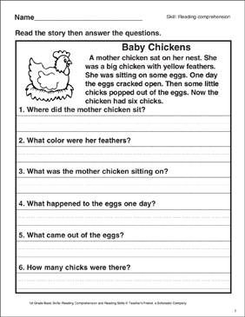](https://www.google.co.uk/url?sa=i&url=https%3A%2F%2Fwww.pinterest.com%2Fpin%2F531424824775560326%2F&psig=AOvVaw2VTVe2FWZGf0yYemhx1vME&ust=1586252803033000&source=images&cd=vfe&ved=0CAIQjRxqFwoTCID2uafC0-gCFQAAAAAdAAAAABAS)

colour