[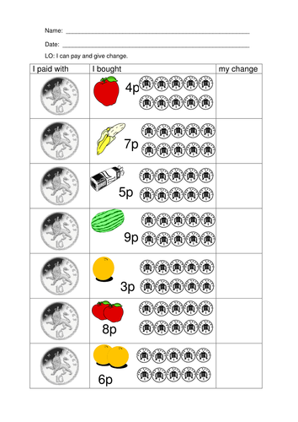](https://www.google.co.uk/url?sa=i&url=https%3A%2F%2Fwww.tes.com%2Fteaching-resource%2Fmoney-worksheets-ks1-coin-recognition-change-and-problem-solving-6009615&psig=AOvVaw2JzliktDxHs0a69IhohgKs&ust=1586512058660000&source=images&cd=vfe&ved=0CAIQjRxqFwoTCNCx1ZCI2-gCFQAAAAAdAAAAABAD)