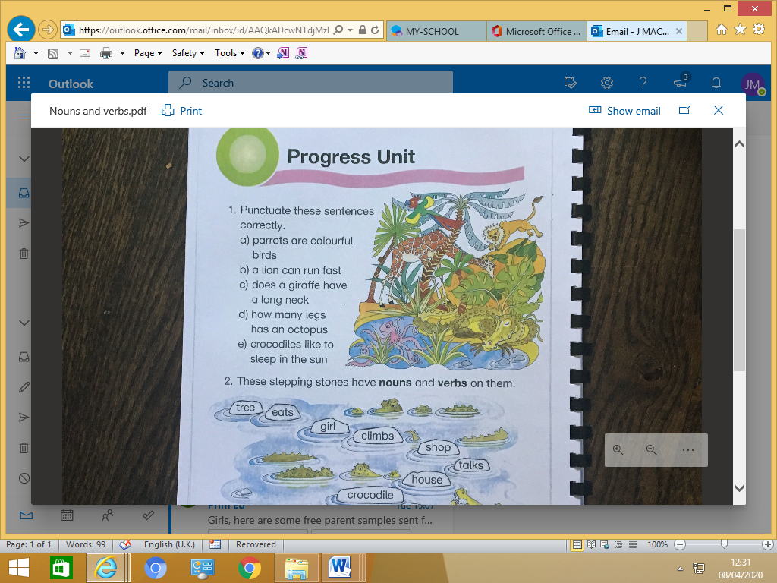Colour the nouns one colour and the verbs another colour.

**Answers**

**1**

1. Parrots are colourful birds.
2. A lion can run fast.
3. Does a giraffe have along neck?
4. How many legs has an octopus?
5. Crocodiles like to sleep in the sun.

2.

**nouns**

tree

girl

shop

house

crocodile

**verbs**

eats

climbs

talks