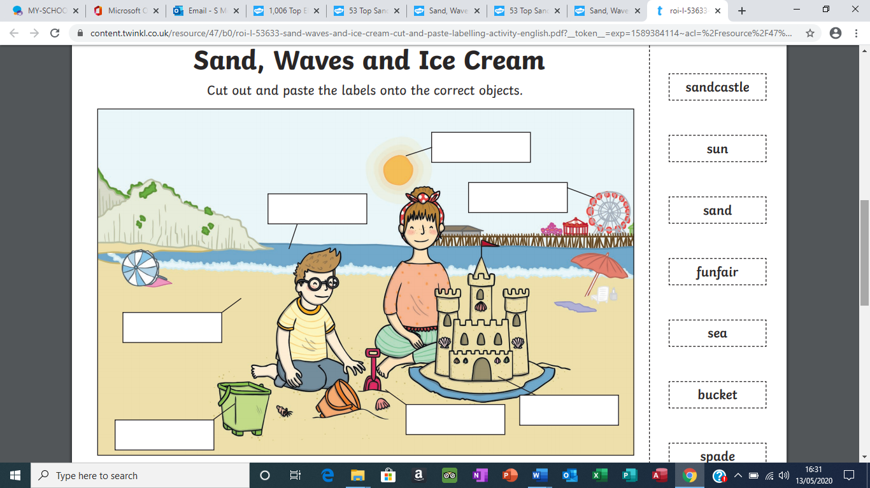

castle

sun

funfair

sand

water spade

bucket