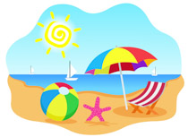

1. What is the boy in the story called?
2. Where were Mum and Michael going?
3. Michael could feel the sand between his toes. Have you ever felt this? What did it feel like? Was it a nice feeling?
4. Why did Mum put sun-cream on Michael’s face? Do you think this is important?
5. Can you remember what Michael wanted to do at the beach? What would you like to do if you could choose?
6. Michael and Mum made a super sandcastle. They made something special around their castle to protect it. Do you know what it was? Have you ever made a sandcastle? How did you build it?
7. Mum bought Michael an ice cream. What flavour did he get? What is your favourite flavour?
8. Have you ever been to the seaside? Was it in Ireland or somewhere else? How did you get there?