Monday 18th May

ASC

Hi everyone, we hope you are all keeping well. We miss you all lots!

Reminder: Next week 25th May- 29th May, is a school holiday therefore NO WORK will be posted next week, but we shall return on Monday 1st June. Please take this time to relax and enjoy some quality family time.

Religious Education:

May is the month of Mary. We celebrate Mary’s month by praying the rosary to Our Lady, singing songs and making a May altar. Why not try to do this as a family at home? We have included a lovely Mary power point which will help familiarise your child. We have also included two colouring pages for your child to complete.

World Around Us:

We shall continue our exploration into Water, this week focusing on the importance of water of its uses.

Please visit the following link for children for some fun facts about water.
- https://www.youtube.com/watch?v=CwpHMPH-WbM
- https://www.youtube.com/watch?v=s2DTW0EMigk

Below are some also some water play activities which is a great way to encourage language development around this topic as well as model skills such as turn taking and waiting turns. Have fun!

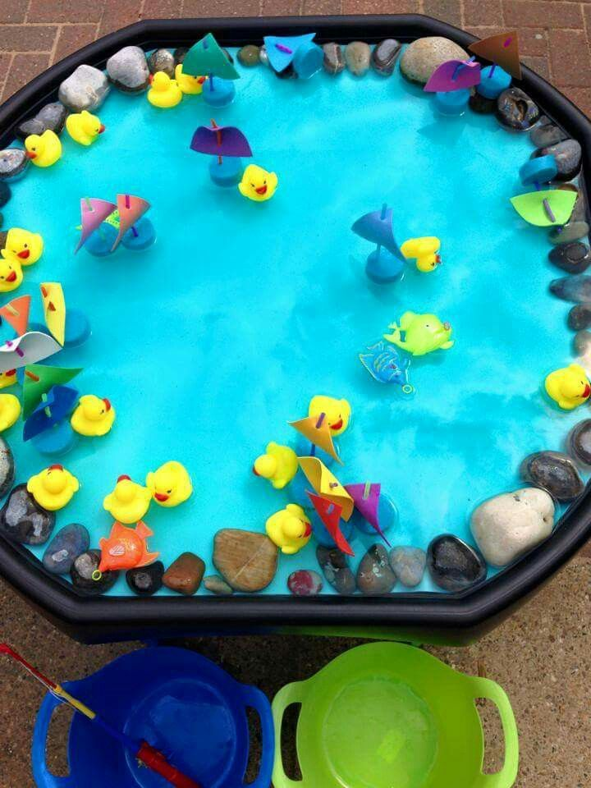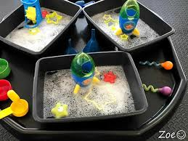
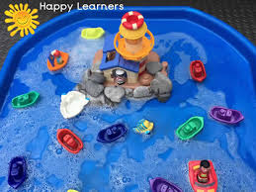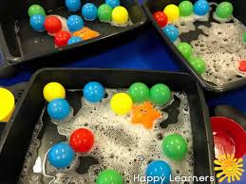

Literacy:

- High frequency words: Please continue to revise all spellings to date. This week is our final week on the ‘a’ word.
- Phonics: Continue to revise the sounds covered to date using the alphabet and Starfall website. Introduce the new sound th:
- Encourage your child to think of words which begin/end with this sound and ask them to draw things beginning with this sound.
- Access the th digraph page Starfall https://www.starfall.com/h/ltr-lv-e/th-skill/?sn=ltr-classic
- Jack Hartman ‘th’ digraph link https://www.youtube.com/watch?v=o3INXFPrfJM
- Alpha blocks ‘th’ digraph link https://www.youtube.com/watch?v=OB43Qgu2Oac
- Watch out for this sound in story books and look for objects within the home that begin with this new sound.
- Practice the correct formation of lowercase th.

- Reading: Continue to access eBooks on the Oxford Owl website:
https://home.oxfordowl.co.uk/books/free-ebooks/

Here is a list of recommended book levels for your child to read, with corresponding titles to search for. If your child finds the level too hard or too easy, move up or down within the Oxford Level/Book Band Colour.

Oxford Level | Book Band Colour | Suggested Title
1 | Lilac | The Haircut
1+ | Pink | Big Feet
2 | Red | Spots
3 | Yellow | The Birthday Cake

It is so important that you continue to do daily reading with your children, in order to maintain the progress made to date! At least 10 minutes every day please.

We suggest the following timetable for Literacy
Week 5 (Monday 18th May-Friday 22nd May)
(Work on high frequency words and reading to be carried out every day)

Monday 18th ‘My th booklet page 2&3’

Tuesday 19th ‘My th booklet page 6&7’

Wednesday 20th th cards cut and stick

Thursday 21st th cards matching bingo pictures

Friday 22nd train track pencil control work

Numeracy

- This week we will be revising time and clock. This is a great opportunity to refresh on language associated with time and clocks
- Use these YouTube songs to remind children how to read a clock to the hour. https://www.youtube.com/watch?v=tEmg914-9xY (Lets learn about the clock- Jack Hartman)
- https://www.youtube.com/watch?v=g6tJAy_7AL4(Hip-Hop around the clock)
- https://www.youtube.com/watch?v=TaFQslk37xg (Telling Time-How to read a clock)
- This week work is much more practical based as we want to encourage building the language around time. You will also find that two activities included are first and then based this is a fun activity teaching time and how events can be sequenced.

- Numeracy games:
- https://www.topmarks.co.uk/time/teaching-clock (telling the time to the hour. Useful teaching tool to use with your child)
- https://www.splashlearn.com/time-games (Some nice little games on telling the time if you make a free account)

We suggest the following timetable for Numeracy:

Week 5 (Monday 18th-Friday 22th May

Monday 18th: Make your own clock

Tuesday 19th: Playdough clocks

Wednesday 20th: First and then visual

Thursday 21st: First, next, then visual

Friday 22nd: Playdough clocks

