Monday 1st June

Welcome back everyone we hope you had a great week off.

As we are in our final month of school I thought it would be a good opportunity this week to look a little bit closer into the topic of summer. I have attached a lovely word building power point to help familiarise your child with images about summer. Also attached are some summer sorting and colouring activities.

Youtube has some great videos to explain summer

* <https://www.youtube.com/watch?v=YE-BI2WRnBU>
* <https://www.youtube.com/watch?v=mVhh0oATqBI>

As the weather has been good here are some outdoor learning ideas which can be made to help encourage children to spend time outside.

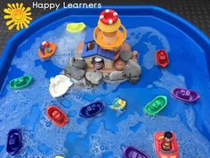 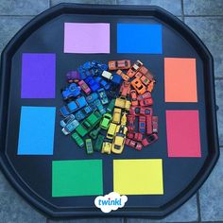

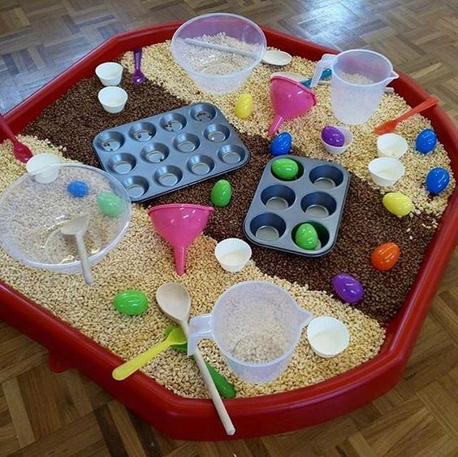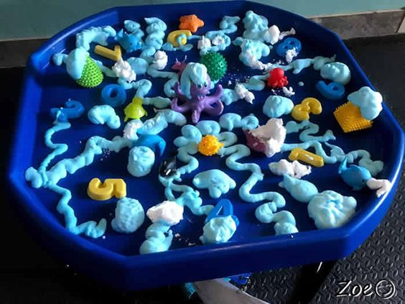

Literacy

* **High frequency words**: Please continue to revise all spellings to date. As we have been doing previously with the high frequency words homework, look and say each word. Orally put each word into a sentence. Practise writing each word and look out for the words in books. This week our new high frequency word is ‘I’ read the story ‘I can’.
* **Phonics:** Continue to revise the sounds covered to date using the alphabet and Starfall website. **Introduce the new sound z:**
* Encourage your child to think of words which begin/end with this sound and ask them to draw things beginning with this sound.
* Access the z sound page on Starfall website https://www.starfall.com/h/abcs/letter-z/?
* Jack Hartman ‘z’ sound <https://www.youtube.com/watch?v=IDeUZy_iNT4>
* Alpha blocks ‘z’ sound link <https://www.youtube.com/watch?v=0PEgL5poqI8>
* Watch out for this sound in story books and look for objects within the home that begin with this new sound.
* Practice the correct formation of *lowercase* z
* **Reading:** Continue to access eBooks on the Oxford Owl website:

<https://home.oxfordowl.co.uk/books/free-ebooks/>

Here is a list of recommended book levels for your child to read, with corresponding titles to search for. If your child finds the level too hard or too easy, move up or down within the Oxford Level/Book Band Colour.

|  |  |  |
| --- | --- | --- |
| Oxford Level | Book Band Colour | Suggested Title |
| 1 | Lilac | The Haircut |
| 1+ | Pink | Big Feet |
| 2 | Red | Spots |
| 3 | Yellow | The Birthday Cake |

*It is so important that you continue to do daily reading with your children, in order to maintain the progress made to date! At least 10 minutes every day please.*

**We suggest the following timetable for Literacy**

**Week 6 (Monday 1st June- Friday 5th June)**

(Work on high frequency words and reading to be carried out every day)

Monday 1st Phonics z tracing and fine motor booklet

Tuesday 2nd ‘Z’ Booklet

Wednesday 3rd Making Z playdough mats

Thursday 4th Letter tracing and colouring

Friday 5th Read story ‘I can’ story

**Numeracy**

This week we will be revising capacity. This is a great opportunity to refresh on language associated with capacity and measuring for example full empty. Use Youtube songs to help encourage language full and empty.

<https://www.youtube.com/watch?v=TJKwtpm6MaY>

Numeracy ordering games

<https://www.topmarks.co.uk/ordering-and-sequencing/coconut-ordering>

This week work is much more practical based as we want to encourage building the language around capacity. Below are some activities which will help encourage learning around this topic.

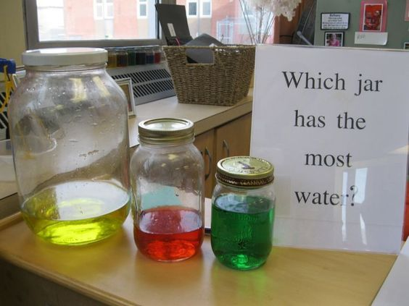 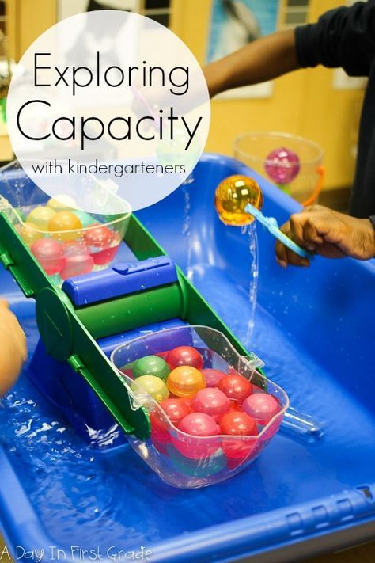 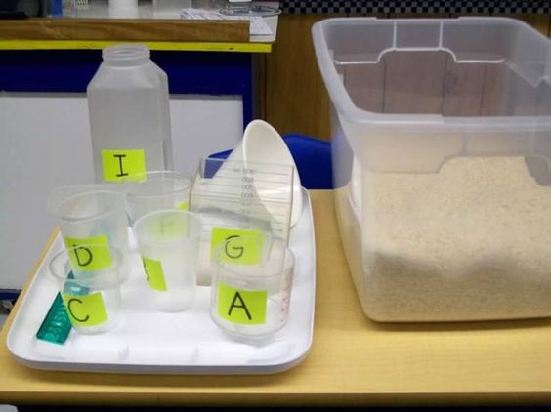 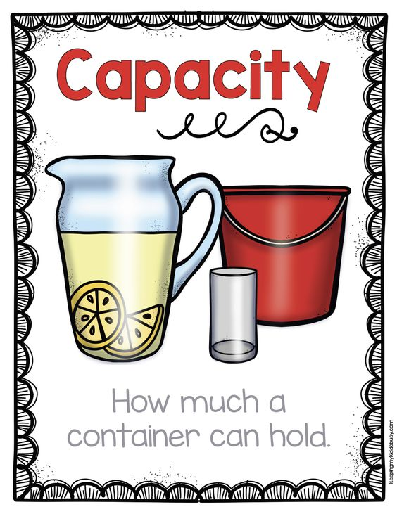

**We suggest the following timetable for Numeracy:**

**Week 5 (Monday 1st -Friday 5th June)**

*Monday 1st June- ‘Full, Half full, Empty’ language sheets*

*Tuesday 2nd June- Full, Empty, Half decorating*

*Wednesday 3rd June- Full, Empty, Half ordering*

*Thursday 4th June- Capacity Bingo*

*Friday 5th June- Capacity Play ideas see separate page for ideas*