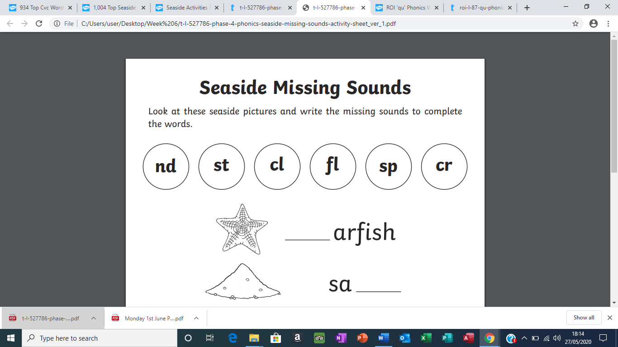

__tarfish

san__

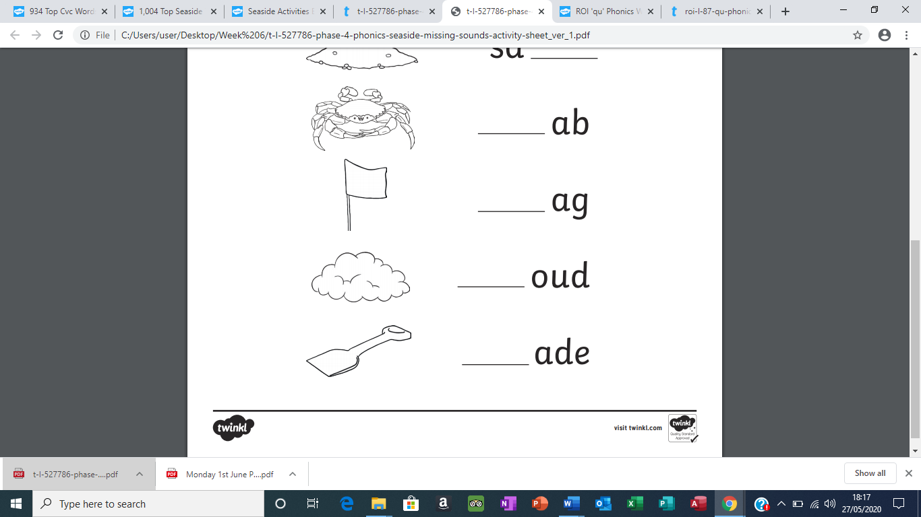

cra__

__lag

clou__

__pade

d s f b s d