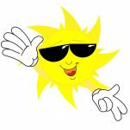

**Freagair na ceisteanna seo ata bunaithe ar an phíosa léitheoireachta :**

**An Samhradh.**

1. **An raibh an aimsir fuar?**

**_________________________________________________**

1. **An raibh an scoil druidte?**

**________________________________**

1. **Cad é a bhí ag fás sa ghairdín?**

**________________________________________________________________**

1. **Cad é a bhí na daoine ag déanamh ar an trá?**

**________________________________________________________________**