[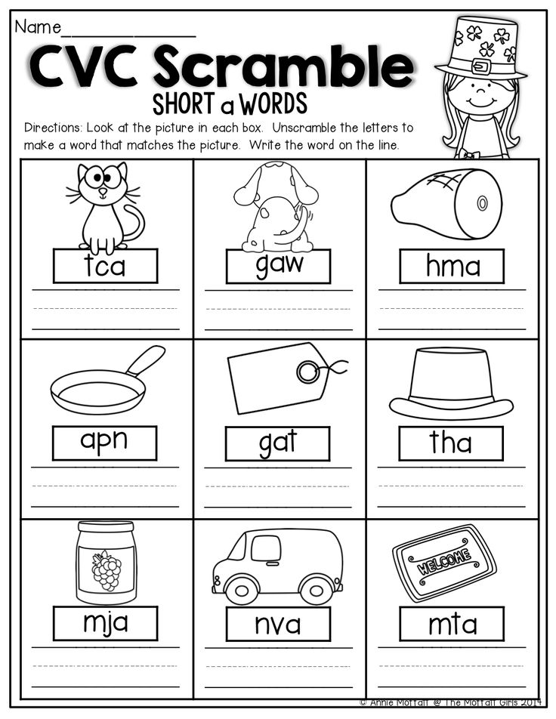](https://www.google.co.uk/url?sa=i&url=http%3A%2F%2Fseventothree.com%2Fcvc-kindergarten-worksheets%2F&psig=AOvVaw09QlGAYdLNKVLLWbNkhHQh&ust=1586856120208000&source=images&cd=vfe&ved=0CAIQjRxqFwoTCNjt_PSJ5egCFQAAAAAdAAAAABAi)

[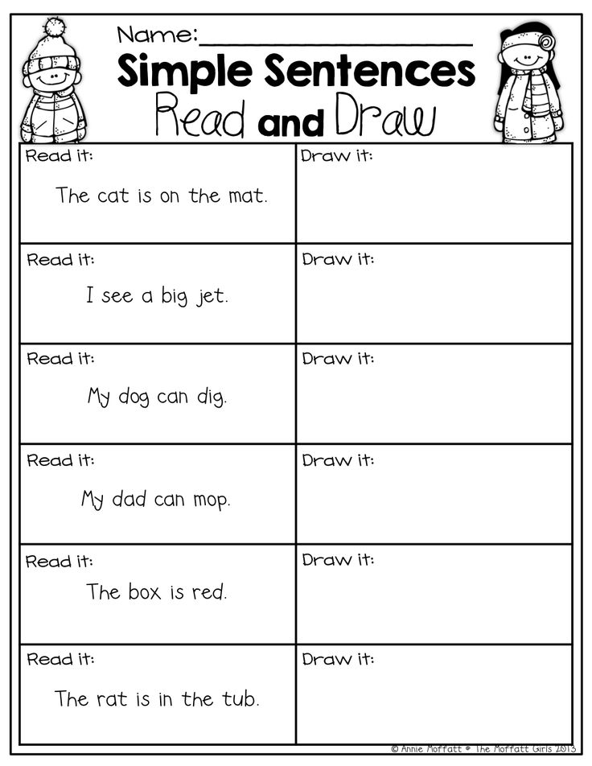](https://www.google.co.uk/url?sa=i&url=http%3A%2F%2Fseventothree.com%2Fsimple-sentences-worksheets-for-kindergarten%2F&psig=AOvVaw0glnqW7ldzPrmyuFjMt3M4&ust=1586857174245000&source=images&cd=vfe&ved=0CAIQjRxqFwoTCMDKruuN5egCFQAAAAAdAAAAABA4)