[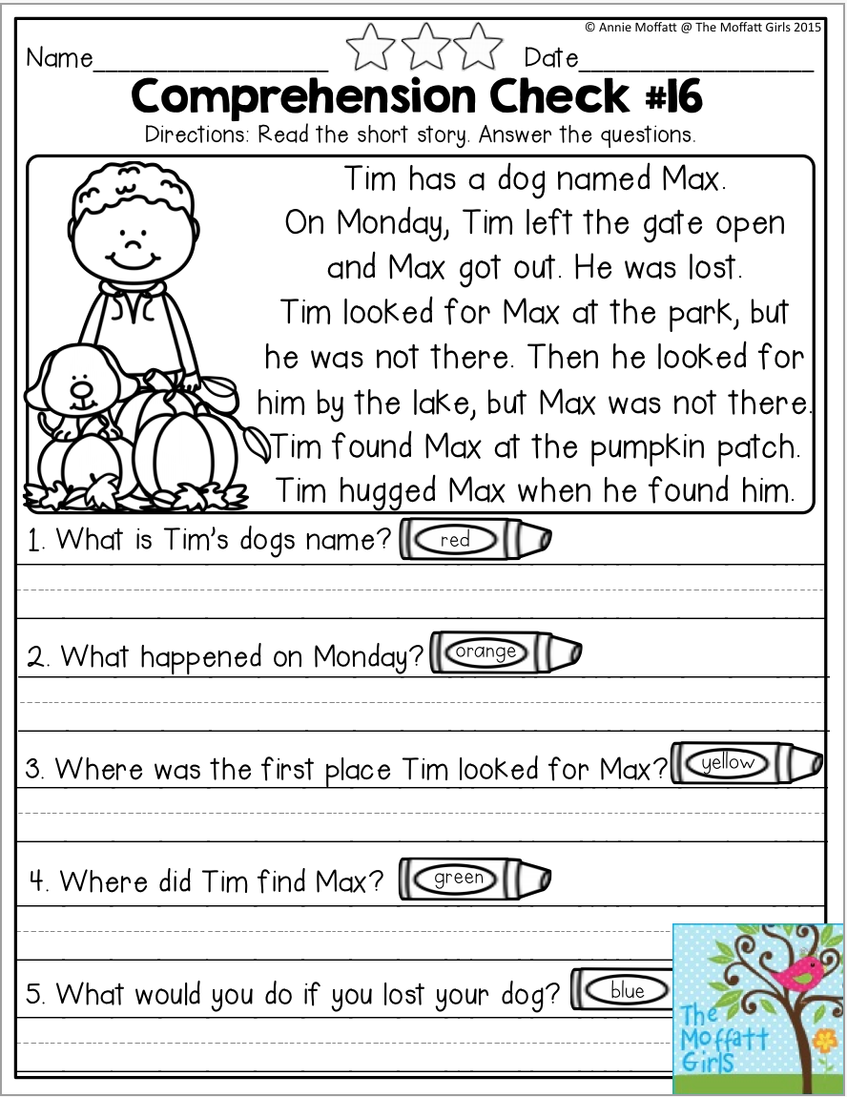](https://www.google.co.uk/url?sa=i&url=http%3A%2F%2Fwww.jtnproadrunner.org%2Fstunning-reading-comprehension-story-and-questions%2Fquestions-to-ask-about-the-story-poster-large-2%2F&psig=AOvVaw0-lkLHLfAxXcyx0lWv0JNC&ust=1586864482094000&source=images&cd=vfe&ved=0CAIQjRxqFwoTCPDWhJSp5egCFQAAAAAdAAAAABAE)

[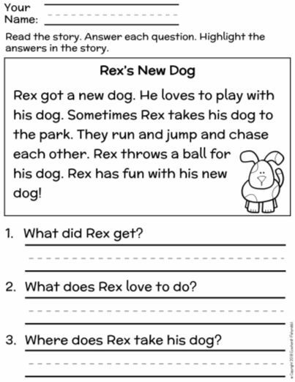](https://www.google.co.uk/url?sa=i&url=https%3A%2F%2Fwww.pinterest.com%2Fpin%2F5981411991419951%2F&psig=AOvVaw32dCE6O5jEOIglG9RAdcJ8&ust=1586865993693000&source=images&cd=vfe&ved=0CAIQjRxqFwoTCOCfjOGu5egCFQAAAAAdAAAAABAE)