[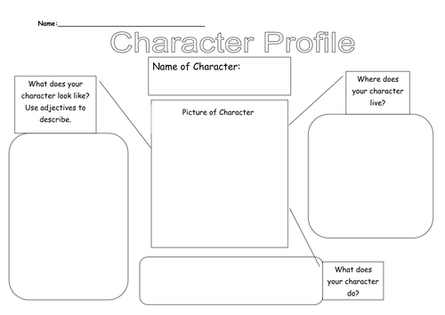](https://www.google.co.uk/url?sa=i&url=https%3A%2F%2Fwww.tes.com%2Fteaching-resource%2Fcharacter-profile-6376580&psig=AOvVaw0RbbvpcD_chg9M7NTCD_V0&ust=1586868432311000&source=images&cd=vfe&ved=0CAIQjRxqFwoTCOjcn9m35egCFQAAAAAdAAAAABAS)