[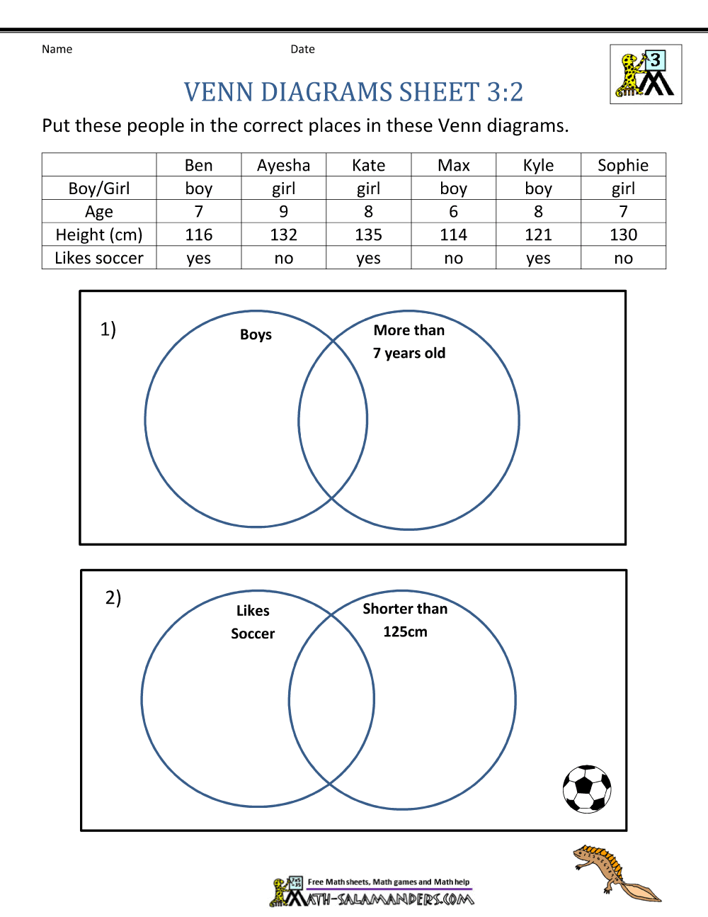](https://www.google.co.uk/url?sa=i&url=https%3A%2F%2Fwww.math-salamanders.com%2Fvenn-diagram-worksheets.html&psig=AOvVaw2jXvtFz9yrGzKt__lDi7Fg&ust=1587206163722000&source=images&cd=vfe&ved=0CAIQjRxqFwoTCJjW_fSh7-gCFQAAAAAdAAAAABAD)

