[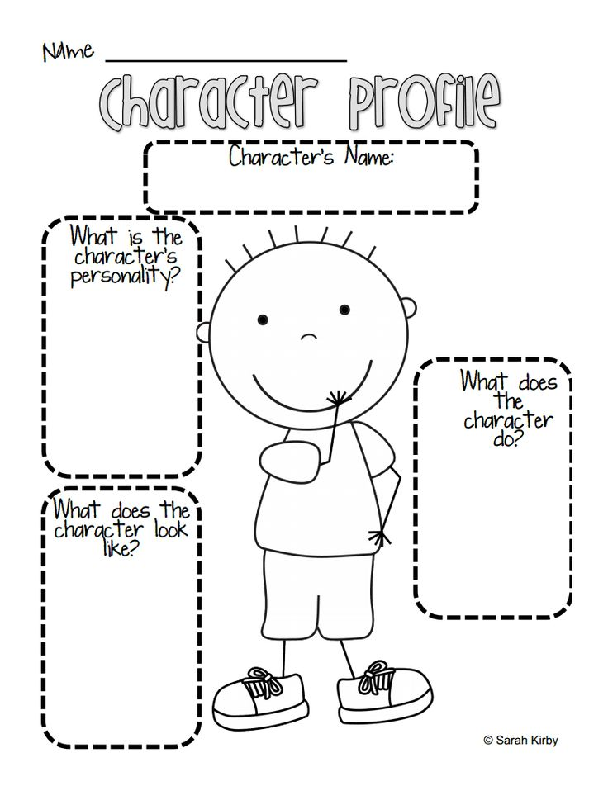](https://www.google.co.uk/url?sa=i&url=https%3A%2F%2Fwww.blackgate.com%2F2017%2F05%2F07%2Fthings-your-writing-teacher-never-told-you-getting-to-know-your-omniscient-narrator%2F&psig=AOvVaw0RbbvpcD_chg9M7NTCD_V0&ust=1586868432311000&source=images&cd=vfe&ved=0CAIQjRxqFwoTCOjcn9m35egCFQAAAAAdAAAAABAE)