[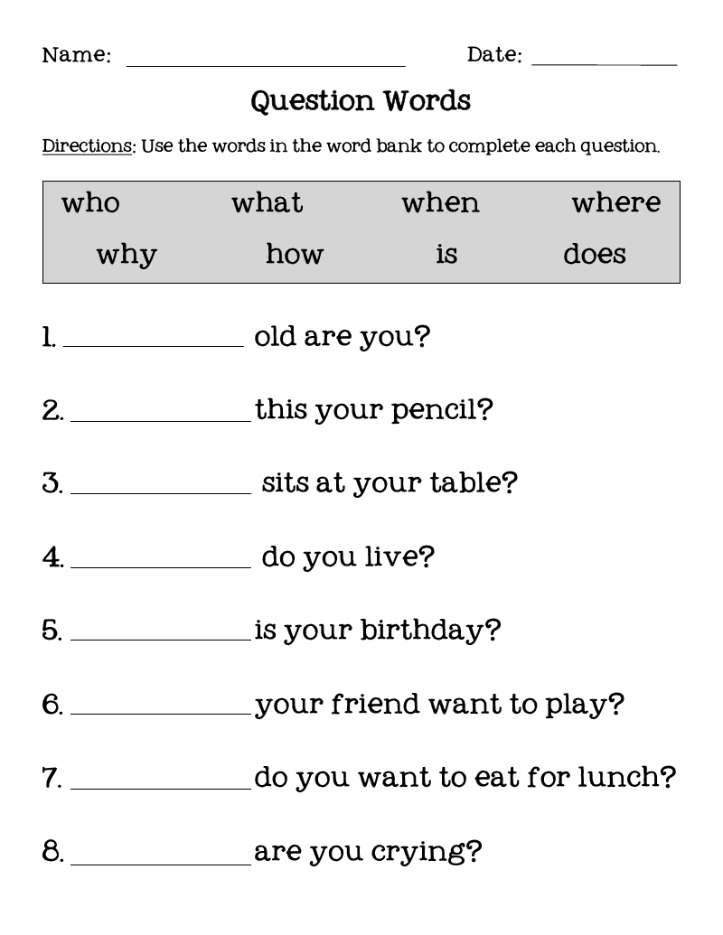](https://www.google.co.uk/url?sa=i&url=https%3A%2F%2Fwww.pinterest.com%2Fpin%2F229894755950500193%2F&psig=AOvVaw2PxeRKjAQ_1v2ni4PRn5yo&ust=1586876107577000&source=images&cd=vfe&ved=0CAIQjRxqFwoTCOjFkaXU5egCFQAAAAAdAAAAABAl)