**Friday 5th June 2020**

*Good morning P.3*

1. Nessy for each pupil (see school website for further details on how to log on)
2. Sumdog for each pupil.
3. Sumdog challenge (a new challenge is set weekly)
4. Mental maths

-Identify missing numbers in a sequence within 100.

1. **Literacy**

*Test*

-Complete test 41 and 42.

(see answers below)

1. **Numeracy**

*Test*

-Complete section a,b and c

(answers provided)

*Have a nice weekend everybody and we hope you are all keeping well!

[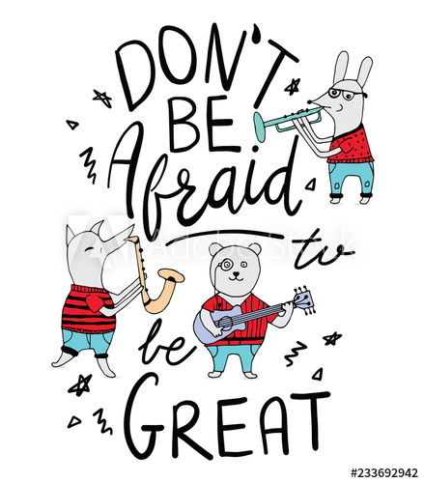](https://www.google.co.uk/url?sa=i&url=https%3A%2F%2Fstock.adobe.com%2Fimages%2Fdon-t-be-afraid-to-be-great-quote-kids-motivational-quote-music-quote-and-say-animal-poster%2F233692942&psig=AOvVaw1eFnS3IkxjnhGzIuvCJUzC&ust=1586869325533000&source=images&cd=vfe&ved=0CAIQjRxqFwoTCMiJ-Zm75egCFQAAAAAdAAAAABAD)

**Literacy Answers**

**Test 41**

1. y

2. Y

3. September

4. 1

5. sh

6. Monday

7. yell, low

8. slow

9. when

10. full stop

**Test 42**

1. r
2. R
3. October
4. 1
5. ch
6. Tuesday
7. lit
8. last
9. what
10. full stop