Monday 8th June

Hello and welcome back. We hope you are all staying safe and well.

This week we will be starting our new topic of Pirates ☺. Please find attached a Pirate Power Point which will help introduce the topic of Pirates to your children. Please find below some small world sensory ideas for our Pirate Topic, I have linked some small world puppets and mask which can used to help build your own sensory small world. Also attached are some pirates art and crafts activities, children can design their own pirate flag, and some pirate colouring. Have fun.

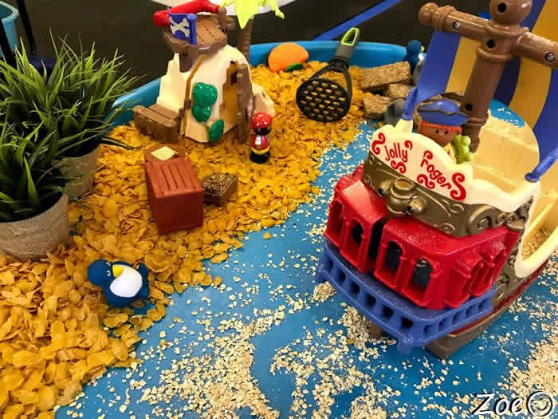 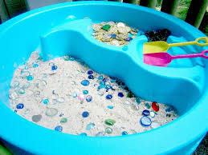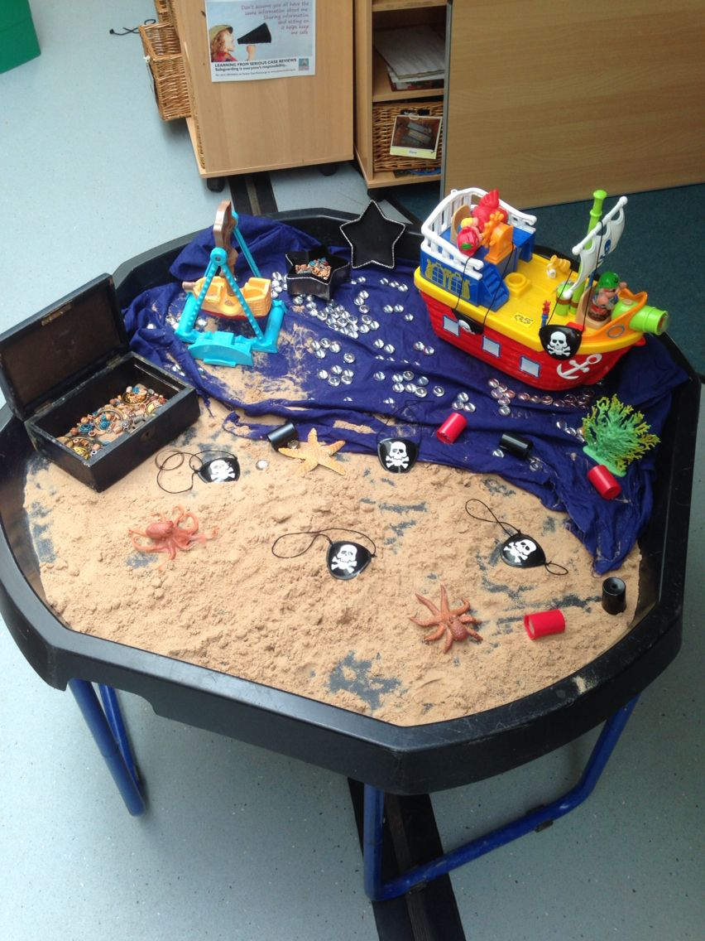 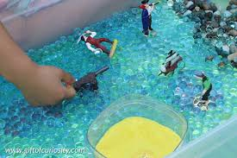

Youtube also has some great Pirate songs

* <https://www.youtube.com/watch?v=jx79dLuqPwQ>
* <https://www.youtube.com/watch?v=XDKlKiMIYv4>
* <https://www.youtube.com/watch?v=_qAngsMJD3I>

Literacy

* **High frequency words**: Please continue to revise all spellings to date. As we have been doing previously with the high frequency words homework, look and say each word. Orally put each word into a sentence. Practise writing each word and look out for the words in books. This week we will be continuing learning the frequency word ‘I’ read the story ‘I can laugh’.
* **Phonics:** Continue to revise the sounds covered to date using the alphabet and Starfall website. **Introduce the new sound ch:**
* Jack Hartman ‘ch’ sound

<https://www.youtube.com/watch?v=FWg2uzAuSe4>

* Alpha blocks ‘ch’ sound link
* <https://www.youtube.com/watch?v=2ncQwQZJ47E>
* Watch out for this sound in story books and look for objects within the home that begin with this new sound.
* Practice the correct formation of *lowercase* ch
* **Reading:** Continue to access eBooks on the Oxford Owl website:

<https://home.oxfordowl.co.uk/books/free-ebooks/>

Here is a list of recommended book levels for your child to read, with corresponding titles to search for. If your child finds the level too hard or too easy, move up or down within the Oxford Level/Book Band Colour.

|  |  |  |
| --- | --- | --- |
| Oxford Level | Book Band Colour | Suggested Title |
| 1 | Lilac | The Haircut |
| 1+ | Pink | Big Feet |
| 2 | Red | Spots |
| 3 | Yellow | The Birthday Cake |

*It is so important that you continue to do daily reading with your children, in order to maintain the progress made to date! At least 10 minutes every day please.*

**We suggest the following timetable for Literacy**

**Week 7 (Monday 8th June- Friday 12th June)**

(Work on high frequency words and reading to be carried out every day)

Monday 1st Phonics ch book twinkl and ch picture words

Tuesday 2nd ‘My Ch booklet’

Wednesday 3rd Making ch playdough mats

Thursday 4th ch cut and stick and ch picture wheel

Friday 5th Read story ‘I can laugh’ story

**Numeracy**

This week we will be covering the topic of data handling and in particular pictograms. This is a great opportunity to encourage practical learning. I have also attached some cutting skills activity books to be completed at the start of the week which will help develop cutting skills when making their pictograms. Please go through the power points attached which will help explain collecting data.

**We suggest the following timetable for Numeracy:**

**Week 7 (Monday 8th –Friday 12th June)**

*Monday 1st June- ‘cutting skills worksheet’*

*Tuesday 2nd June- Family eye colour pictogram*

*Wednesday 3rd June- Favourite ice cream*

*Thursday 4th June- Animal pictogram*

*Friday 5th June- Interpretation of pictograms*